SEVAI
Be the beast you can be
2K21-2K22
Real Leaders are ordinary people with extraordinary determination
8th EDITION
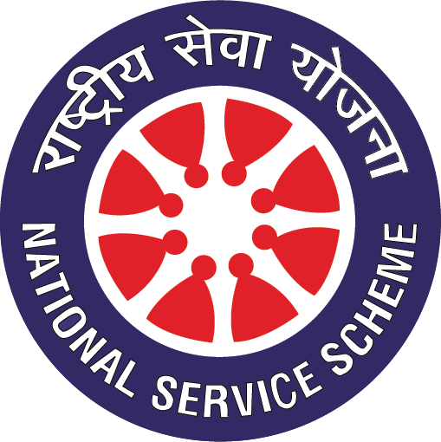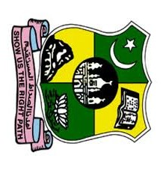
Not me but you Since 1951
NATIONAL SERVICE SCHEME
JAMAL MOHAMED COLLEGE
(Autonomous)
College with Potential for Excellence
Accredited (3rd cycle) with ‘A’ grade by NAAC
DBT Star Scheme & DST – FIST Funded
(Affiliated to Bharathidasan University)
Tiruchirappalli - 620 020.

EDITORIAL BOARD
2K21-22

Editor in Chief:

M. YOGANTHRAJ
N. GANESAN

Reviewers:

Dr. S. Mohamed Yusuff Ansari
Dr. B. MOHAMED RAFEEQ
Dr. S. Gopi
Mr. D. Prabaharan
Dr. S. ABDUL RAJAK

PRAYER

In the name of Allah
The most gracious and the most merciful
By the heaven and the nightly star!
And what will make you realize what the nightly star is?
It is the star of piercing brightness.
There is no soul but without a vigilant angel recording everything.
Let people then consider what they were created from!
They were created from a spurting fluid,
Stemming from between the backbone and the ribcage
Surely, he is fully capable of bringing them back to life
On the day all secrets will be disclosed.
Then one will have neither power nor any helper.
By the sky with its recurring cycles,
And the earth with its sprouting plants!
Surely this Quran is a decisive word,
And is not to be taken lightly.
They are certainly devising evil plans,
But I am too planning.
So bear with the disbeliever’s O Prophet. Let them be for just a little while.

(AL QUR’AN: 86:1-17)

NATIONAL SERVICE SCHEME
The National Service Scheme popularly known as NSS was launched on 24th September 1969, Mahatma Gandhi’s birth centenary year initially in 37 universities involving 40000 Volunteers. Today it has more than 3.91 Million volunteers spread over 657 universities and 51[+2] councils and implemented in 20,669 academic institutions including higher as well as technical education.
The aim of National Service Scheme is “Development of the Personality of Students through Community Service”. In order to fulfil the objective student volunteers and programme functionaries are engaged in constructive and productive programmes involving students in various awareness drives social reforms communal harmony, creation of community assets, relief work, blood donation, disaster management, environmental protection, literacy programme, health education campaign etc. under the scheme each volunteer contributes 240 hours of community work during a period of 2 years and participate in one special campaign programs.

MOTTO
The motto of NSS “NOT ME BUT YOU”, reflects the essence of democratic living and upholds the need for yourself the need for selfless service.

SYMBOL
The symbol for the NSS has been on the Giant rath wheel of the world famous Konark Sun Temple (the black pagoda) situated in Odisha, India. The wheel portrays the cycle of creation, preservation, and release and signifies the movement in thin life across time and space

BADGE
The NSS symbol is embossed on the badge. The 24 hours of the day. The red colour indicates that the volunteers in full of young blood that is lively active, energetic, and full of high spirit. The navy blue indicates the cosmos of which the NSS in tiny part, ready to contribute its share for the welfare of the mankind. And the white colour indicates peace.

RECOGNITIONS
The NSS program functionaries and volunteers have been benefiting through incentives via participation in national level events like NSS mega camp, Rajiv Gandhi adventure programs, National Integration, Interstate Youth Exchange and homes stay programmes, training programmes organized by Rajiv Gandhi Institute of youth development as well as awards at University/Directorate state and national level

NSS SONG

Uthen samaj ke liye uthen uthen,
Jagen swarashtra ke liye jagen jagen,
Sawayam sajen vasundhara sarwar den
Hum uthen uthega jag hamare sang sathiyon,
Hum bade to sab badenge apne ap sathiyon,
Jamin pe asman ko utar den
Udasiyon ko dur kar khushi ko banten chalen,
Gaon aur shahar ki durion ko patate chalen,
Gyan ko parchar den prasar den
Vidyan ko prachar de prasar de
Swaying saje vasumdhara sanwar de
Samathi bal vurdh aur narian rahe sada
Hare bhare vanon ki shawl odhti rahe dhra
Tarakhiyon ki ek nayee katar den
Swayang saje vasundhara sanwar de
Ye jati dharm bollyan bane na shool rah ki,
Badhayen bel prem ki akhanda ki chah ki,
Bhawna se ye chamam nikhar den
Sadbhawan se ye chamanu nikhar de
Swayanm saje vasundhara sanwar de
Uthen samaj ke liye uthen uthen,
Jage swarashtra ke liye jagen jagen,
Sawayam sajen vasundhara sanwar den.

FOUNDERS

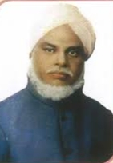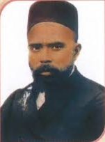
Hajee. M. Jamal Mohamed Sahib Janab. N.M. Khajamian Rowther

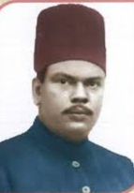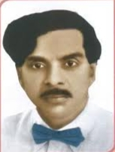
Janab. M.J. Jamal Mohideen Sahib Janab. K. Abdul Samad Sahib
Founder Secretary Founder Treasurer

Management Committee

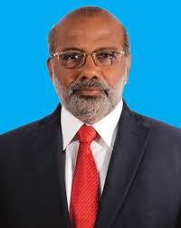
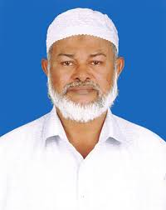 Hajee.M.J. Jamal Mohamed Bilal Dr. A.K. Khaja Nazeemudeen
President Secretary & Correspondent

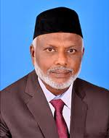
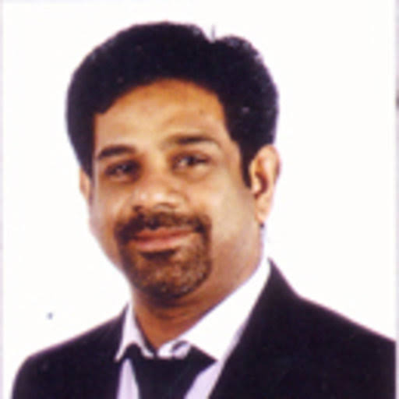
Hajee.M.J. Jamal Mohamed Dr. K. Abdus Samad
Treasurer Assistant secretary
Academic
Administration
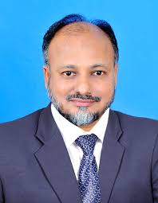

Dr. S. Ismail Mohideen
PRINCIPAL

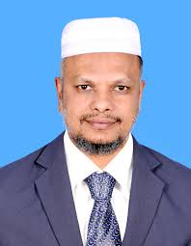
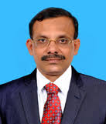

Dr. A. Mohamed Ibraheem Dr. M. Mohamed Sihabudeen
Vice-Principal Addl. Vice-Principal

DIRECTORS

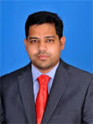

Dr. K.N. Abdul Kader Nihal
Hon. Member & Director

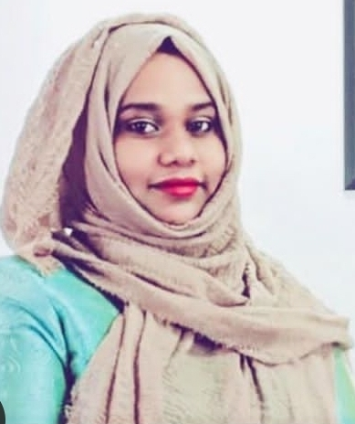
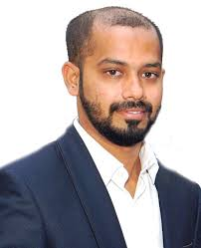

Dr. K.N. Mohamed Fazil Ms. J. Hajira Fathima Director-Hostel Administration. Director-Women Hostel

FROM THE EDITOR’S DESK........
We are very happy to edit this NSS magazine SEVAI 2K23. We NSS Students are happy to serve our college forever. We gain a lot of good experiences from NSS and it is a platform that gives us knowledge and leadership qualities. We are very proud to publish this 9th edition of SEVAI 2K23. May Almighty Allah bless our service to shine with flying colours always and all ways.
EDITORS

YOGANTHRAJ. M GANESAN. N

INTERNAL QUALITY ASSURANCE CELL

FORMAT FOR PART-V EXTENSION ACTIVITIES (2021-2022)
(NCC / NSS / Leo Club / Rotaract Club / Anti Dowry / Consumer Club / Youth Red Cross / Red Ribbon Club / TSCMM / Gender Club / Exnora / Helping Hearts/ Drug Abolishers/ JAMCROP)

- Details of Extension and outreach programme conducted in collaboration with industry, community and Non-Government Organizations during the year (except seminars, conferences and workshops)

Name of the programme¹ | Name of the activity² | Organizing unit and collaborating agency and place | Date of activity  DD-MM-YYYY | N0. of students participated | No. of faculty members coordinated | Number of beneficiaries
COVID-19 Prevention Help Desk Opening | COVID-19 Prevention Help Desk Opening | NSS Unit Cell of Jamal Mohamed College, Tiruchirappalli | 01.06.2021 | 15 | 01 | 40
Vaccination Camp | Vaccination Camp | NSS Unit Cell of Jamal Mohamed College, Tiruchirappalli | 16.06.2021 | 06 | 02 | 150
Vaccination Camp | Vaccination Camp | NSS Unit Cell of Jamal Mohamed College, Tiruchirappalli | 02.09.2021 | 05 | 01 | 150
Vaccination Camp | Vaccination Camp | NSS Unit Cell of Jamal Mohamed College, Tiruchirappalli | 11.09.2021 | 05 | 01 | 150
Mega Vaccination Camp | Mega Vaccination Camp | NSS Unit Cell of Jamal Mohamed College, Tiruchirappalli | 12.09.2021 | 30 | 02 | 500
Mega Vaccination Camp | Mega Vaccination Camp | NSS Unit Cell of Jamal Mohamed College, Tiruchirappalli | 19.09.2021 | 06 | 02 | 150
World Sight Day | World Sight Day | NSS Unit Cell of Jamal Mohamed College, Tiruchirappalli | 21.10.2021 | 110 | 02 | 200
Cycle Rally | Cycle Rally | NSS Unit Cell of Jamal Mohamed College, Tiruchirappalli | 23.10.2021 | 20 | 05 | 30
Transgender Identity Updating | Transgender Identity Updating | NSS Unit Cell of Jamal Mohamed College, Tiruchirappalli | 25.10.202 | 02 | 01 | 100
Diwali Awareness | Diwali Awareness | NSS Unit Cell of Jamal Mohamed College, Tiruchirappalli | 28.10.2021 | 95 | 02 | 400
Mega Vaccination Camp | Mega Vaccination Camp | NSS Unit Cell of Jamal Mohamed College, Tiruchirappalli | 30.10.2021 | 50 | 01 | 250
World Diabetes Day Awareness & Medical Camp | World Diabetes Day Awareness & Medical Camp | NSS Unit Cell of Jamal Mohamed College, Tiruchirappalli | 17.11.2021 | 50 | 02 | 150
Placement Cell Interview | Placement Cell Interview | NSS Unit Cell of Jamal Mohamed College, Tiruchirappalli | 15.12.2021 | 05 | 01 | 29
Placement Cell Interview | Placement Cell Interview | NSS Unit Cell of Jamal Mohamed College, Tiruchirappalli | 17.12.2021 | 10 | 01 | 42
Pulwama Attack | Pulwama Attack | NSS Unit Cell of Jamal Mohamed College, Tiruchirappalli | 14.02.2022 | 10 | 01 | 200
Placement Cell Interview | Placement Cell Interview | NSS Unit Cell of Jamal Mohamed College, Tiruchirappalli | 16.03.2022 | 10 | 01 | 23
Placement Cell Interview | Placement Cell Interview | NSS Unit Cell of Jamal Mohamed College, Tiruchirappalli | 17.03.2022 | 10 | 01 | 18
Placement Cell Interview | Placement Cell Interview | NSS Unit Cell of Jamal Mohamed College, Tiruchirappalli | 22.03.2022 | 06 | 01 | 64
TB Rally | TB Rally | NSS Unit Cell of Jamal Mohamed College, Tiruchirappalli | 24.03.2022 | 10 | 01 | 300
Bike Rally | Bike Rally | NSS Unit Cell of Jamal Mohamed College, Tiruchirappalli | 25.03.2022 | 30 | 03 | 50
FIT INDIA 2022 | FIT INDIA 2022 | NSS Unit Cell of Jamal Mohamed College, Tiruchirappalli | 25.03.2022 | 10 | 01 | 100
Mega Job Fair | Mega Job Fair | NSS Unit Cell of Jamal Mohamed College, Tiruchirappalli | 27.03.2022 | 57 | 01 | 110
Placement Cell Interview | Placement Cell Interview | NSS Unit Cell of Jamal Mohamed College, Tiruchirappalli | 28.03.2022 | 06 | 01 | 30
Placement Cell Interview | Placement Cell Interview | NSS Unit Cell of Jamal Mohamed College, Tiruchirappalli | 30.03.2022 | 05 | 01 | 20

- Details of students / faculty members participated in extension activities held outside the college during the year:
Name of the programme¹ | Name of the activity² | Name of the institution and place | Date of activity  DD-MM-YYYY | Number of students participated | Number of faculty members participated
World Environment Day | World Environment Day | NSS Unit Cell of Jamal Mohamed College, Tiruchirappalli | 05.06.2021 | 22 | 01
International Yoga Day | International Yoga Day | NSS Unit Cell of Jamal Mohamed College, Tiruchirappalli | 21.06.2021 | 30 | 02
International Day Against Drug Abuse | International Day Against Drug Abuse | NSS Unit Cell of Jamal Mohamed College, Tiruchirappalli | 26.06.2021 | 25 | 02
World Population Day | World Population Day | NSS Unit Cell of Jamal Mohamed College, Tiruchirappalli | 11.07.2021 | 36 | 03
World Nature Conservation Day | World Nature Conservation Day | NSS Unit Cell of Jamal Mohamed College, Tiruchirappalli | 28.07.2021 | 15 | 01
National Hospital Day | National Hospital Day | NSS Unit Cell of Jamal Mohamed College, Tiruchirappalli | 30.07.2021 | 15 | 01
National Anthem Singing | National Anthem Singing | NSS Unit Cell of Jamal Mohamed College, Tiruchirappalli | 07.08.2021 | 61 | 02
International Youth Day | International Youth Day | NSS Unit Cell of Jamal Mohamed College, Tiruchirappalli | 12.08.2021 | 10 | 01
75th Independence Day at JMC | 75th Independence Day | NSS Unit Cell of Jamal Mohamed College, Tiruchirappalli | 15.08.2021 | 16 | 04
75th Independence Day at BDU | 75th Independence Day | NSS Unit Cell of Jamal Mohamed College, Tiruchirappalli | 15.08.2021 | 37 | 01
Certificate Verification (UG-Aided Students) | Certificate Verification | NSS Unit Cell of Jamal Mohamed College, Tiruchirappalli | 01.09.2021  TO  04.09.2021 | Day01:03  Day02:03  Day03:03  Day04:03 | Day01:01  Day02:01  Day03:01  Day04:01
Certificate Verification (UG-SF Students) | Certificate Verification | NSS Unit Cell of Jamal Mohamed College, Tiruchirappalli | 01.09.2021  TO  04.09.2021 | Day01:03  Day02:03  Day03:03  Day04:03 | Day01:01  Day02:01  Day03:01  Day04:01
Teacher’s Day | Teacher’s Day | NSS Unit Cell of Jamal Mohamed College, Tiruchirappalli | 04.09.2021 | 25 | 5
International Literacy Day | Quiz Programme | NSS Unit Cell of Jamal Mohamed College, Tiruchirappalli | 08.09.2021 | 130 | 03
Deworming Awareness | Deworming Awareness | NSS Unit Cell of Jamal Mohamed College, Tiruchirappalli | 13.09.2021 | 30 | 01
Social Justice Day | Social Justice Day | NSS Unit Cell of Jamal Mohamed College, Tiruchirappalli | 17.09.2021 | 50 | 02
Kabasura Drink | Kabasura Drink | NSS Unit Cell of Jamal Mohamed College, Tiruchirappalli | 17.09.2021 | 06 | 02
Tree Plantation | Tree Plantation | NSS Unit Cell of Jamal Mohamed College, Tiruchirappalli | 24.09.2021 | 10 | 05
NSS Day | NSS Day | NSS Unit Cell of Jamal Mohamed College, Tiruchirappalli | 24.09.2021 | 150 | 05
College Day Celebration | College Day Celebration | NSS Unit Cell of Jamal Mohamed College, Tiruchirappalli | 27.09.2021 | 30 | 05
FIT IndiaRally 2.0 | FIT India Rally 2.0 | NSS Unit Cell of Jamal Mohamed College, Tiruchirappalli | 02.10.2021 | 10 | 01
Pre-RD Selection Camp | Pre-RD Selection Camp | NSS Unit Cell of Jamal Mohamed College, Tiruchirappalli | 06.10.2021 | 30 | 01
Campus Cleaning | Swachh Bharath | NSS Unit Cell of Jamal Mohamed College, Tiruchirappalli | 09.10.2021 | 35 | 02
Fresher’s Welcome Day | Fresher’s Welcome Day | NSS Unit Cell of Jamal Mohamed College, Tiruchirappalli | 18.10.2021 | 30 | 03
Mega Cleaning | Swachh Bharath | NSS Unit Cell of Jamal Mohamed College, Tiruchirappalli | 23.10.2021 | 60 | 03
Clean India | Swachh Bharath | NSS Unit Cell of Jamal Mohamed College, Tiruchirappalli | 29.10.2021 | 110 | 05
National Unity Day Pledge | Pledge | NSS Unit Cell of Jamal Mohamed College, Tiruchirappalli | 31.10.2021 | 40 | 03
Children’s Day | Competition | NSS Unit Cell of Jamal Mohamed College, Tiruchirappalli | 15.11.2021 | 15 | 01
Book Fair | Book Fair | NSS Unit Cell of Jamal Mohamed College, Tiruchirappalli | 15.11.2021 TO  16.11.2021 | 08 | 02
National Integration Day Pledge | Pledge | NSS Unit Cell of Jamal Mohamed College, Tiruchirappalli | 19.11.2021 | 15 | 05
Student Induction | Student Induction | NSS Unit Cell of Jamal Mohamed College, Tiruchirappalli | 29.11.2021  AND 01.12.2021 | Day01:30  Day02:33 | Day01:01  Day02:01
Tree Plantation at BDU | Tree Plantation at BDU | NSS Unit Cell of Jamal Mohamed College, Tiruchirappalli | 04.12.2021 | 30 | 01
Herbal Garden Cleaning at BDU | Herbal Garden Cleaning at BDU | NSS Unit Cell of Jamal Mohamed College, Tiruchirappalli | 06.12.2021 | 40 | 01
Herbal Garden Cleaning at BDU | Herbal Garden Cleaning at BDU | NSS Unit Cell of Jamal Mohamed College, Tiruchirappalli | 07.12.2021 | 40 | 01
NSS Orientation | NSS Orientation | NSS Unit Cell of Jamal Mohamed College, Tiruchirappalli | 08.12.2021 | 230 | 05
University  Convocation | University  Convocation | NSS Unit Cell of Jamal Mohamed College, Tiruchirappalli | 09.12.2021 | 50 | 01
Tamil Department Programme | Tamil Department Programme | NSS Unit Cell of Jamal Mohamed College, Tiruchirappalli | 16.12.2021 | 10 | 01
Swami Vivekananthan Birthday (National Youth Day) | Swami Vivekananthan Birthday (National Youth Day | NSS Unit Cell of Jamal Mohamed College, Tiruchirappalli | 12.01.2022 | 06 | 01
Cleaning Programme | Swachh Pakhwada | NSS Unit Cell of Jamal Mohamed College, Tiruchirappalli | 12.01.2022 | 06 | 01
Cleaning Programme | Swachh Pakhwada | NSS Unit Cell of Jamal Mohamed College, Tiruchirappalli | 12.01.2022 | 10 | 01
National Voter’s Day | National Voter’s Day | NSS Unit Cell of Jamal Mohamed College, Tiruchirappalli | 25.01.2022 | 48 | 01
Republic Day at JMC | Republic Day | NSS Unit Cell of Jamal Mohamed College, Tiruchirappalli | 26.01.2022 | 40 | 04
Republic Day at BDU | Republic Day | NSS Unit Cell of Jamal Mohamed College, Tiruchirappalli | 26.01.2022 | 40 | 01
Child Labour Day | Child Labour Day | NSS Unit Cell of Jamal Mohamed College, Tiruchirappalli | 11.02.2022 | 07 | 05
Convocation Day Men (Aided) | Convocation Day (Aided) | NSS Unit Cell of Jamal Mohamed College, Tiruchirappalli | 05.03.2022 | 60 | 05
Convocation Day (Women) | Convocation Day (Women) | NSS Unit Cell of Jamal Mohamed College, Tiruchirappalli | 06.03.2022 | 60 | 05
Convocation Day Men (SF) | Convocation Day Men (SF) | NSS Unit Cell of Jamal Mohamed College, Tiruchirappalli | 07.03.2022 | 30 | 05
Parade Training for Sports Meet | Parade Training for Sports Meet | NSS Unit Cell of Jamal Mohamed College, Tiruchirappalli | 11.03.2022  TO  24.03.2022 | 60 | 02
Tamil Department (Padipom Pagirvom) | Tamil Department | NSS Unit Cell of Jamal Mohamed College, Tiruchirappalli | 18.03.2022 | 08 | 01
Marty’s Day | Marty’s Day | NSS Unit Cell of Jamal Mohamed College, Tiruchirappalli | 23.03.2022 | 55 | 05
Sports Meet | Sports  Meet | NSS Unit Cell of Jamal Mohamed College, Tiruchirappalli | 25.03.2022 | 10 | 01
Tamil Department (Pannul Ayvarangam) | Tamil Department (Pannul Ayvarangam) | NSS Unit Cell of Jamal Mohamed College, Tiruchirappalli | 26.03.2022 | 07 | 01
Food Donation | Food Donation | NSS Unit Cell of Jamal Mohamed College, Tiruchirappalli | 27.03.2022 | 08 | 01
Masjidh Cleaning | Swachh Pakhwada | NSS Unit Cell of Jamal Mohamed College, Tiruchirappalli | 30.03.2022 | 37 | 03

- Details of Special lectures, seminars, conferences and workshops organized by the college during the year:

Name of the seminar / conference / workshop | Name of collaborating agency, if any | Date(s)  DD-MM-YYYY | Number of students participated | Number of faculty members coordinated | Resource persons (Name & address)
Wish Programme | Bharathidasan University | 01.10.2021 | 15 | 01 | Dr.A.LakshmiPrabha  (NSS Co-ordinator of Bharathidasan University)
Science Exhibition | Bharathidasan University | 28.02.2022 | 50 | 01 | Dr.M. Selvam  (Former Vice Chancellor Alagappa University)
Archaeological Department | Archaeological Department and Tamil Department | 11.03.2022 | 10 | 02 | Dr.N. Rajendran  (Former Vice Chancellor Alagappa University)
NSS One Day Orientation on Life skills and Ending Child Marriage | Bharathidasan University | 15.03.2022 | 05 | 01 | Dr.L. Ganesan  (Registrar of Bharathidasan University)
RRC Programme Officer’s Meeting | Bharathidasan University | 17.03.2022 | 12 | 01 | Dr.M. Selvam  (Vice Chancellor Bharathidasan University)
Women Empowerment and Personality Development | Bharathidasan University | 29.03.2022 | 13 | 01 | Dr.K. Ruckmani  (Professor of Anna University)

- Awards and recognition received for extension activities from Government and other recognized bodies during the year

- Faculty members:

Name of the faculty member | Name of the recognition | Name of the awarding body and place | Month & year of award
Dr.S. Mohamed Yusuff Ansari | National Integration Camp (Coimbatore) | Ministry of Youth Affairs and Sports | December,2021

- Students:

Name of the student | Name of the  Recognition | Name of the awarding body and place | Month & year of award
A. Ashiq Basha | National Integration Camp (Mysore) | Ministry of Youth Empowerment & Sports | November,2021
K. Kaviya Chelvan | National Youth Festival Camp | Ministry of Youth Affairs and Sports | January,2022
S. Shiyam Kumar | Pre-RD Parade Camp | Ministry of Youth Affairs and Sports | September,2021

Camp Name | Evidence
National Integration Camp (Coimbatore) | https://in.docworkspace.com/d/sIGe0rOagAf7k3pIG
National Integration Camp (Mysore) | https://in.docworkspace.com/d/sIHD247NW1-DekgY
National Youth Festival Camp | https://in.docworkspace.com/d/sIH_247NWzOLekgY
Pre-RD Parade Camp | https://in.docworkspace.com/d/sILb247NWp-fekgY

- Any other information related to extension activities:
SPECIAL CAMP

Day | Name of the Programme | Venue | No. of NSS Volunteers Participated | No. of NSS Programme Officer’s | Evidence
01 | Cleaning | Burma Colony samuthaya Kudam | 20 | 02 | https://in.docw  orkspace.co  m/d/sIPz24  7NWyYjbkgY
 | Awareness | Burma Colony samuthaya Kudam | 170 | 05 | https://in.docw  orkspace.co  m/d/sIPn24  7NWkInbkgY
02 | Exercise | Burma Colony samuthaya Kudam | 170 | 05 | https://in.docw  orkspace.co  m/d/sIPn247N  WxIvbkgY
 | 75th Independence Day Amulet Festival | Burma Colony samuthaya Kudam | 170 | 05 | https://in.docw  orkspace.co  m/d/sIB3247N  WwYnbkgY
 | CM Medical Camp | Burma Colony samuthaya Kudam | 20 | 02 | https://in.docw  orkspace.co  m/d/sIKD247N  WkovbkgY
 | Cleaning | Anna Nagar Church | 120 | 03 | https://in.docw  orkspace.co  m/d/sII7247N  Wy4rbkgY
 | Awareness | Burma Colony samuthaya Kudam | 170 | 05 | https://in.docw  orkspace.co  m/d/sIBf247N  WhYrbkgY
03 | Exercise | Burma Colony samuthaya Kudam | 170 | 05 | https://in.docw  orkspace.co  m/d/sILW0rO  agAd6a25IG
 | 75th Independence Day Amulet Festival | Burma Colony samuthaya Kudam | 170 | 05 | https://in.docw  orkspace.co  m/d/sIPC0rO  agAZub25IG
 | Cleaning | Navalpattu Govt Hospital | 70 | 03 | https://in.docwor  kspace.co  m/d/sICC0rO  agAf2Z25IG
 | Cleaning | Burma Colony Govt School | 70 | 02 | https://in.docw  orkspace.co  m/d/sIDW0rO  agAbea25IG
04 | Exercise | Burma Colony samuthaya Kudam | 170 | 05 | https://in.docw  orkspace.co  m/d/sIFu0rO  agAcWd25IG
 | 75th Independence Day Amulet Festival | Burma Colony samuthaya Kudam | 170 | 05 | https://in.docw  orkspace.co  m/d/sILS0rO  agAcae25IG
 | Cleaning | Sholamadevi | 120 | 04 | https://in.docw  orkspace.co  m/d/sILO0rO  agAY-e25IG
 | Chemistry Department Hands on Programme | Burma Colony samuthaya Kudam | 20 | 01 | https://in.docw  orkspace.co  m/d/sIIy0rO  agAfGe25IG
 | Motivation Speech By our Former NSS volunteer | Burma Colony samuthaya Kudam | 170 | 05 | https://in.docw  orkspace.co  m/d/sIBW0rO  agAZef25IG
05 | Exercise | Burma Colony samuthaya Kudam | 170 | 05 | https://in.docw  orkspace.co  m/d/sIJ_247N  WzNzekgY
 | Cleaning | Kauveri Nagar | 80 | 03 | https://in.docw  orkspace.co  m/d/sIOL247N  WmtzekgY
 | Culturals | Burma Colony samuthaya Kudam | 170 | 05 | https://in.docw  orkspace.co  m/d/sIK3247N  Wgd3ekgY
06 | Exercise | Burma Colony samuthaya Kudam | 170 | 05 | https://in.docw  orkspace.co  m/d/sID3247N  W6tnekgY
 | Pamphlet Distribution for Free Eye Checkup | Burma Colony | 30 | 02 | https://in.docw  orkspace.co  m/d/sIKv247N  Wi9vekgY
 | Plastic Awareness | Burma Colony | 30 | 02 | https://in.docw  orkspace.co  m/d/sIHL247N  W3NvekgY
 | Eye Checkup Camp | Burma Colony samuthaya Kudam | 60 | 03 | https://in.docw  orkspace.co  m/d/sIBD247N  WrdrekgY
 | Omicron Awareness | Burma Colony | 20 | 02 | https://in.docw  orkspace.co  m/d/sIHz247N  W29rekgY
 | Maintenance Work | Burma Colony | 30 | 02 | https://in.docw  orkspace.co  m/d/sICz247N  WrdjekgY
 | Debate | Burma Colony samuthaya Kudam | 170 | 05 | https://in.docw  orkspace.co  m/d/sINz247N  WuNnekgY
07 | Valediction | Burma Colony samuthaya Kudam | 170 | 05 | https://in.docw  orkspace.co  m/d/sIG3247N  Wy9fekgY

OUR ACTIVITIES 2021 – 2022

- COVID -19 PREVENTION HELP CENTRE OPENING
- WORLD ENVIRONMENT DAY
- VACCINATION CAMP
- INTERNATIONAL YOGA DAY
- INTERNATIONAL DAY AGAINST DRUG ABUSE
- WORLD POPULATION DAY
- WORLD NATURE CONVERSATION DAY
- NATIONAL HOSPITAL DAY
- NATIONAL ANTHEM SINGING PROGRAMME
- INTERNATIONAL YOUTH DAY
- 75TH INDEPENTANCE DAY AT JMC
- 75TH INDEPENTANCE DAY AT BDU
- CERTIFICATE VERIFICATION (UG-AIDED STUDENTS)
- CERTIFICATE VERIFICATION (UG-SF STUDENTS)
- VACCINATION CAMP
- TEACHER’S DAY
- INTERNATIONAL LITERACY DAY
- VACCINATION CAMP
- MEGA VACCINATION CAMP
- DEWORMING AWARENESS
- SOCIAL JUSTICE DAY
- KABASURA DRINK
- MEGA VACCINATION CAMP
- TREE PLANTATION
- NSS DAY
- COLLEGE DAY CELEBRATION
- WISH PROGRAMME
- FIT INDIA RALLY 2.0
- MEGA VACCINATION CAMP
- PRE-RD PARADE SELECTION AT BDU
- CAMPUS CLEANING
- VACCINATION CAMP
- FRESHER’S WELCOME
- WORLD SIGHT DAY
- CYCLE RALLY
- MEGA CLEANING PROGRAMME
- TRANSGENDER ID CARD UPDATION
- DIWALI AWARENESS
- CLEAN INDIA
- MEGA VACCINATION CAMP
- NATIONAL UNITY DAY PLEDGE
- CHILDREN’S DAY
- BOOK FAIR
- WORLD DIABETES DAY AWARENESS PROGRAMME & MEDICAL CAMP AT BDU
- NATIONAL INTEGRATION DAY PLEDGE
- STUDENT INDUCTION PROGRAMME AT BDU
- TREE PLANTATION AT BDU
- HERBAL GARDEN CLEANING AT BDU
- NSS ORIENTATION PROGRAMME
- UNIVERSITY CONVOCATION PROGRAMME
- PLACEMENT CELL INTERVIEW
- PLACEMENT CELL INTERVIEW
- NATIONAL YOUTH DAY
- CLEANING PROGRAMME
- CLEANING PROGRAMME
- NATIONAL VOTER’S DAY
- REPUBLIC DAY AT BDU
- REPUBLIC DAY AT JMC
- PULWAMA ATTACK
- SCIENCE EXHIBITION
- CONVOCATION DAY MEN (AIDED)
- CONVOCATION DAY WOMEN
- CONVOCATION DAY MEN (SF)
- ARCHAEOLOGICAL DEPARTMENT
- PARADE TRAINING FOR SPORTS MEET
- NSS ONE DAY ORIENTATION ON LIFE SKILL & ENDING CHILD MARRIAGE
- PLACEMENT CELL INTERVIEW
- PLACEMENT CELL PROGRAMME
- RRC PROGRAMME OFFICER MEETING
- PLACEMENT CELL PROGRAMME
- MARTY’S DAY PLEDGE
- TB RALLY
- BIKE RALLY
- SPORTS DAY MEET
- FIT INDIA 2022
- PANNATTU AYVARANGAM
- MEGA JOB FAIR
- FOOD DONATION
- PLACEMENT INTERVIEW
- WOMEN EMPOWERMENT & PERSONALITY DEVELOPMENT
- PLACEMENT CELL INTERVIEW
- MASJID CLEANING
- TNPSC COACHING & GUIDING
- NO PARKING AWARENESS

Part-V Coordinator

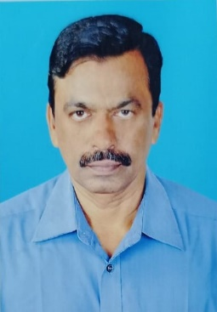
Mr. M. Sheik Ismail
NSS Program Officers

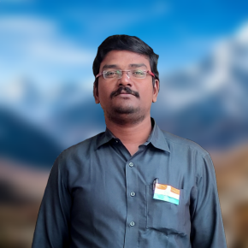
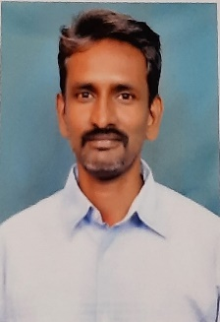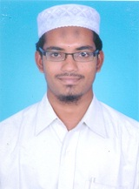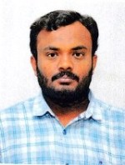
DR. S. MOHAMED DR. S. BASHEER DR. S. GOPI MR. D. PRABAHARAN
YUSUFF ANSARI AHAMED

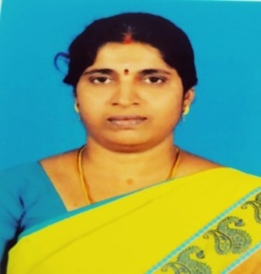
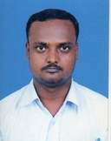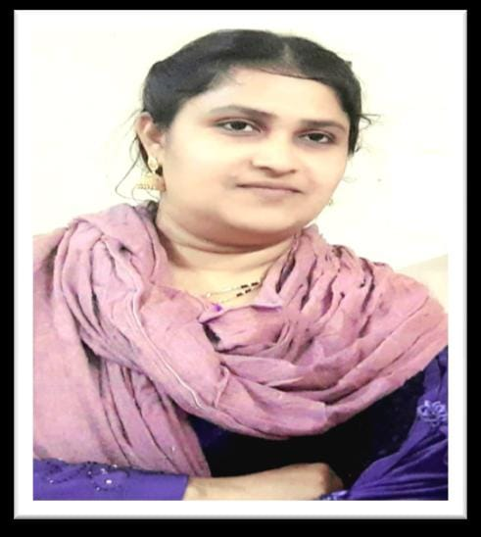
DR. M. SHAJAHAN DR. R. ARULNANGAI MRS. A. RAMEEZA

OVERALL I/C

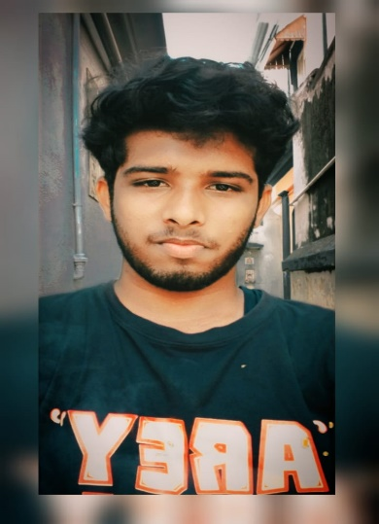
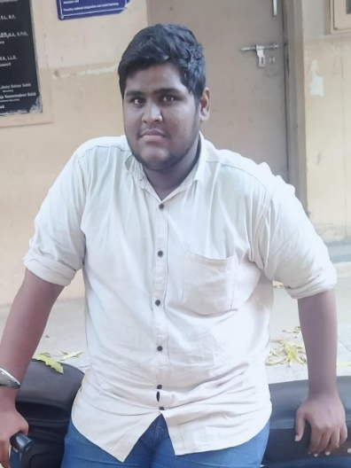

A. ASHIQ BASHA P. SUBRAMANI

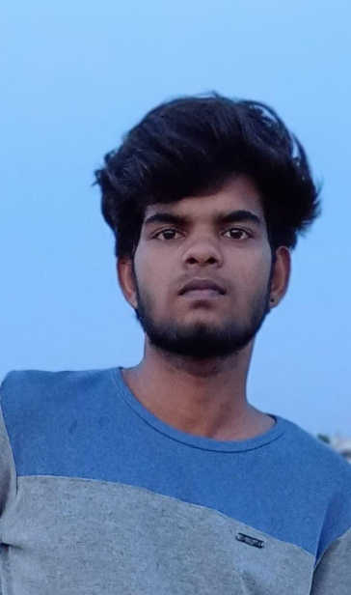
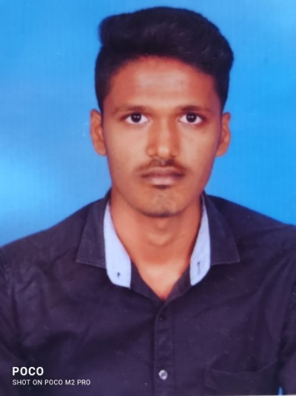

P. MANIKANDAN M. MANIKANDAN

PROJECT LEADERS

YOGANTHRAJ. M MOHAMED SALMAAN. M GANESAN. N
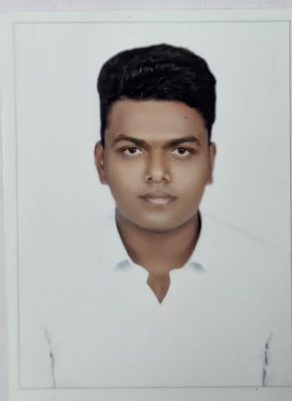
SIVA PRAKASH. M SYED SAMEER. S SHIYAM KUMAR. S
MOHAMED FAISAL. M NIRMAL PRASATH. L

OUR GOLDEN ACHIEVEMENTS
NATIONAL AWARDS

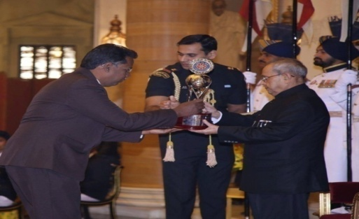
Best NSS Unit (College)
JAMAL MOHAMED COLLEGE

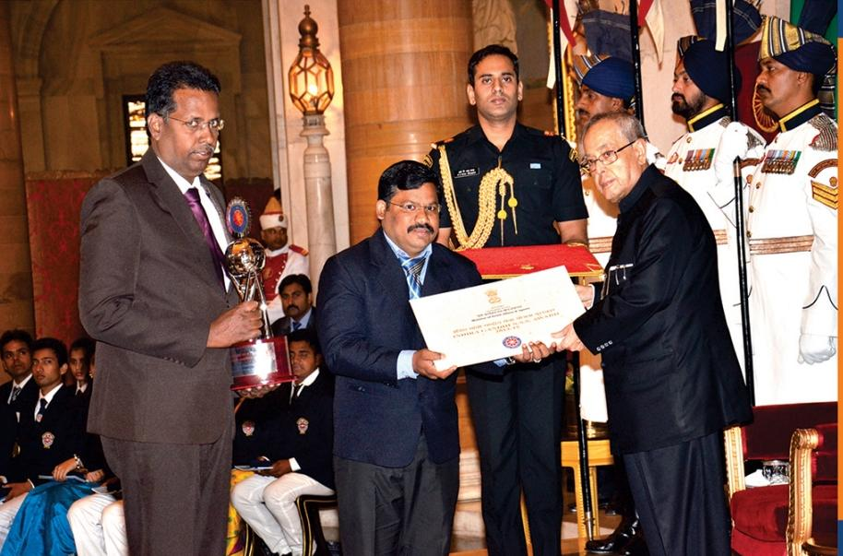
Best NSS Programme officer
Dr. A. ABDUL HAKEEM

STATE AWARDS

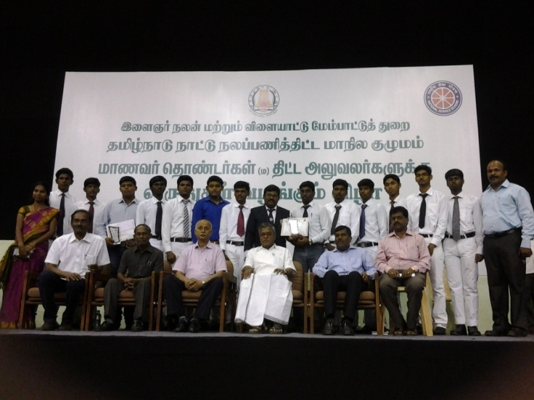
Best NSS Programme officer
Dr. A. ABDUL HAKEEM

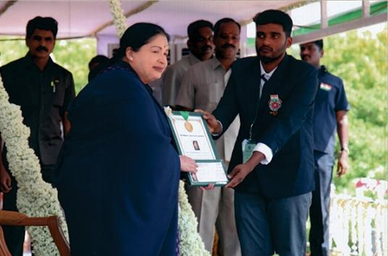
CM State Youth Award
Mr. J. MOHAMED RAFEEK

ACHIEVEMENTS

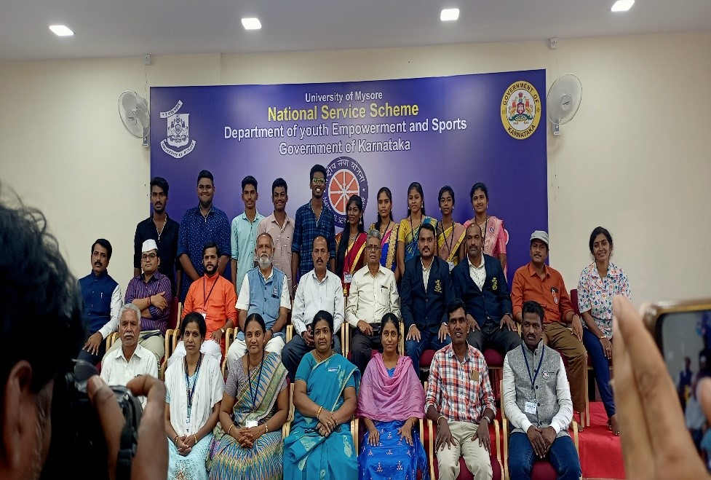
- ASHIQ BASHA
NATIONAL INTEGRATION CAMP, MYSORE
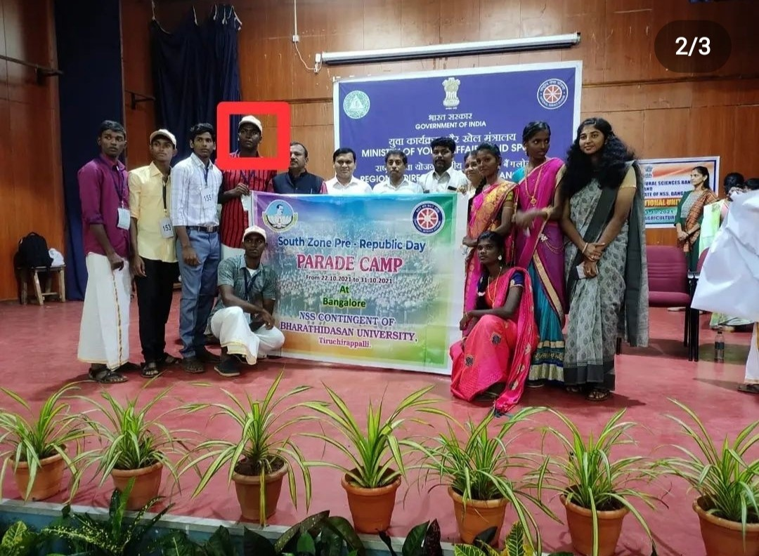
S. SHIYAM KUMAR
SOUTH ZONE PRE RD PARADE CAMP- BANGALORE
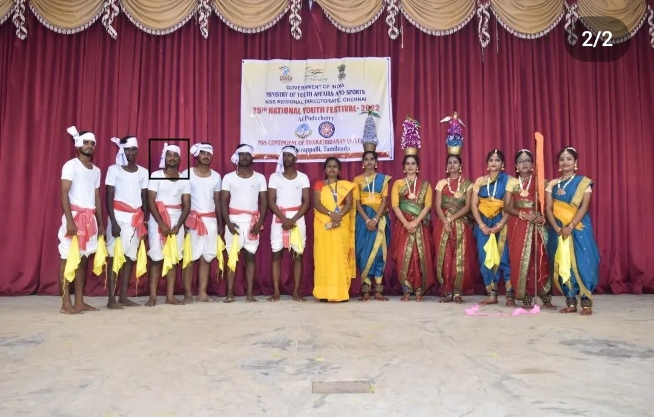
K. KAVIYACHELVAN
NATIONAL YOUTH FESTIVAL – PONDICHERRY
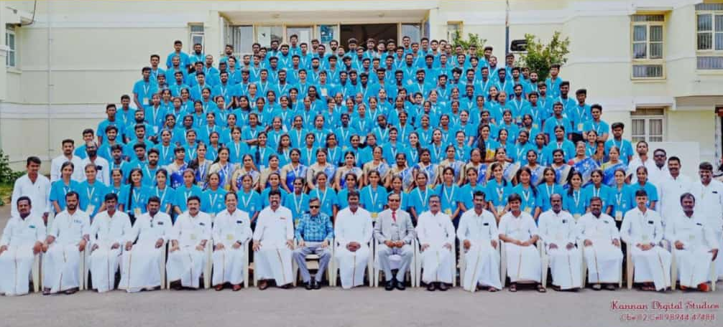
M.YOGANTHRAJ
NATIONAL INTEGRATION CAMP - COIMBATORE

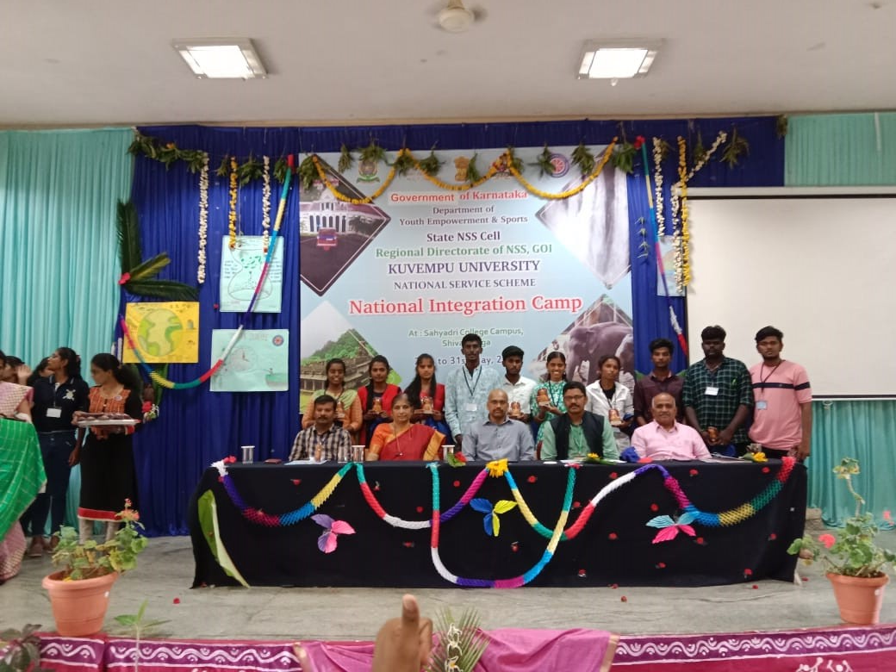
J. TAMIZHARASAN
NATIONAL INTEGRATION CAMP - KARNATAKA

REGULAR ACTIVITIES

COVID 19 PREVENTION HELP CENTRE OPENING

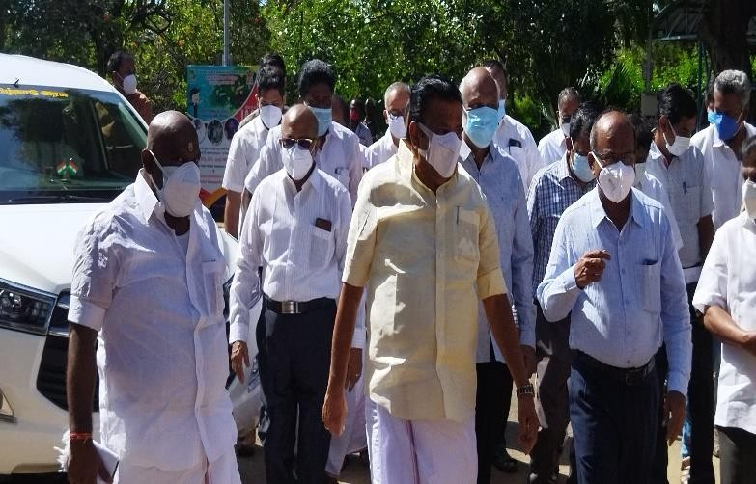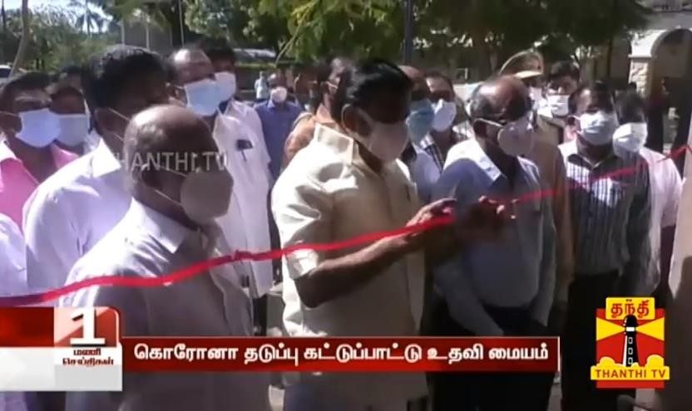

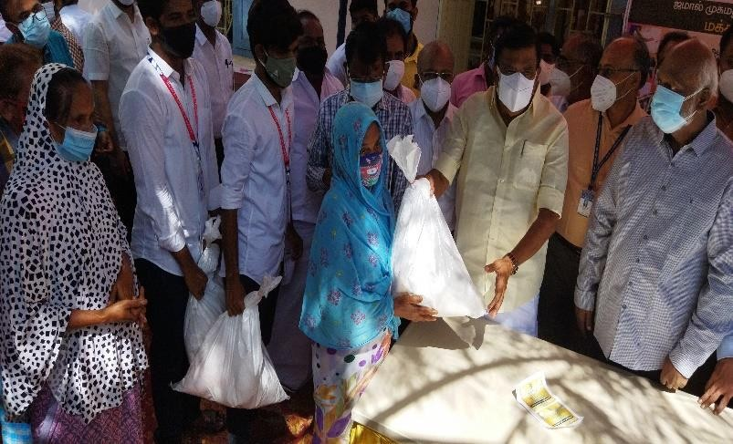
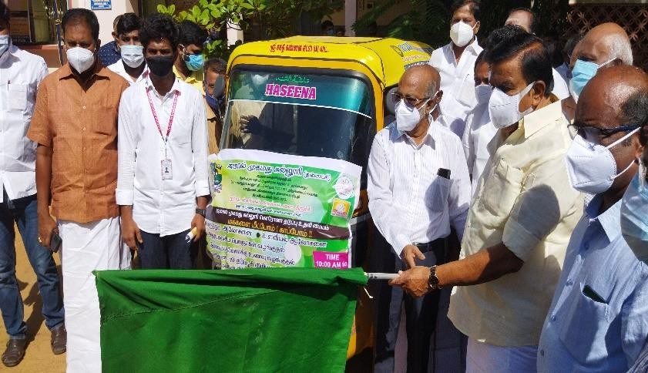

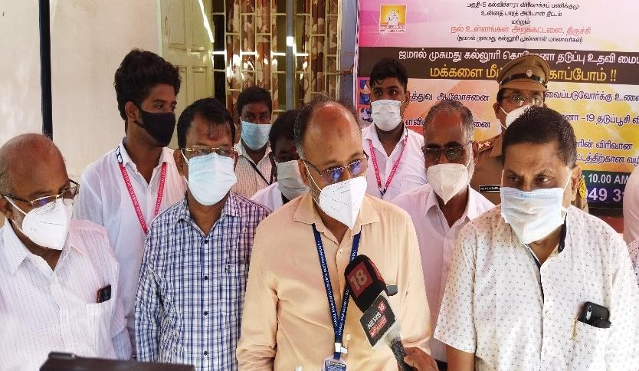
WORLD ENVIRONMENT DAY

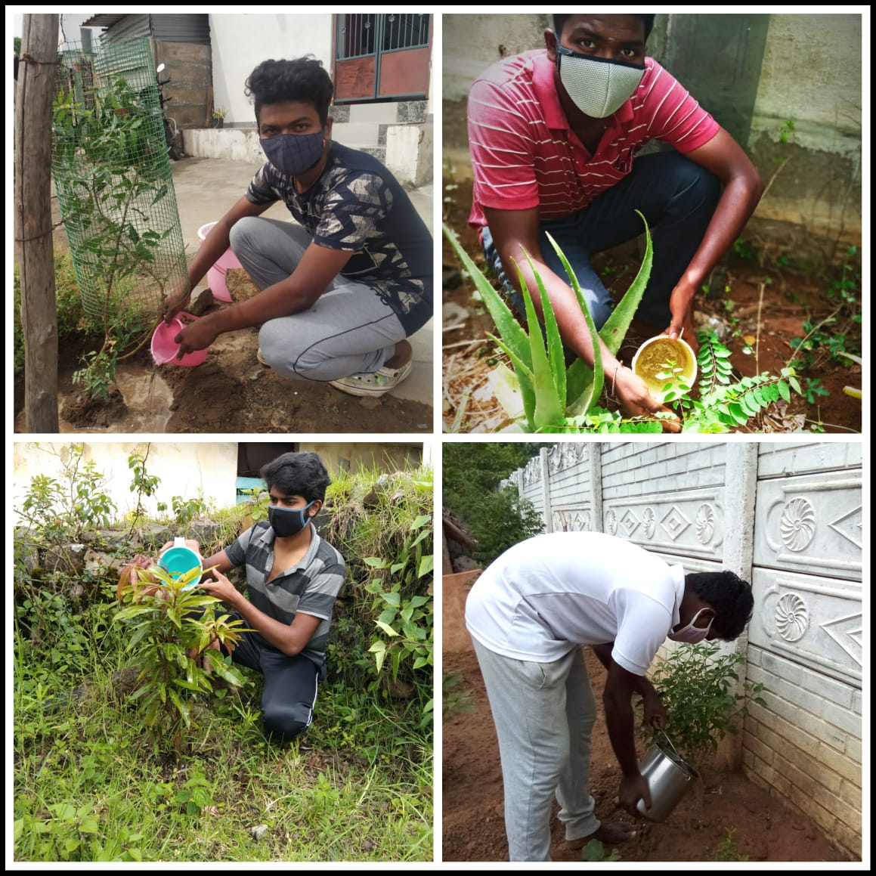
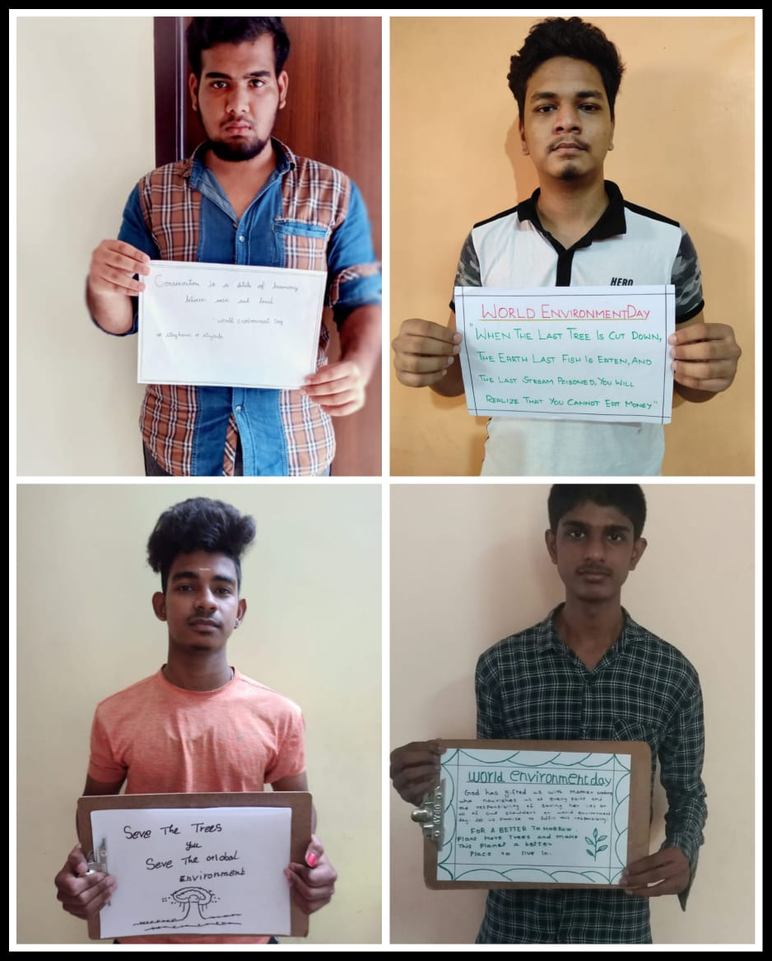
VACCINATION CAMP

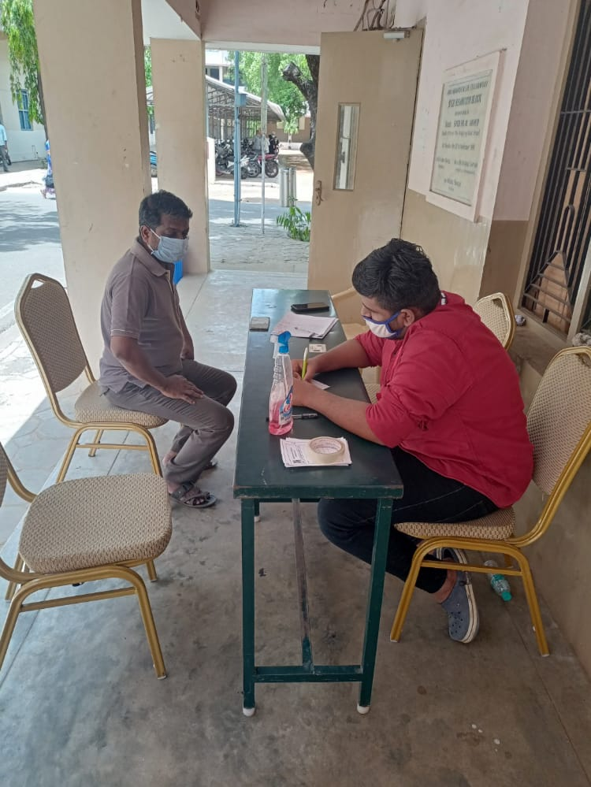

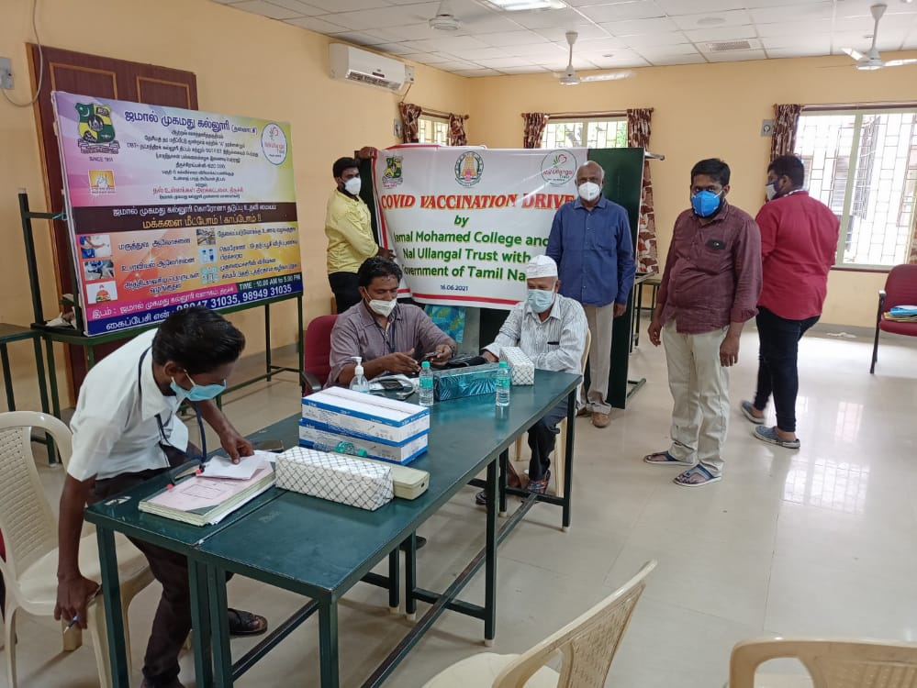

INTERNATIONAL YOGA DAY

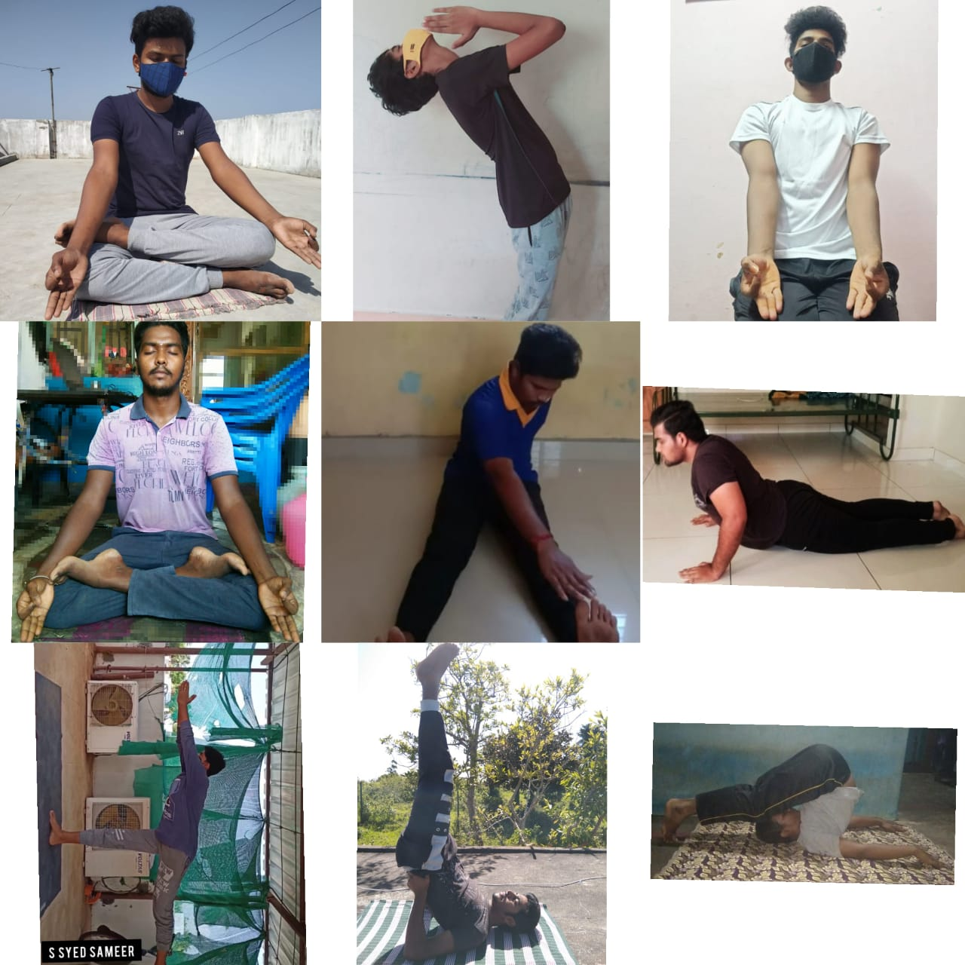
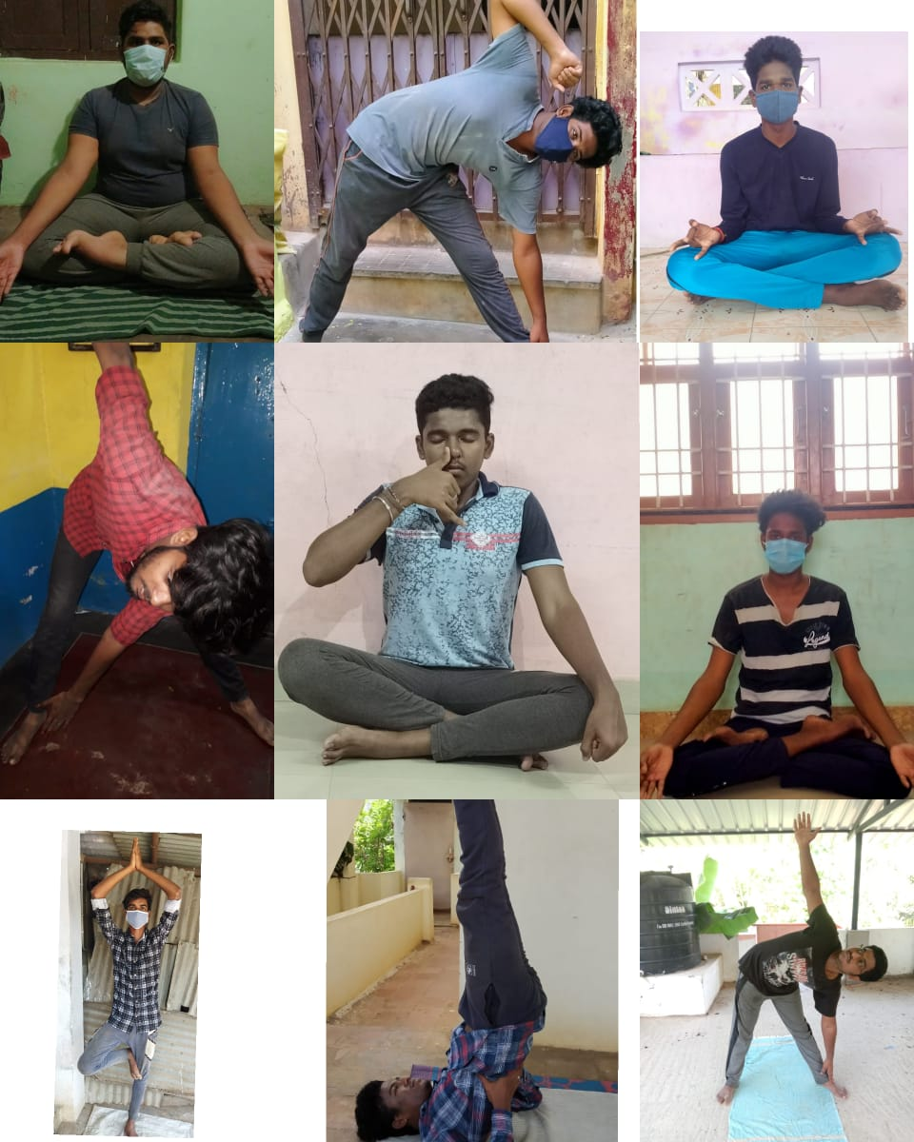

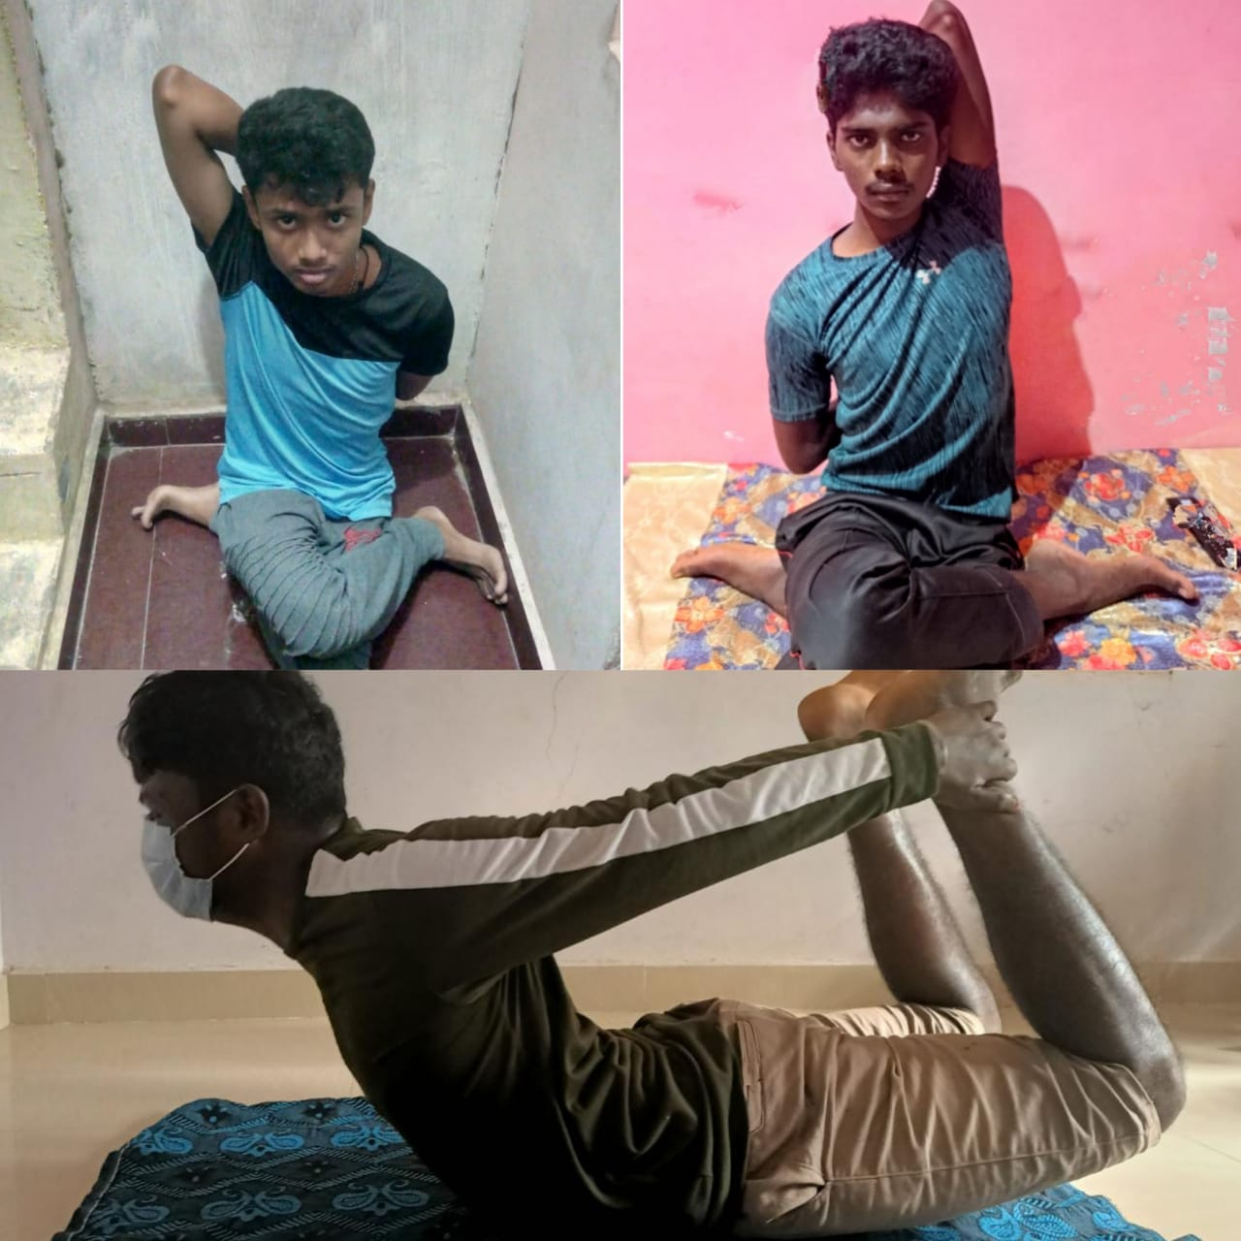
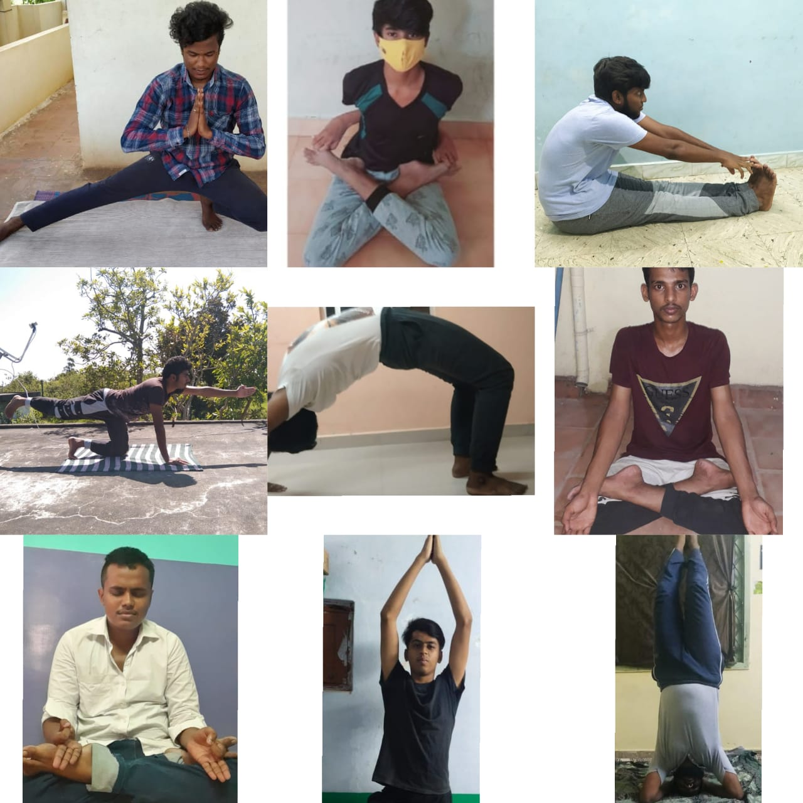

INTERNATIONAL DRUG ABUSE DAY PLEDGE

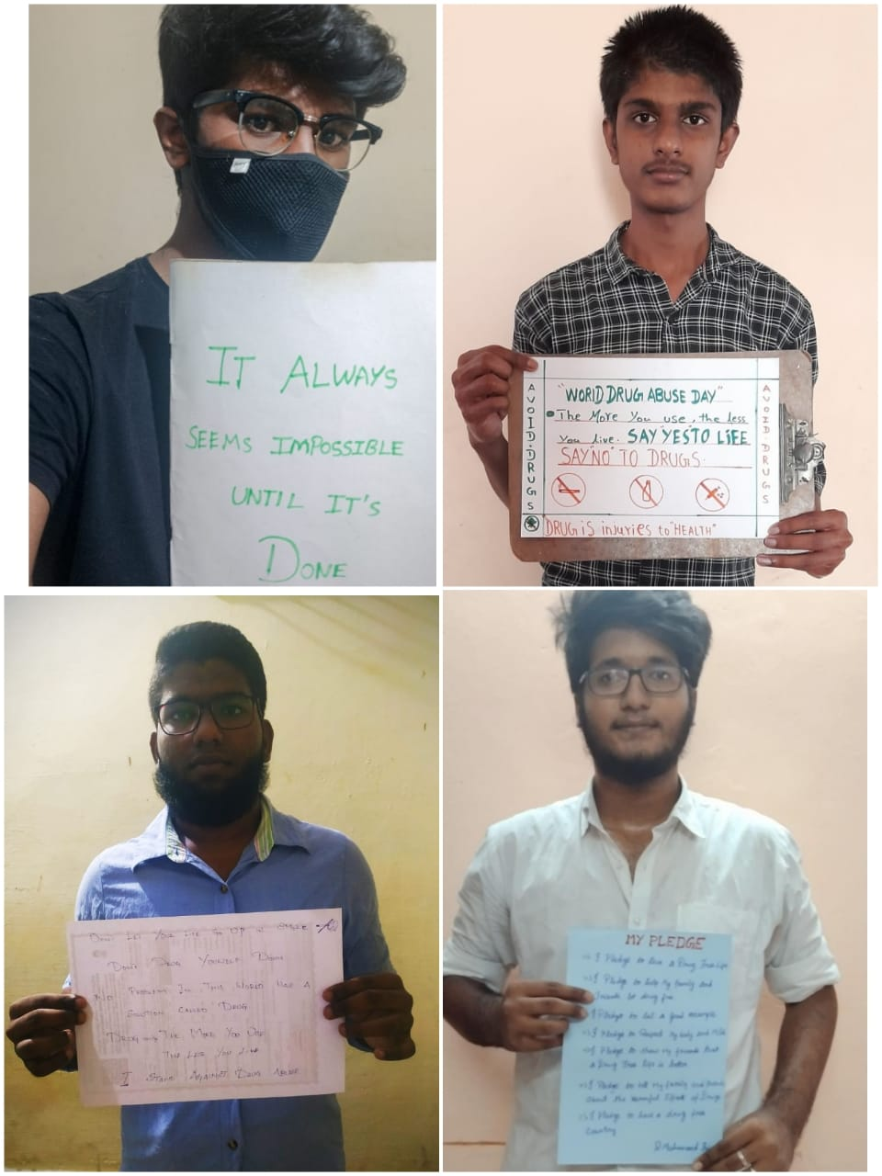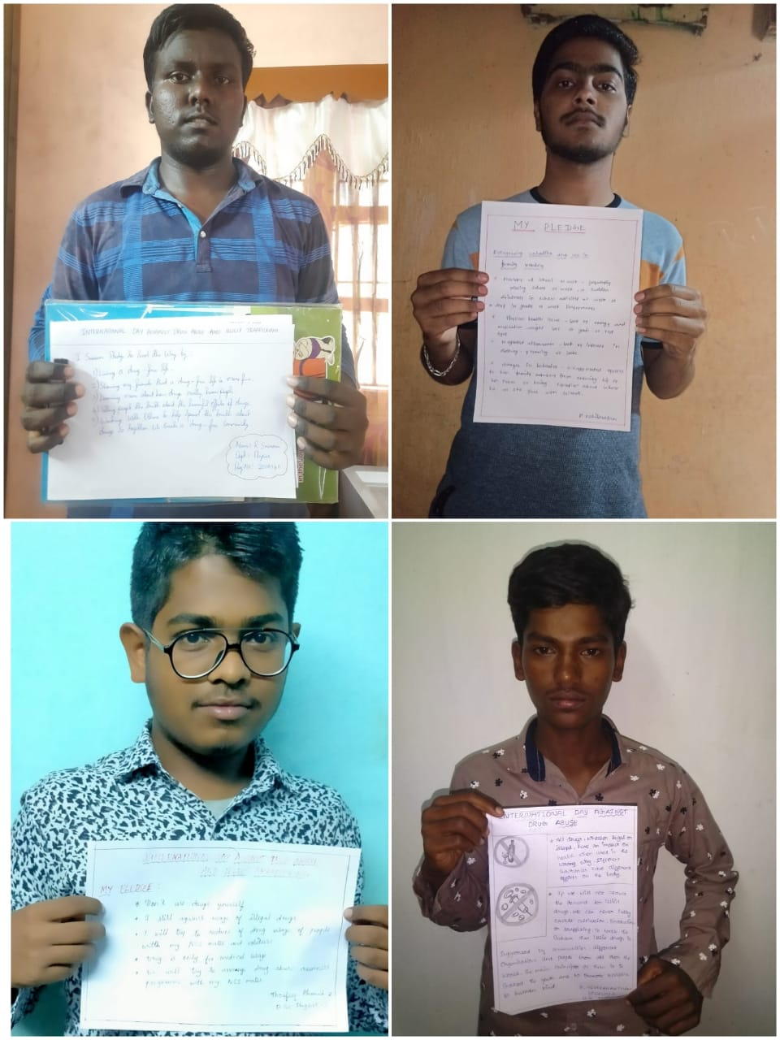

WORLD POPULATION DAY
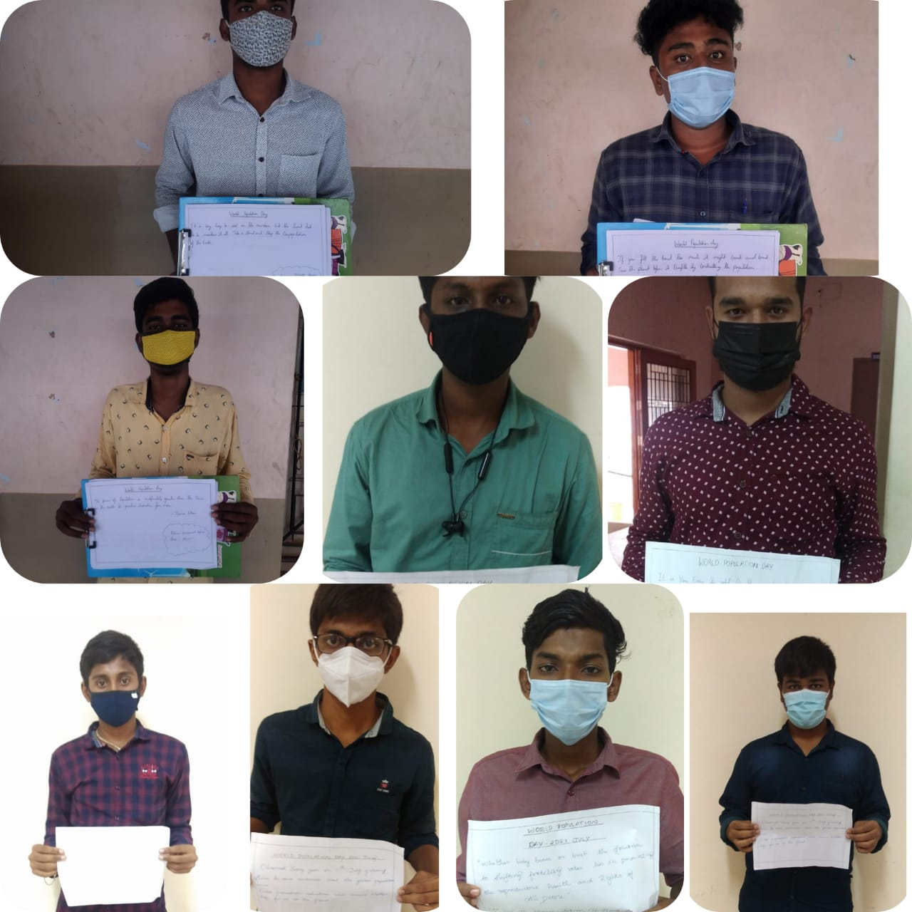
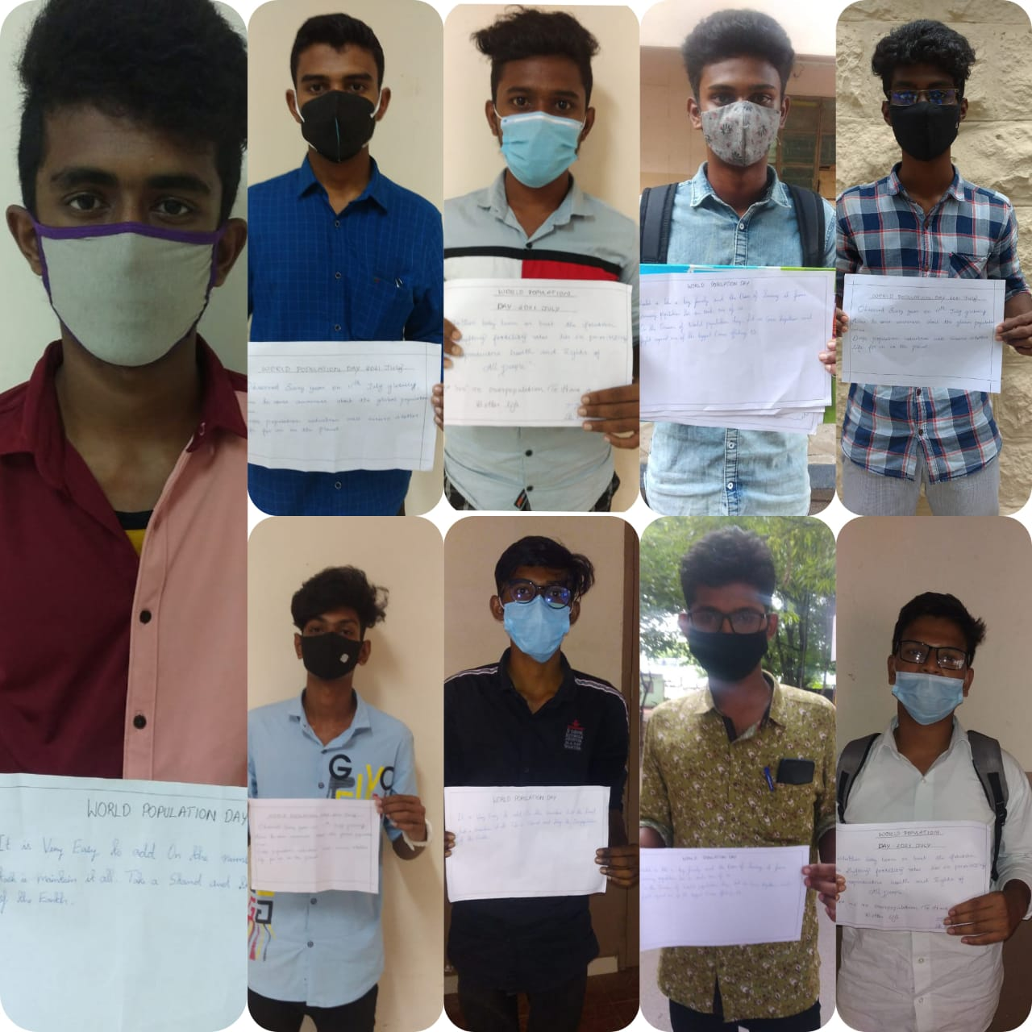
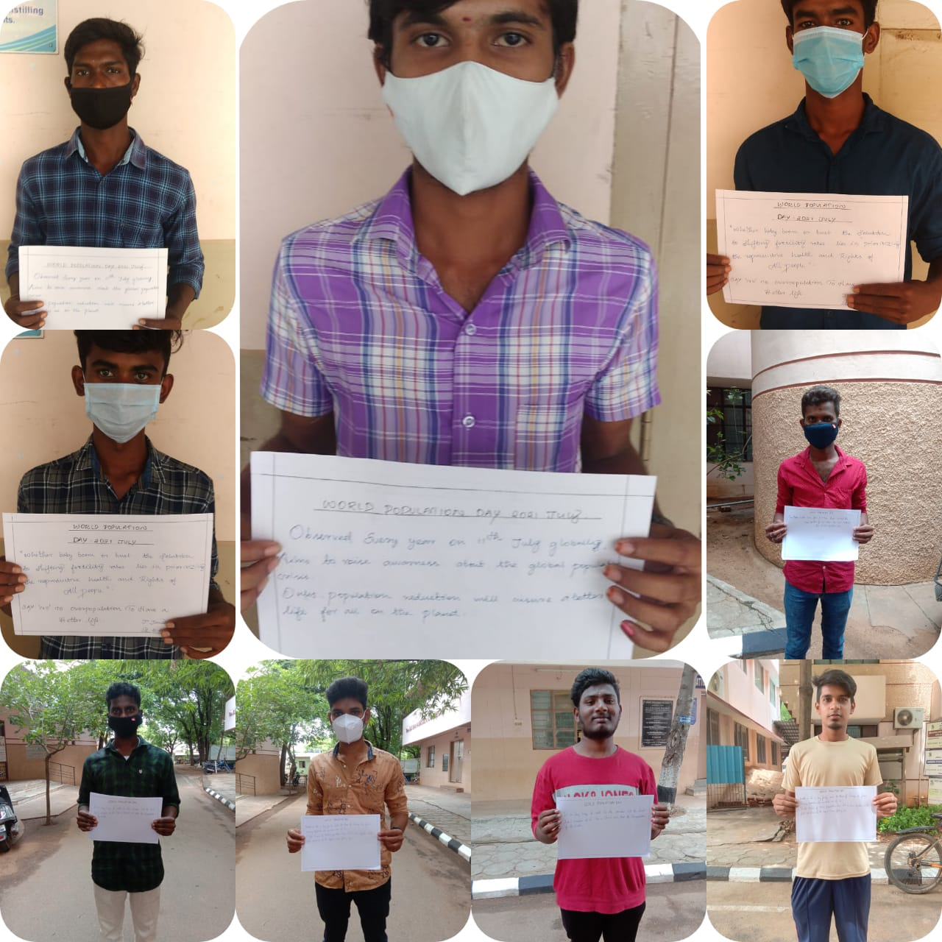
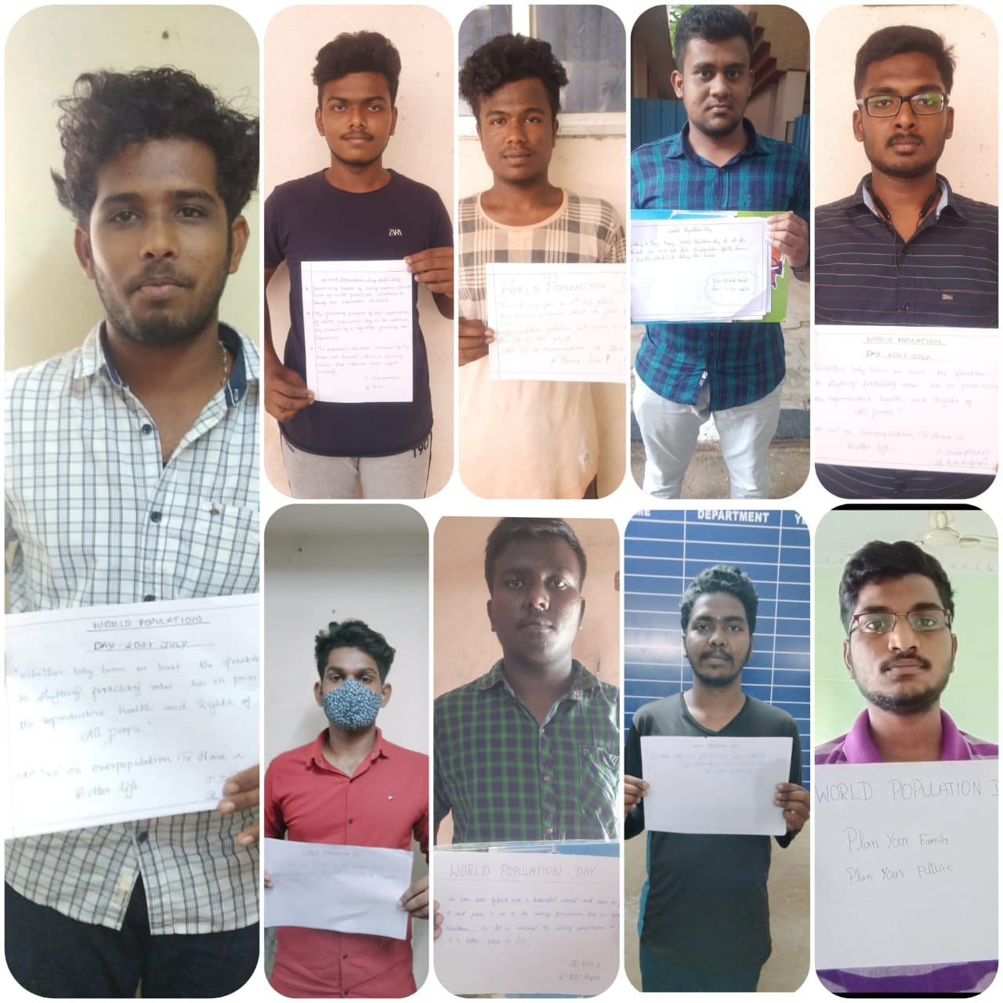

WORLD NATURE CONSERVATION DAY

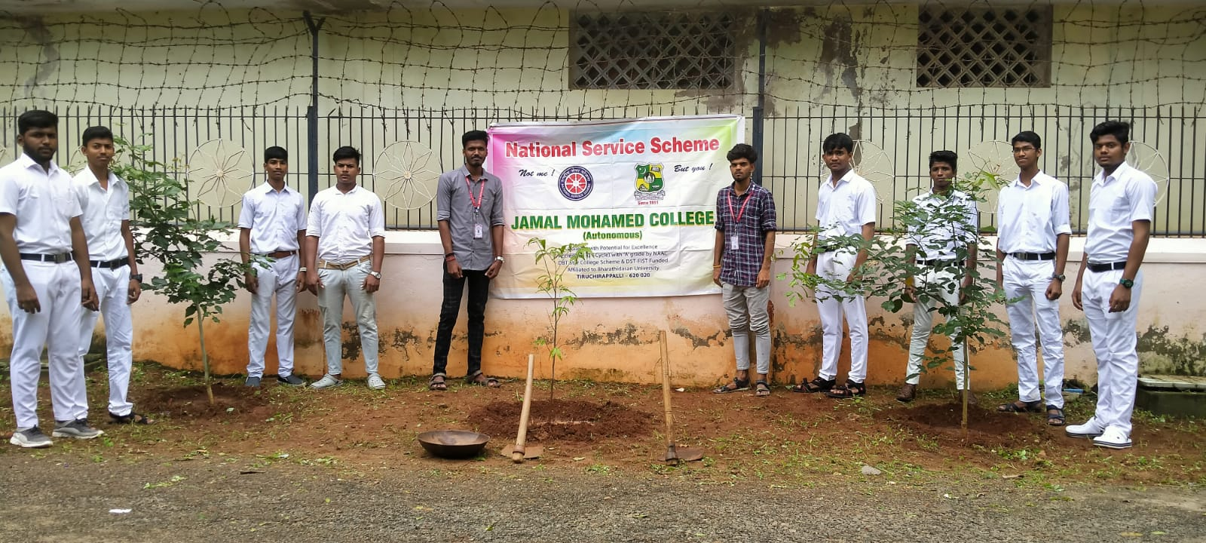
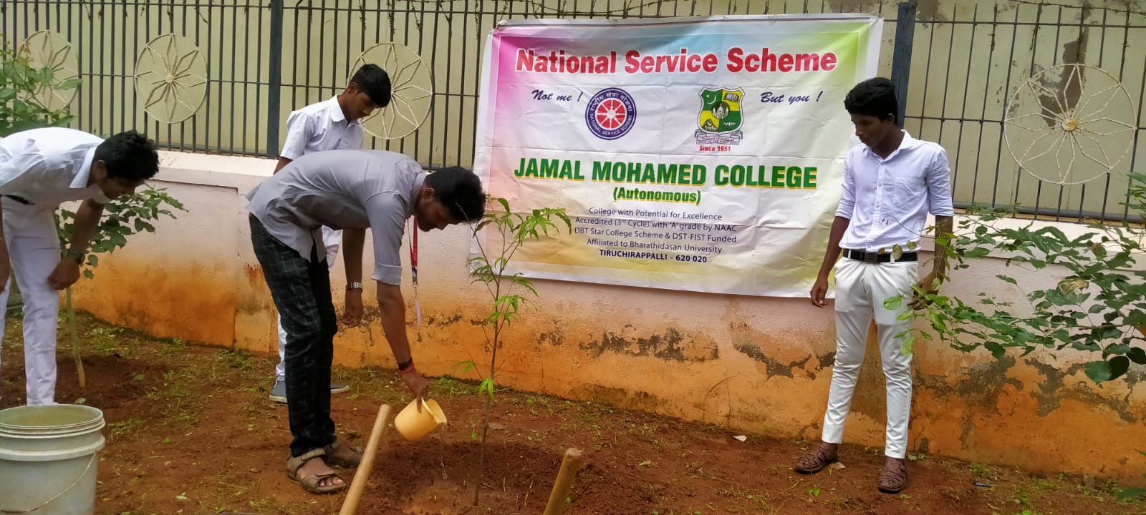
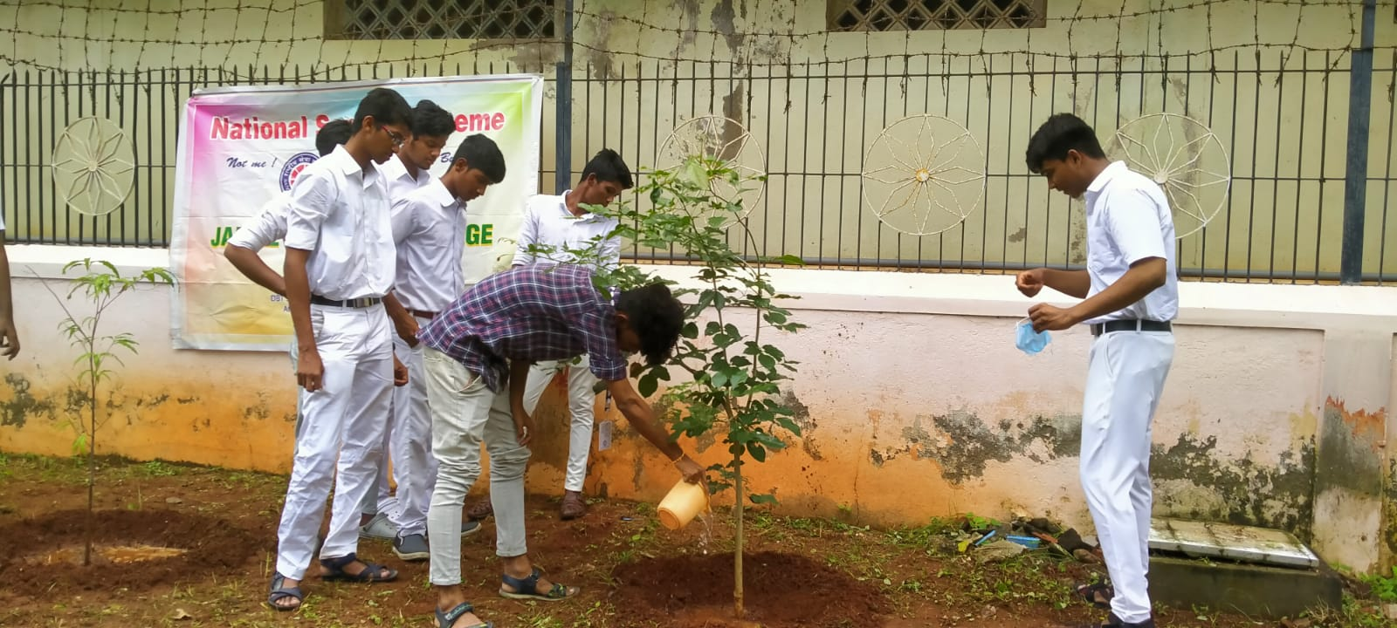
NATIONAL HOSPITAL DAY

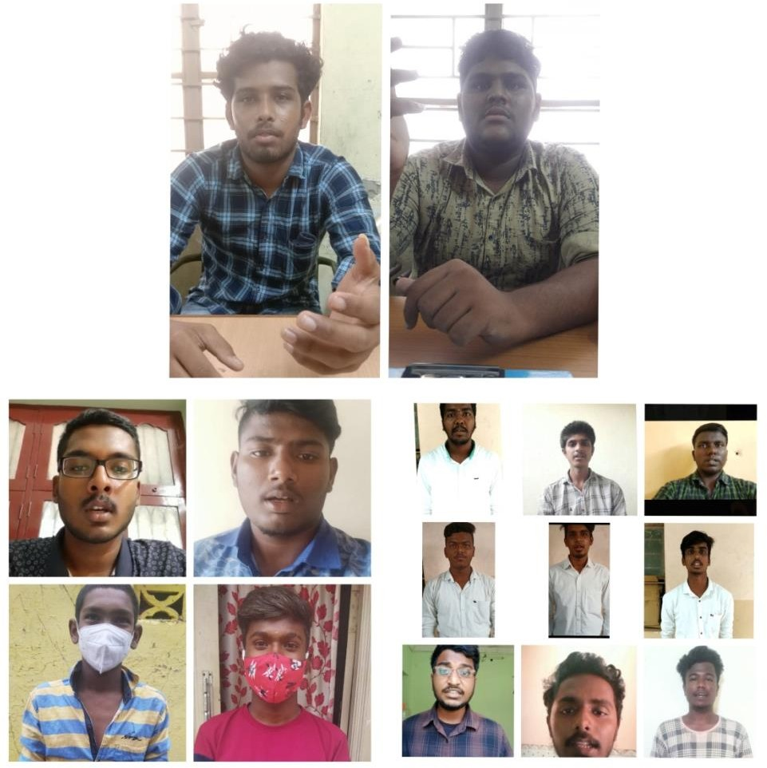

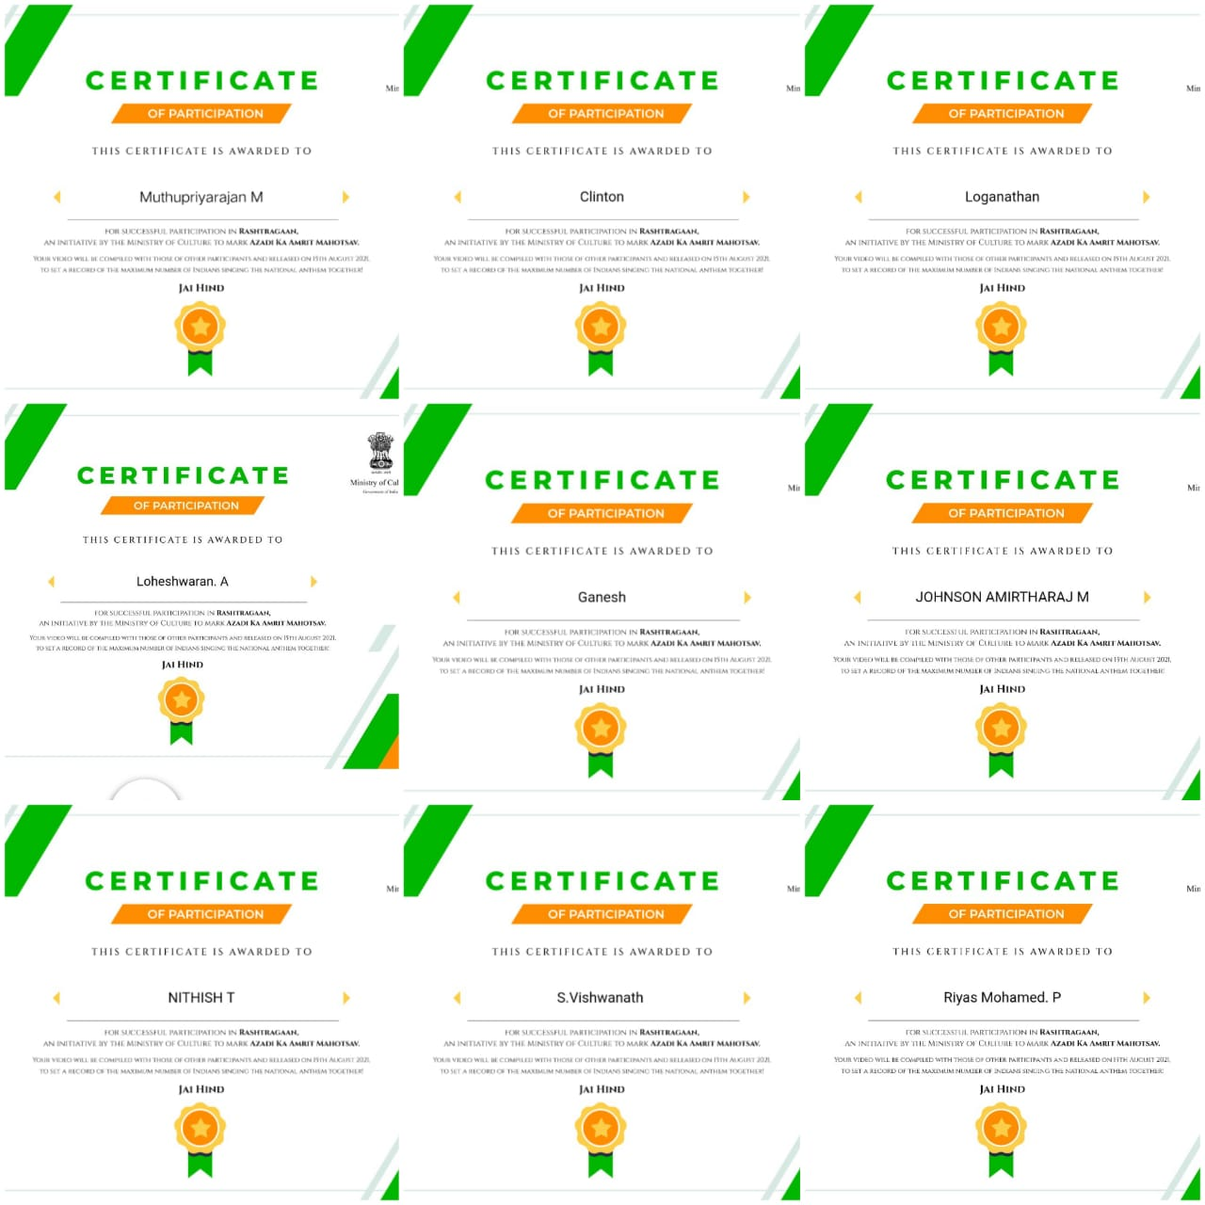
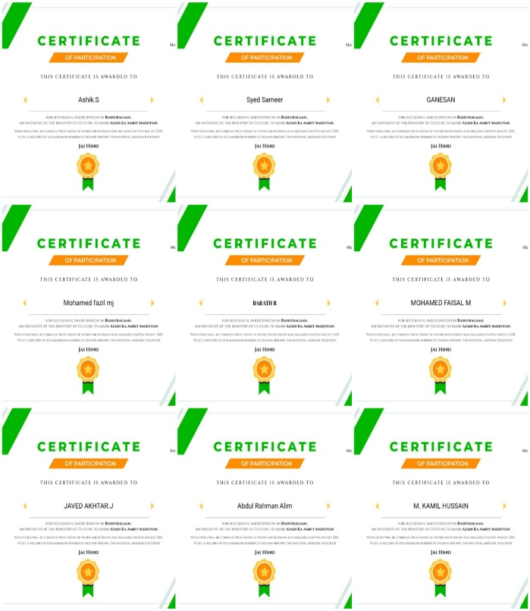
NATIONAL ANTHEM SINGING PROGRAMME
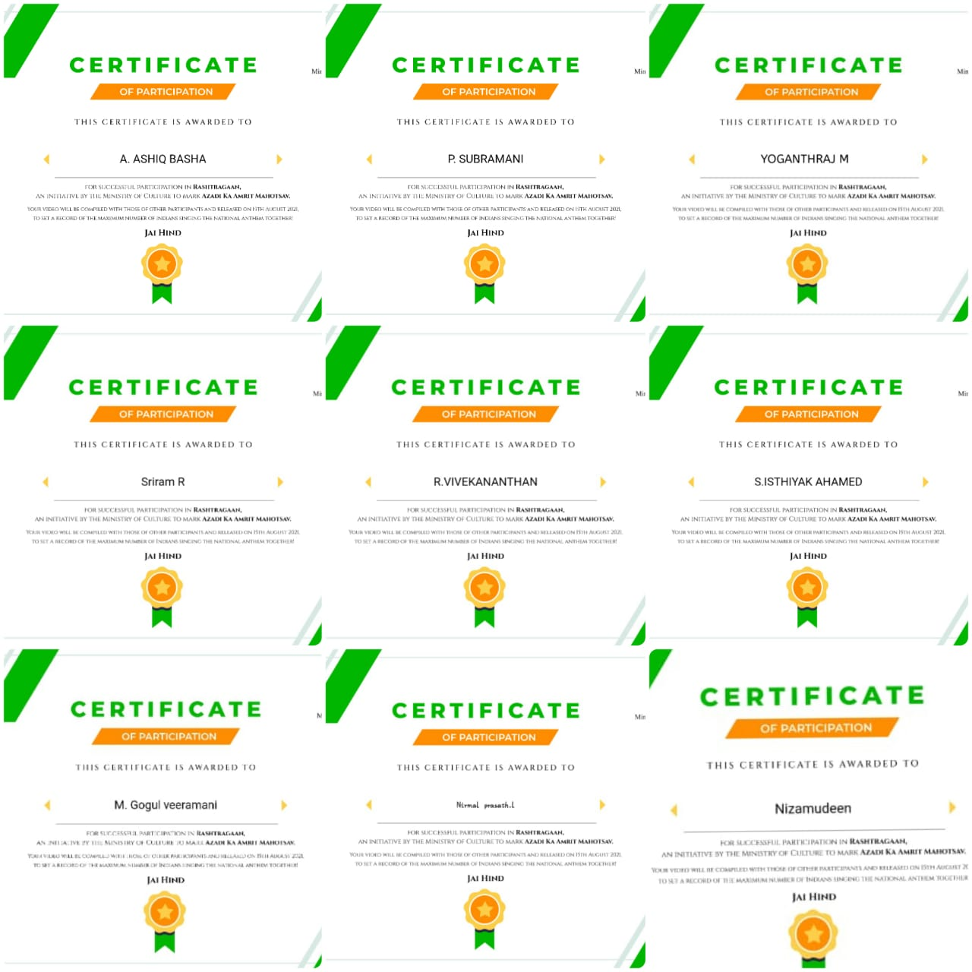
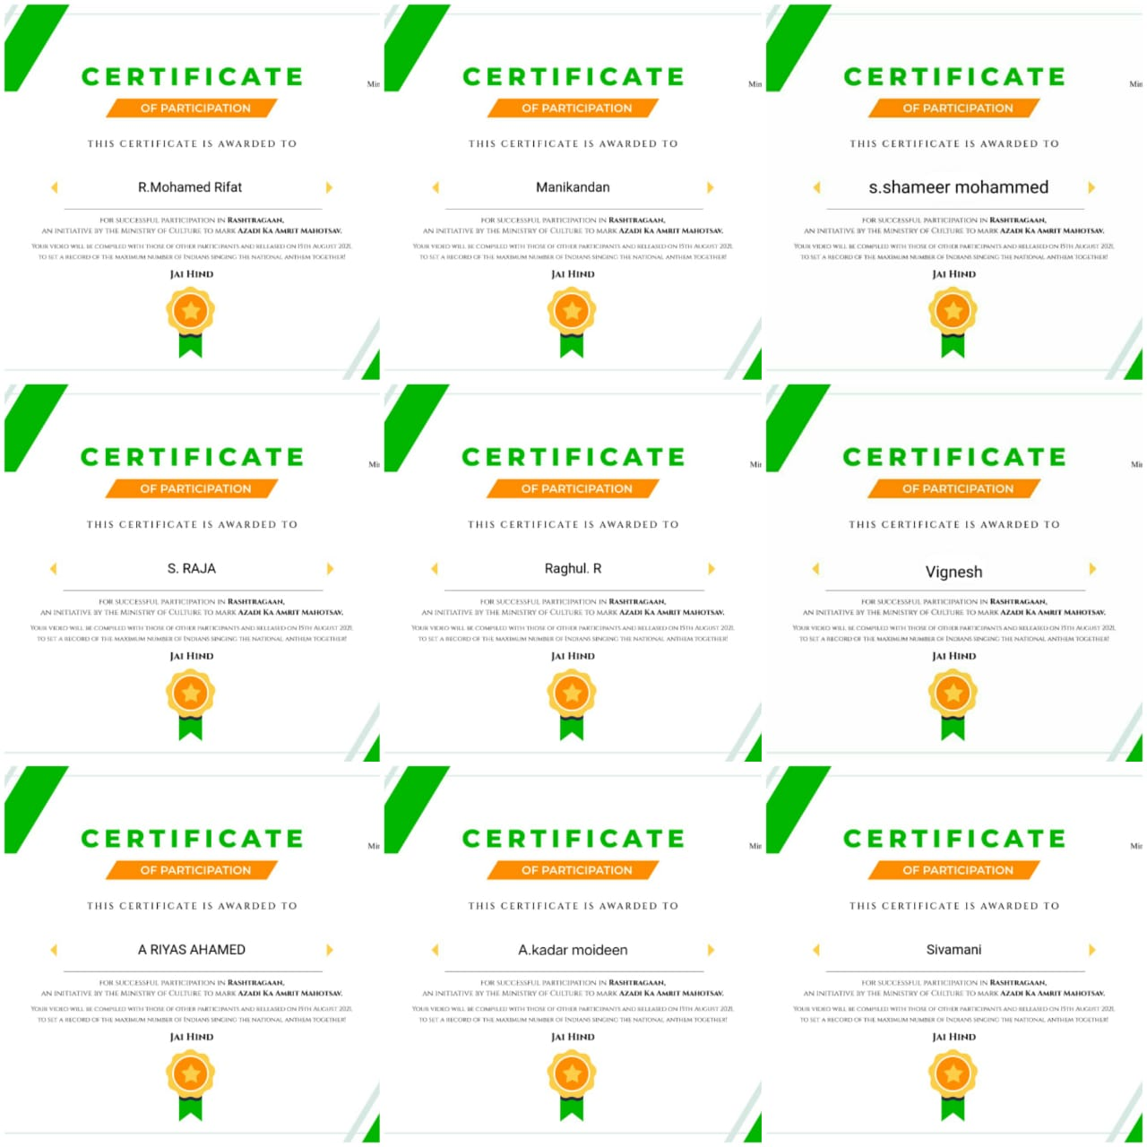
INTERNATIONAL YOUTH DAY
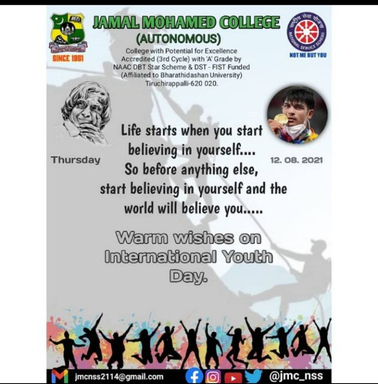

75TH INDEPENDENCE DAY AT BDU
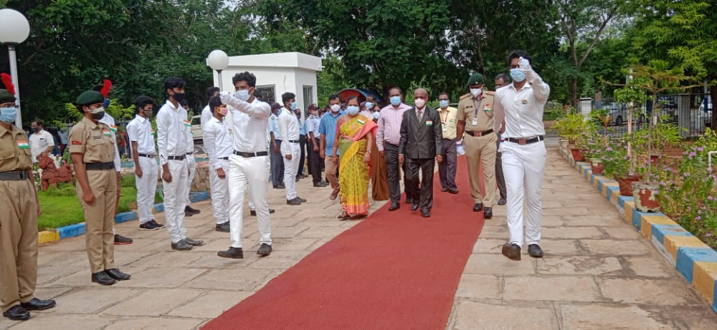
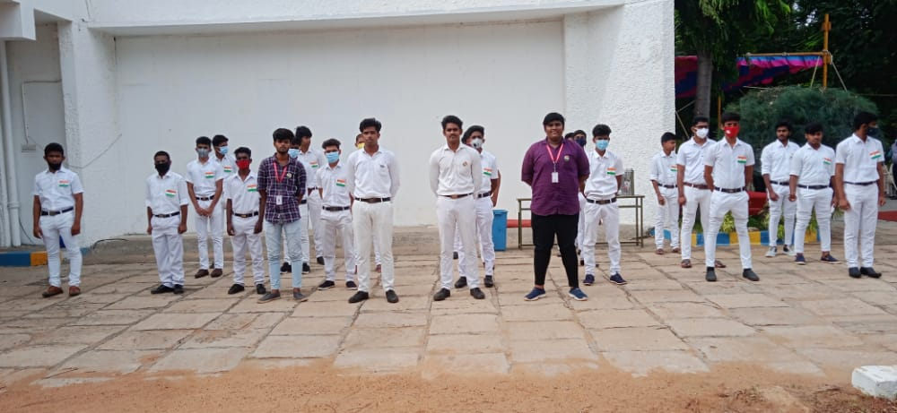
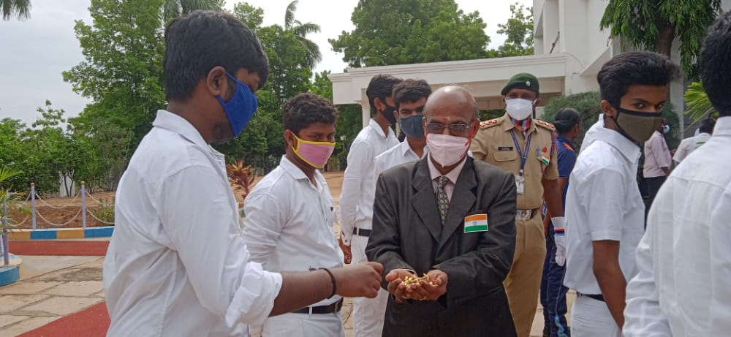
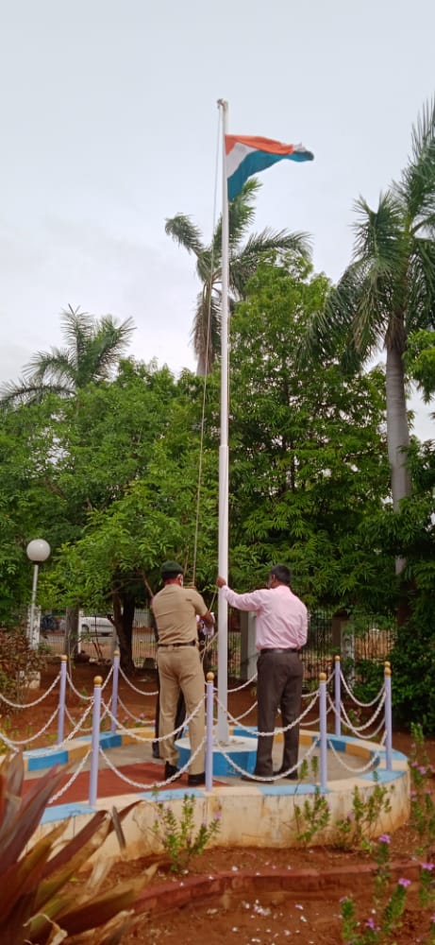
75TH INDEPENDENCE DAY AT JMC

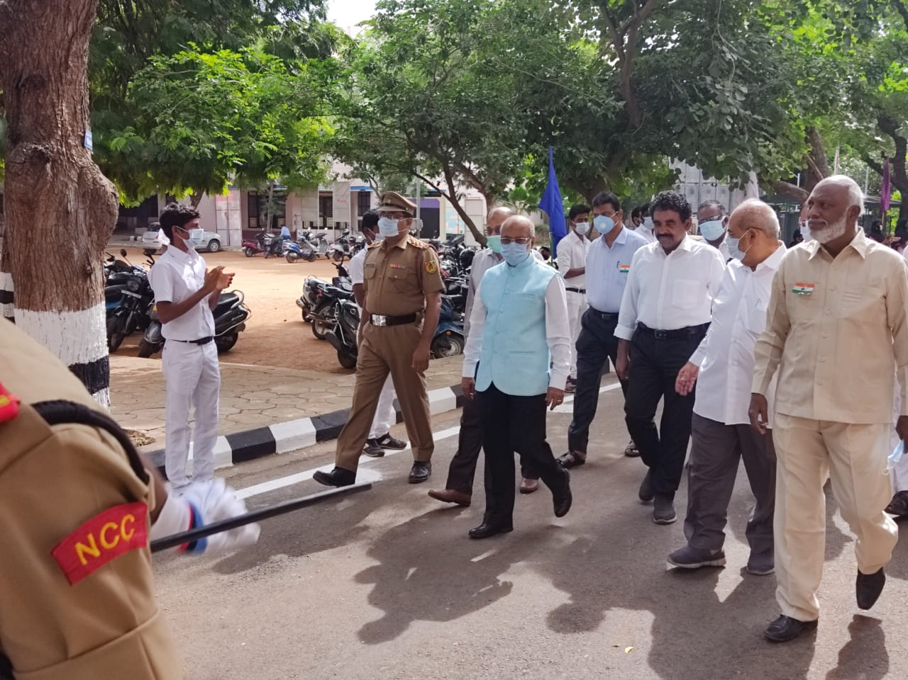
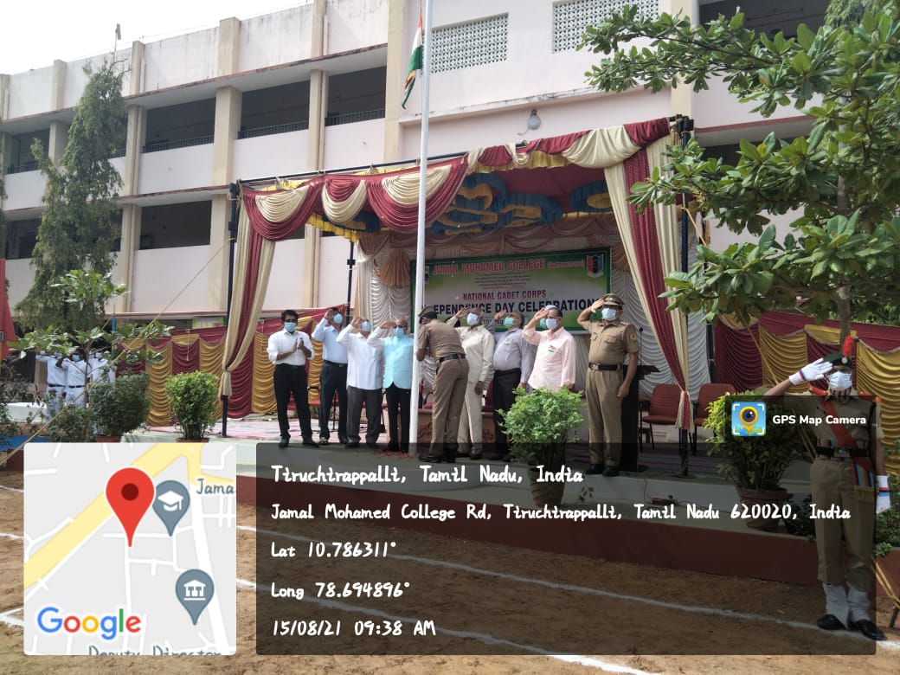
FRESHER’S CERTIFICATE VERIFICATION PROGRAMME

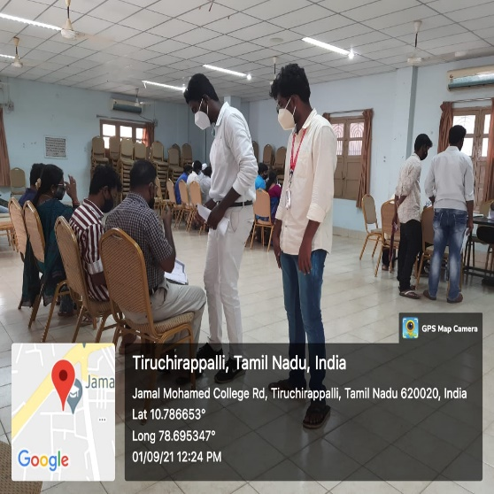
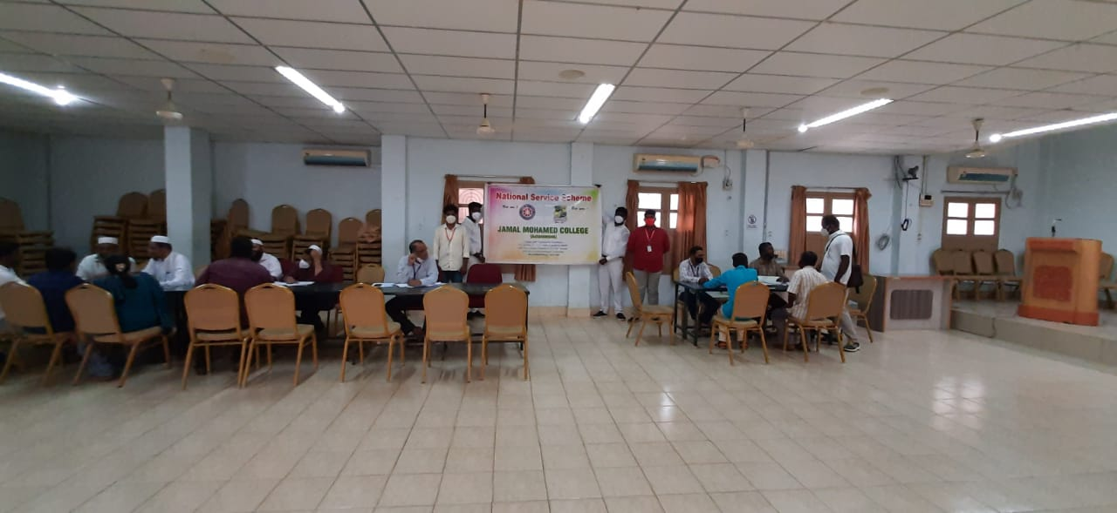
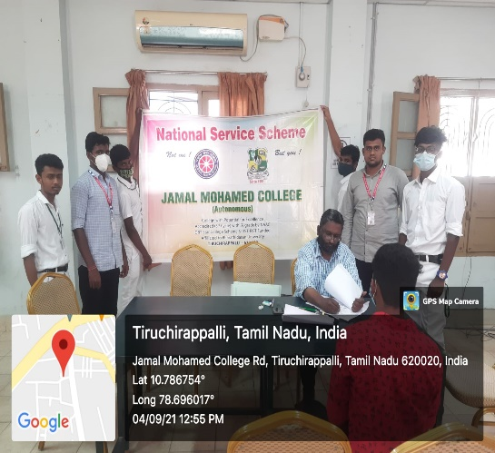
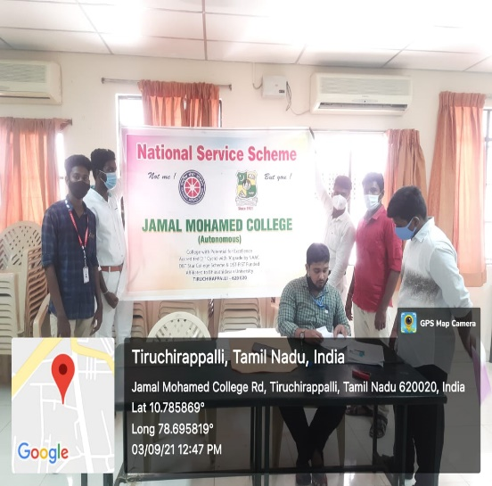
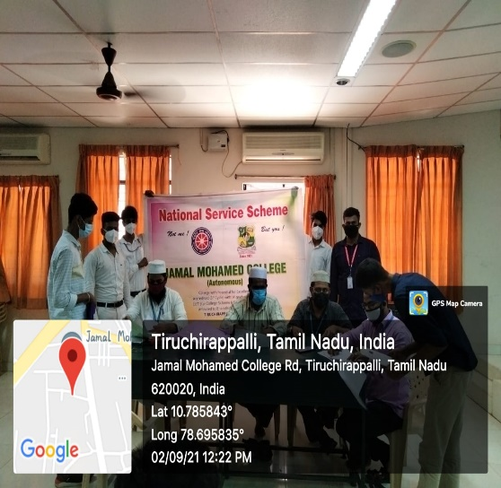
VACCINATION CAMP

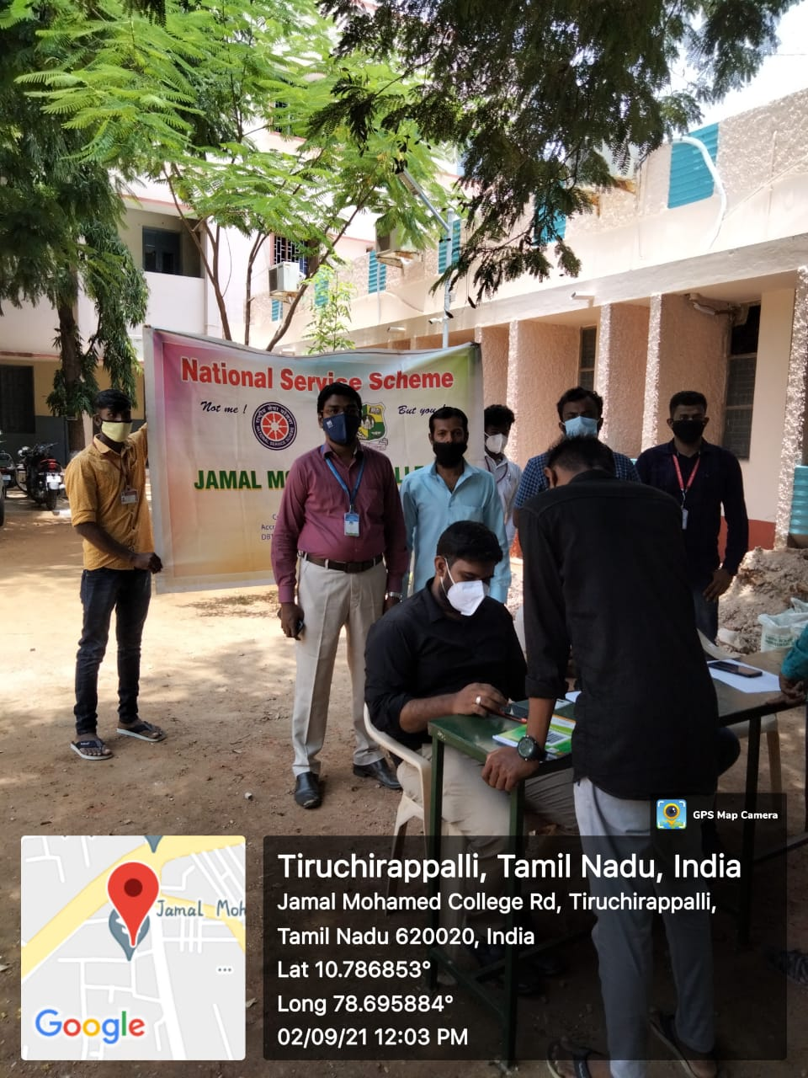

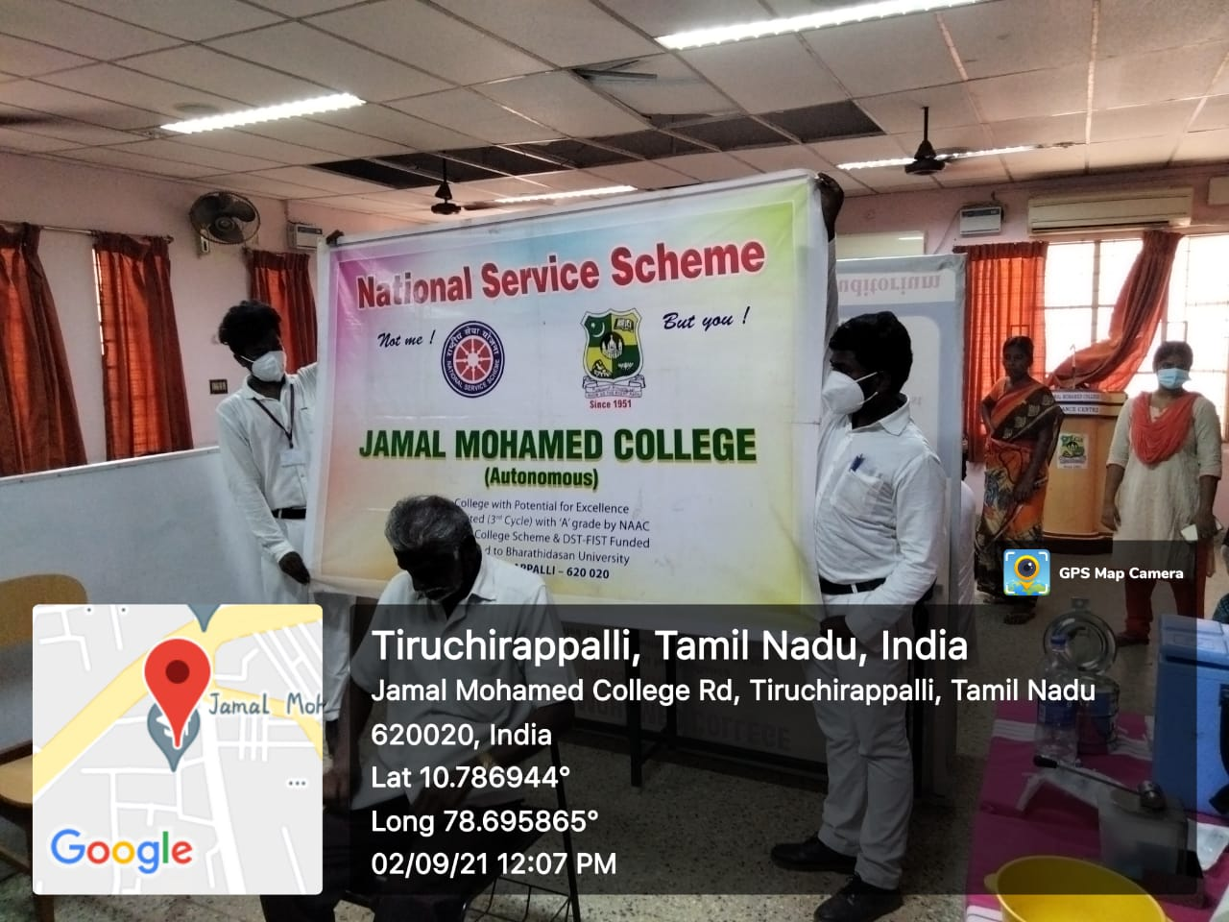

TEACHER’S DAY CELEBRATION

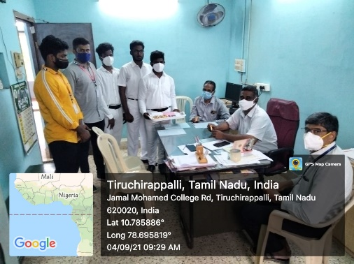
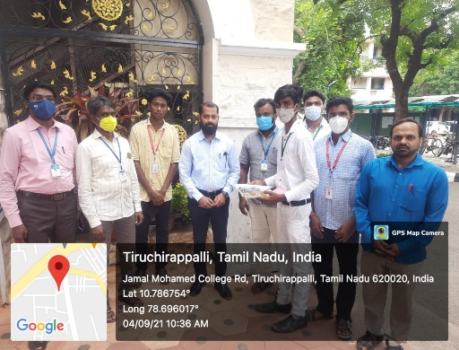
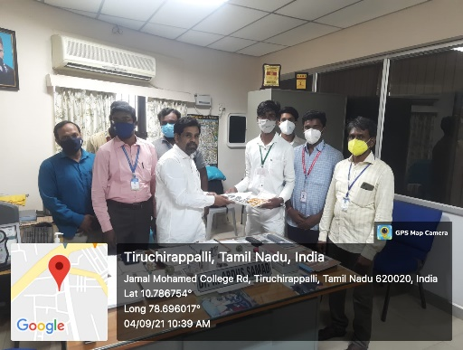
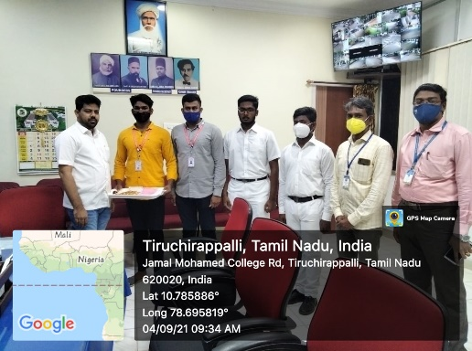
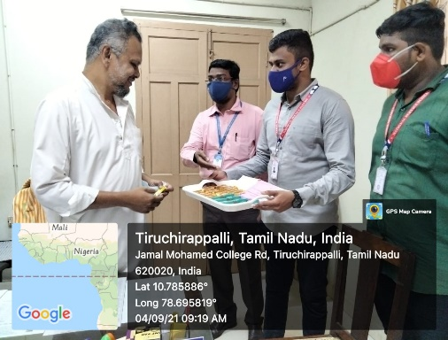
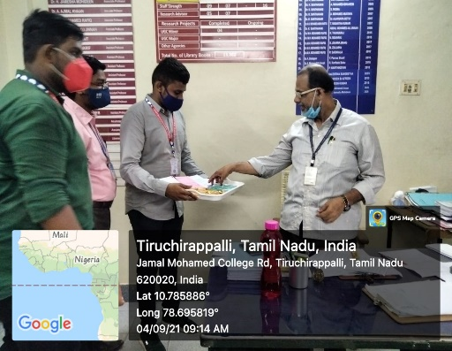
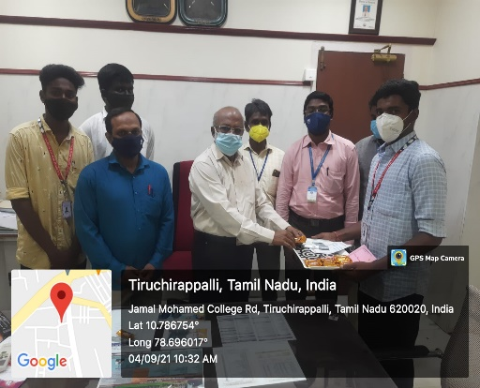
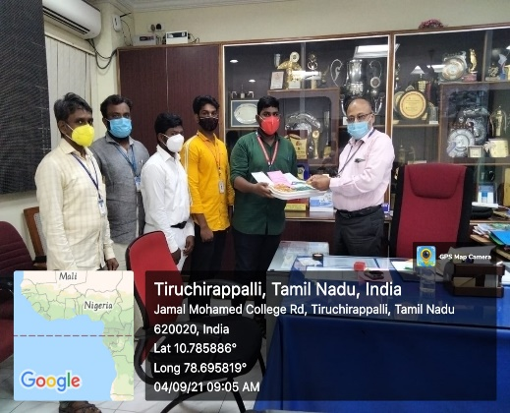
INTERNATIONAL LITERACY DAY QUIZ

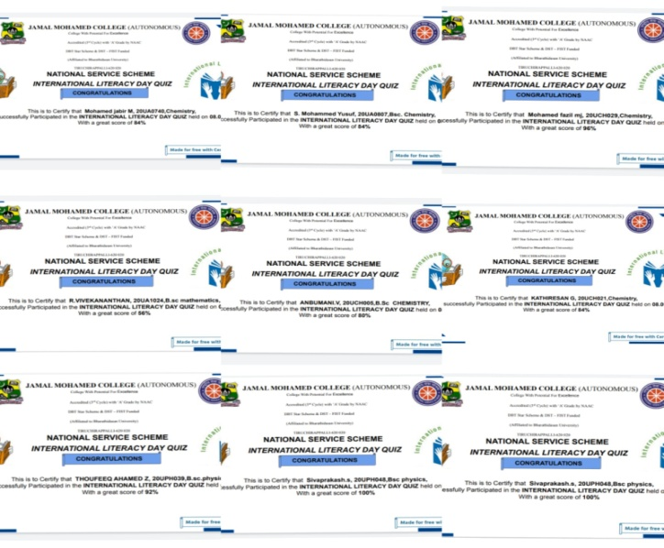
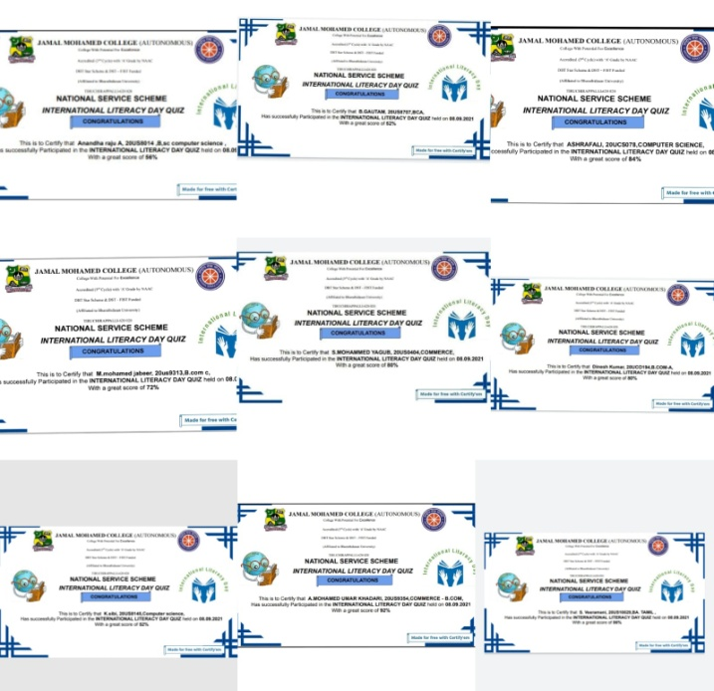
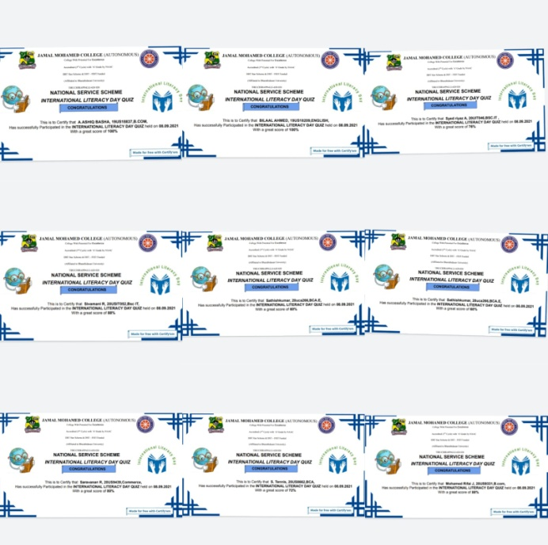
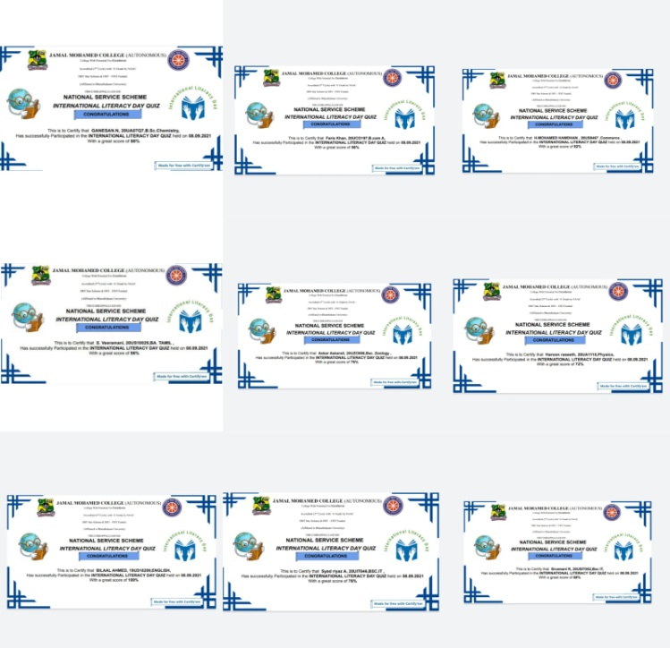
MEGA VACCINATION CAMP

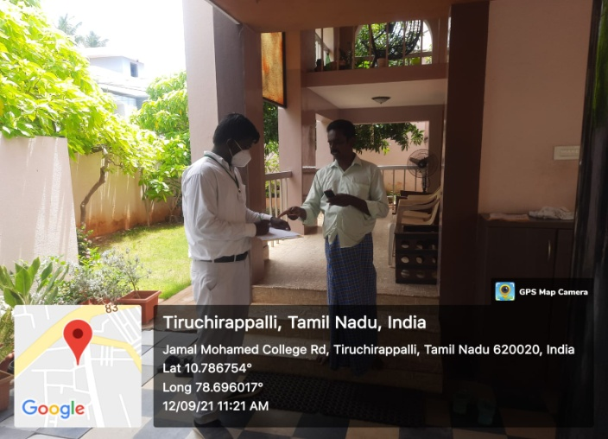
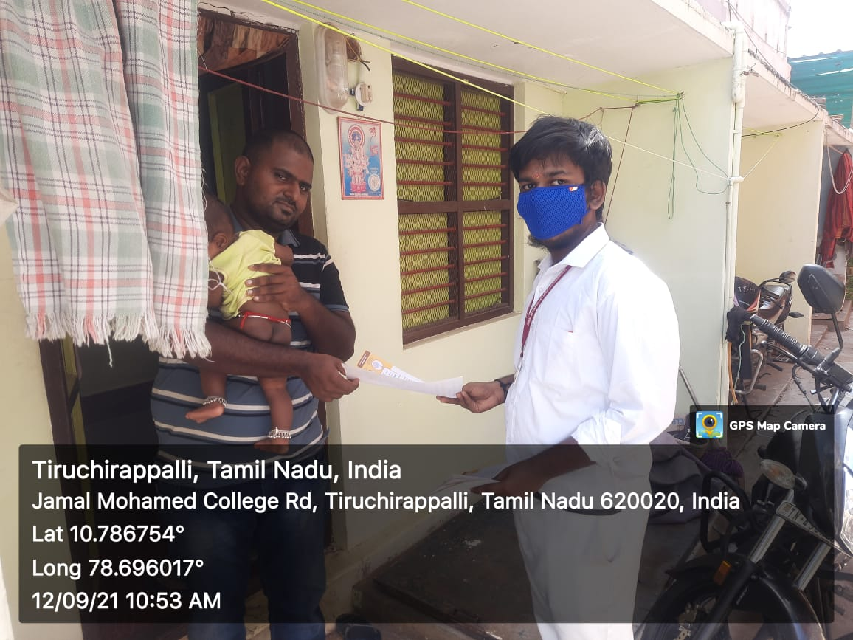

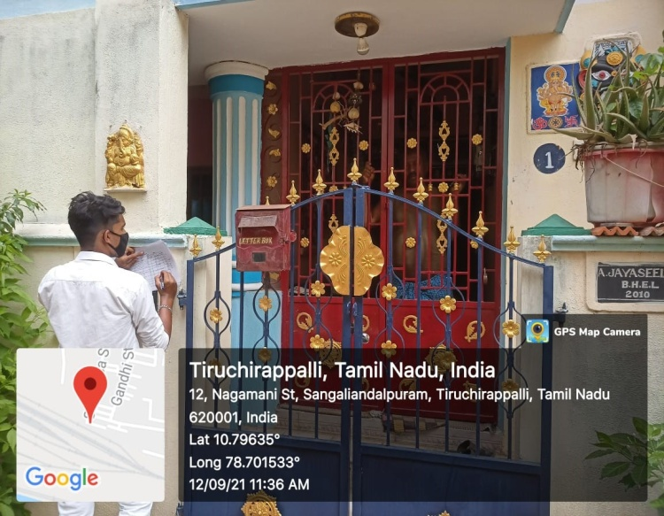
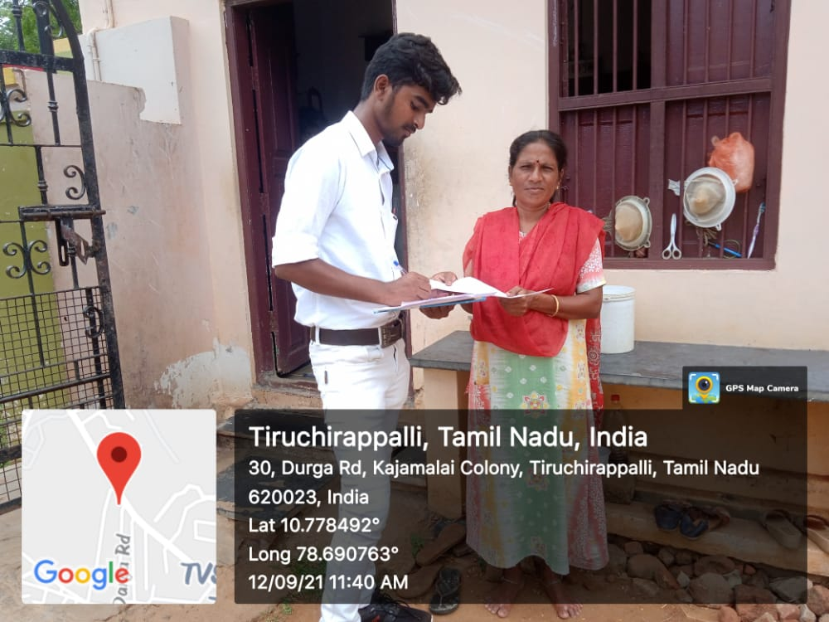
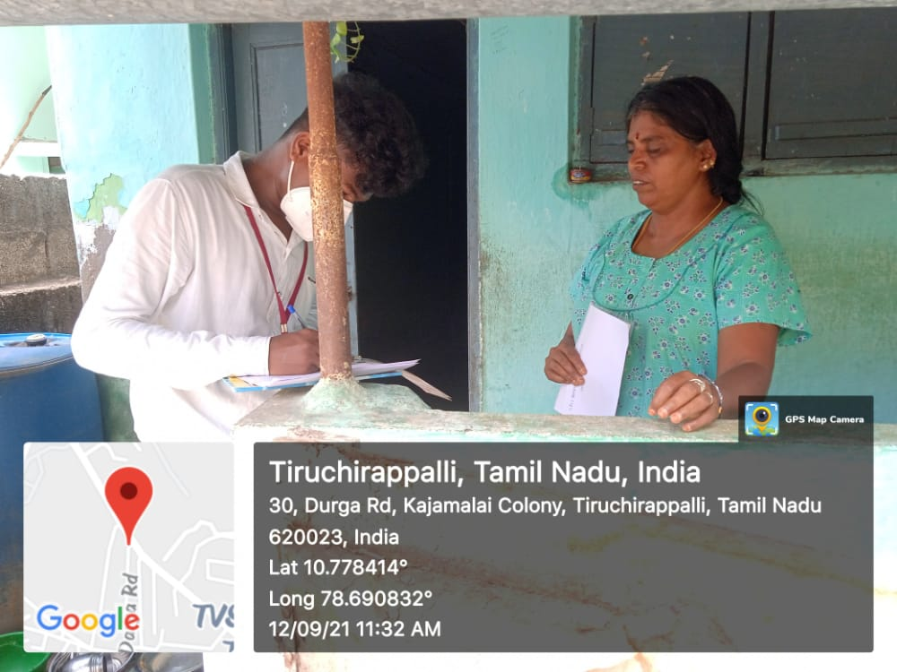
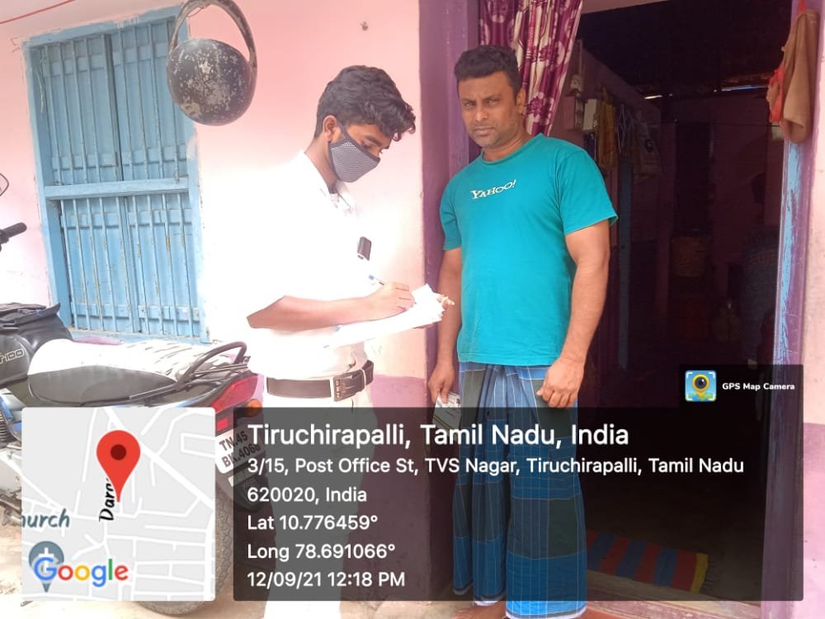
NATIONAL DEWORMING DAY
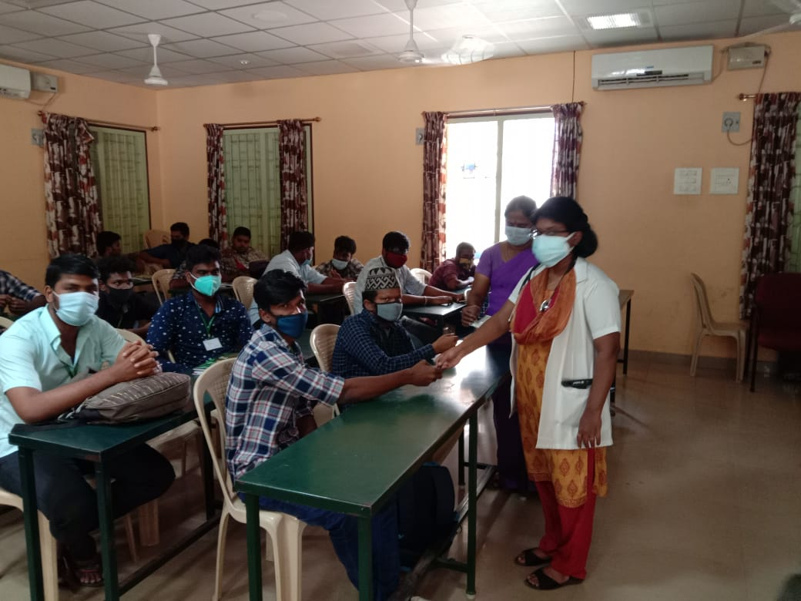
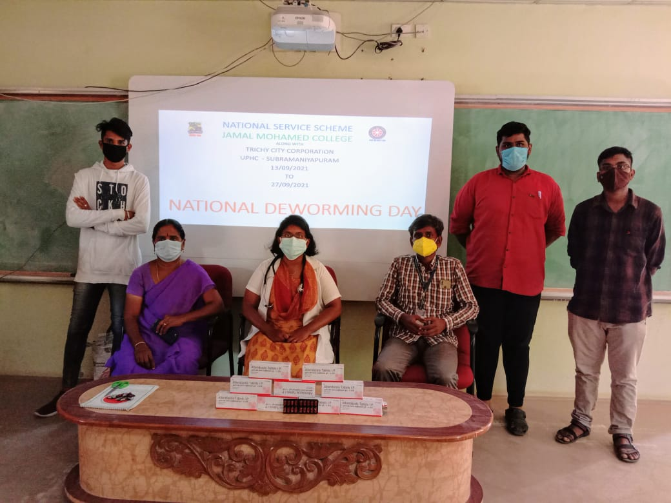

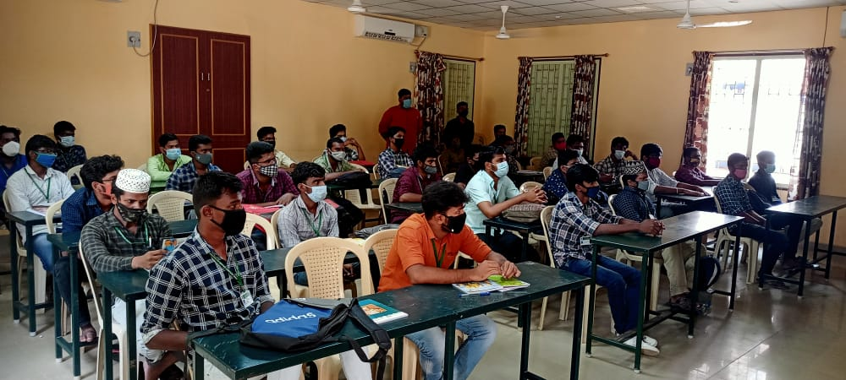
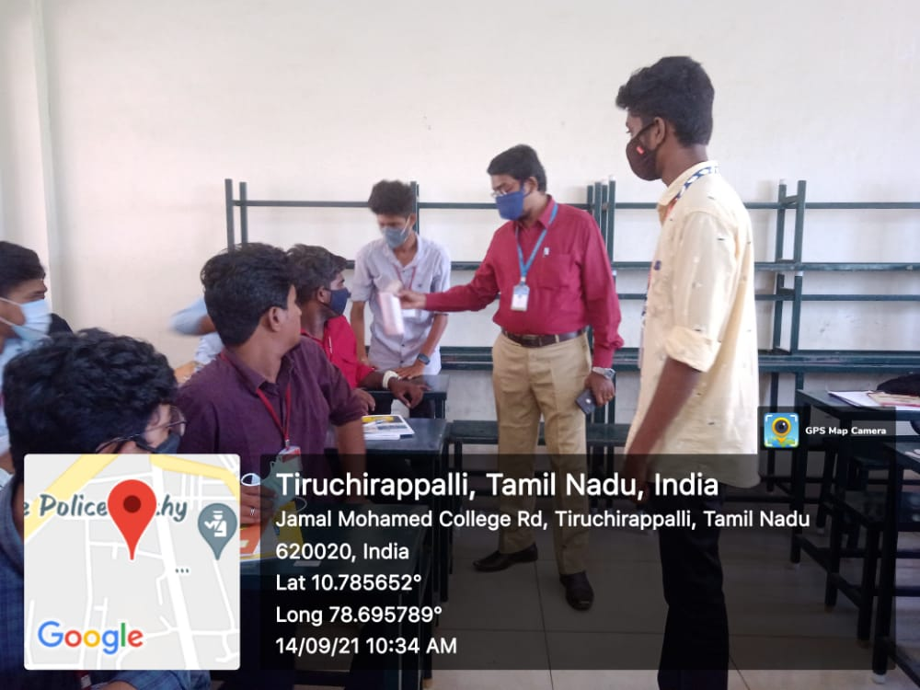
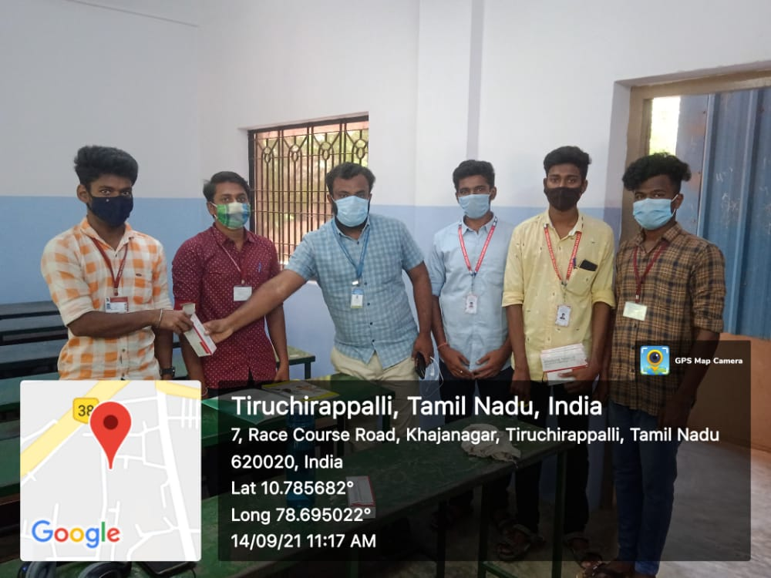
SOCIAL JUSTICE DAY PLEDGE
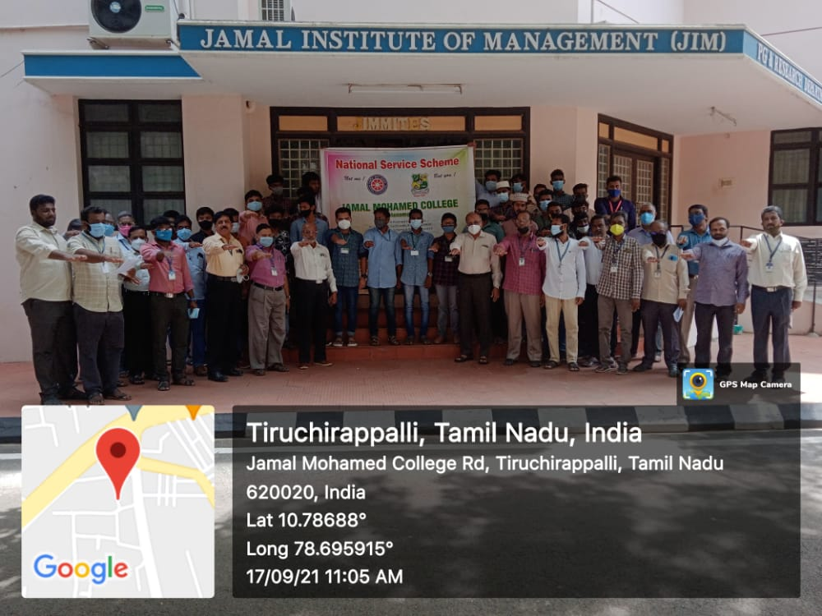

KABASURA KUDINEER
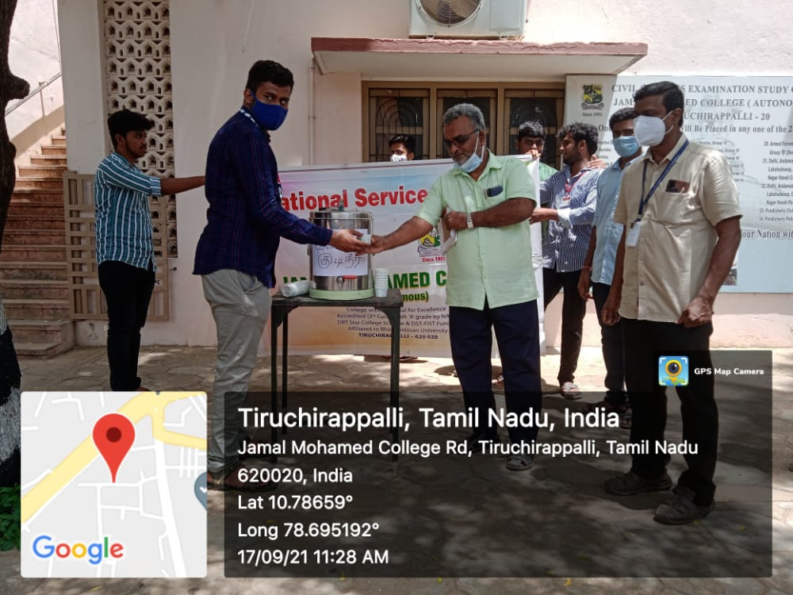

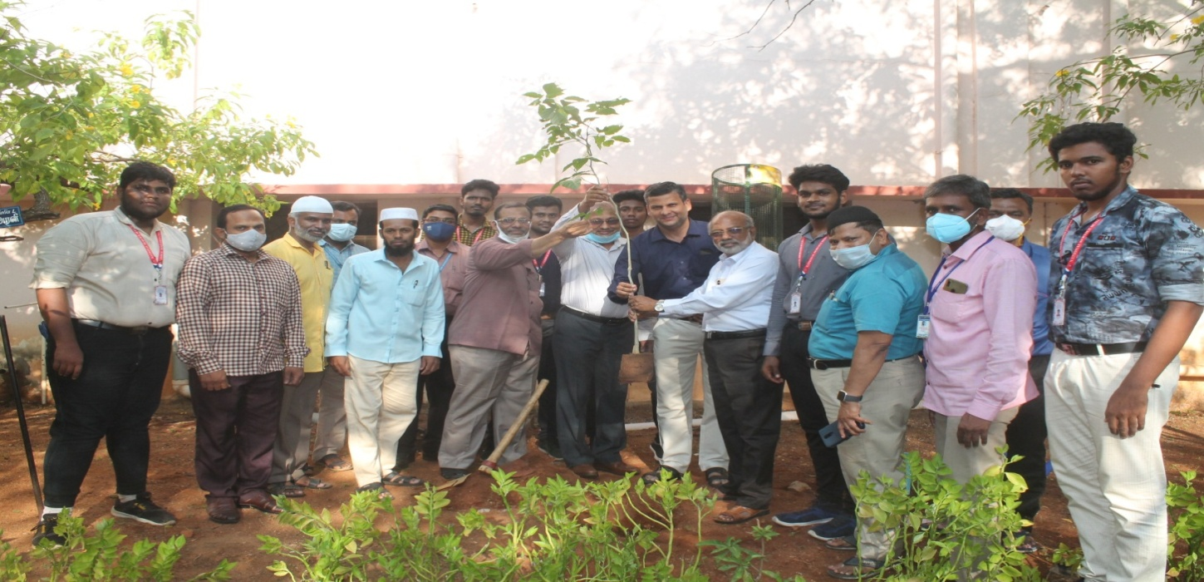
75TH INDEPENDENCE DAY TREE PLANTATION
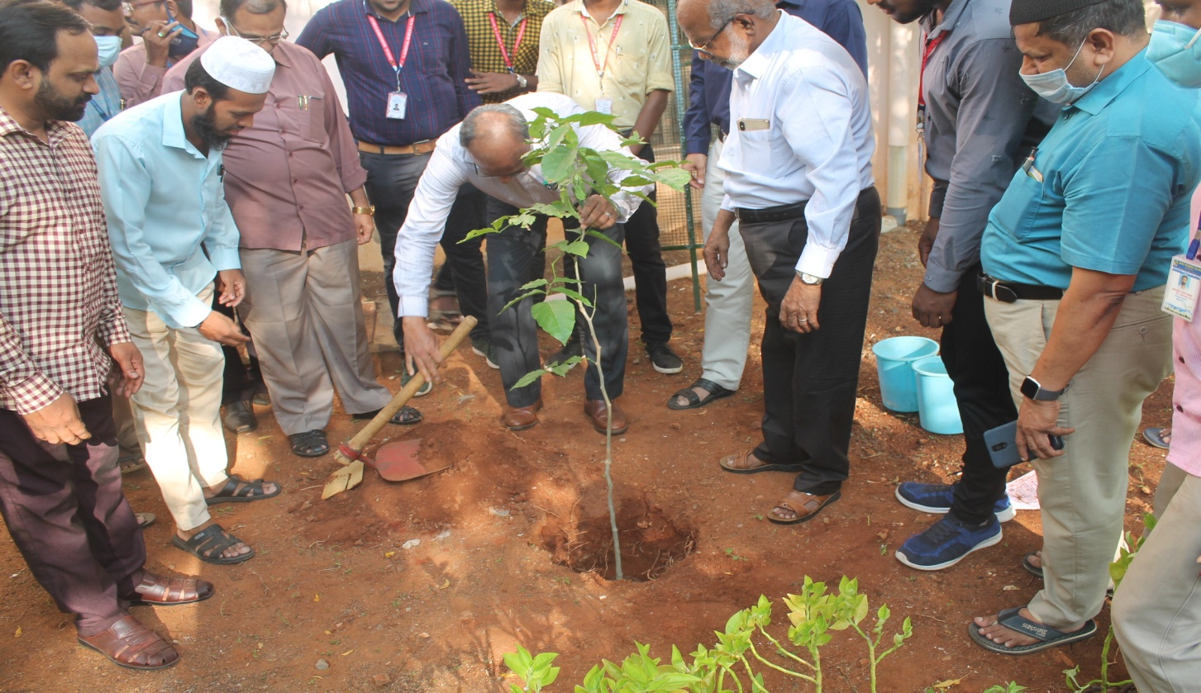

NSS DAY CELEBRATION

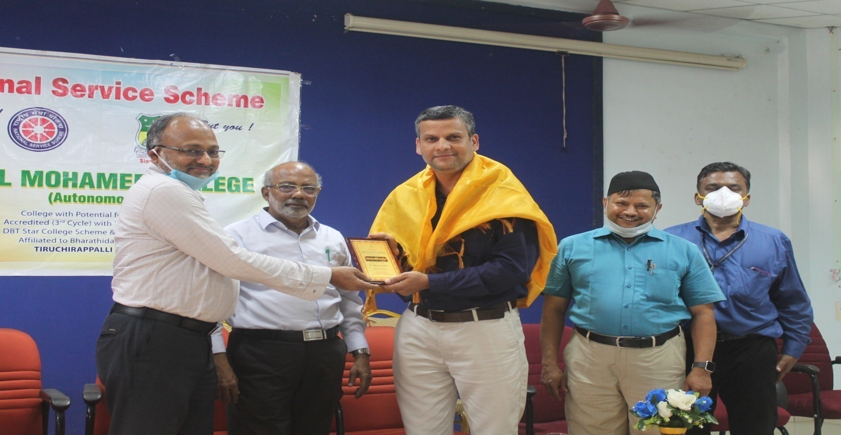
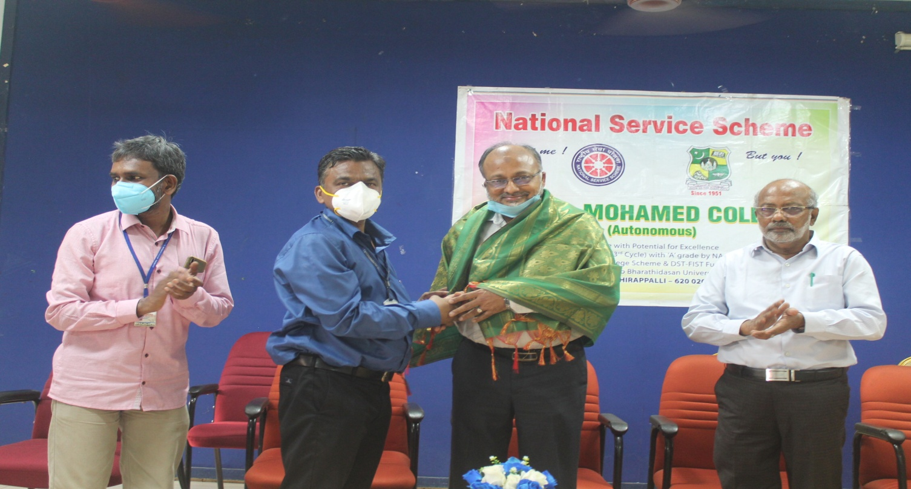

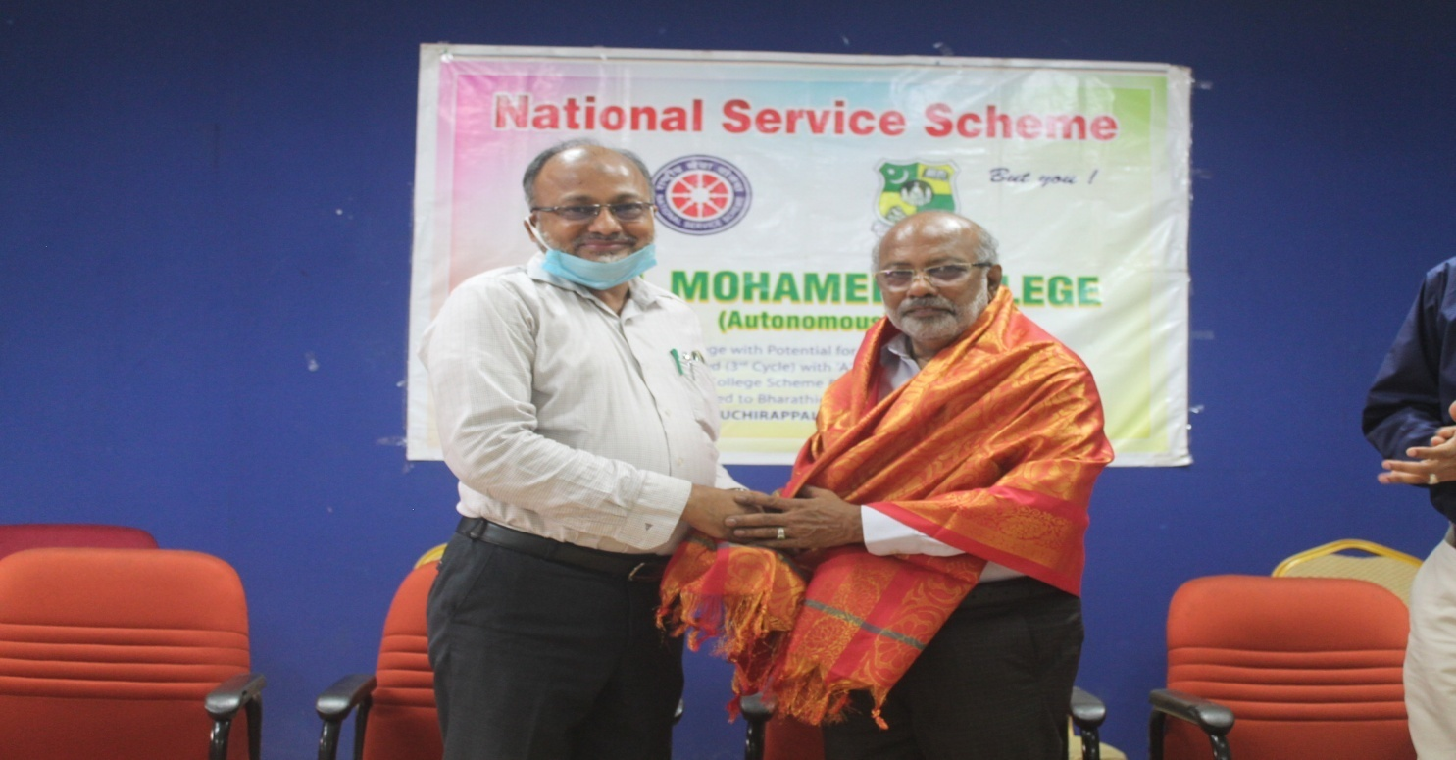
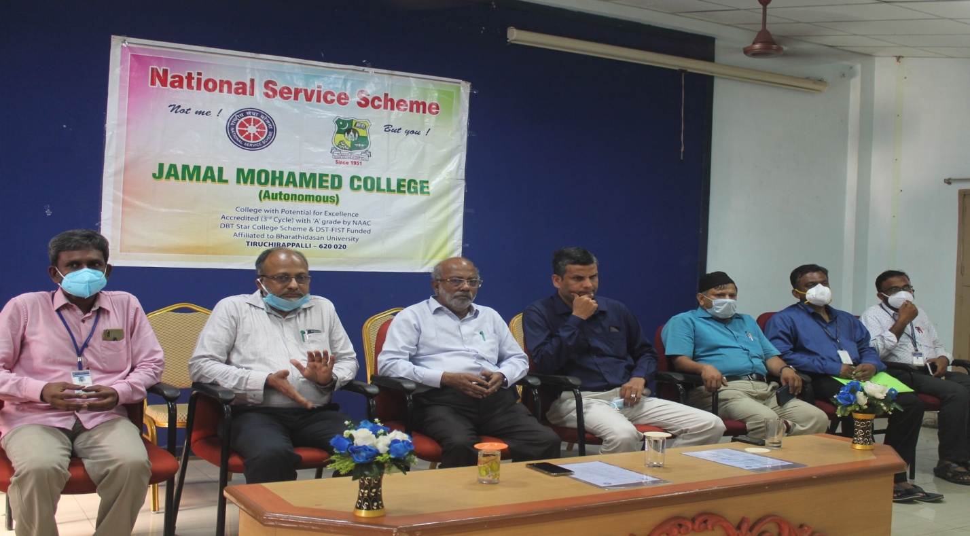

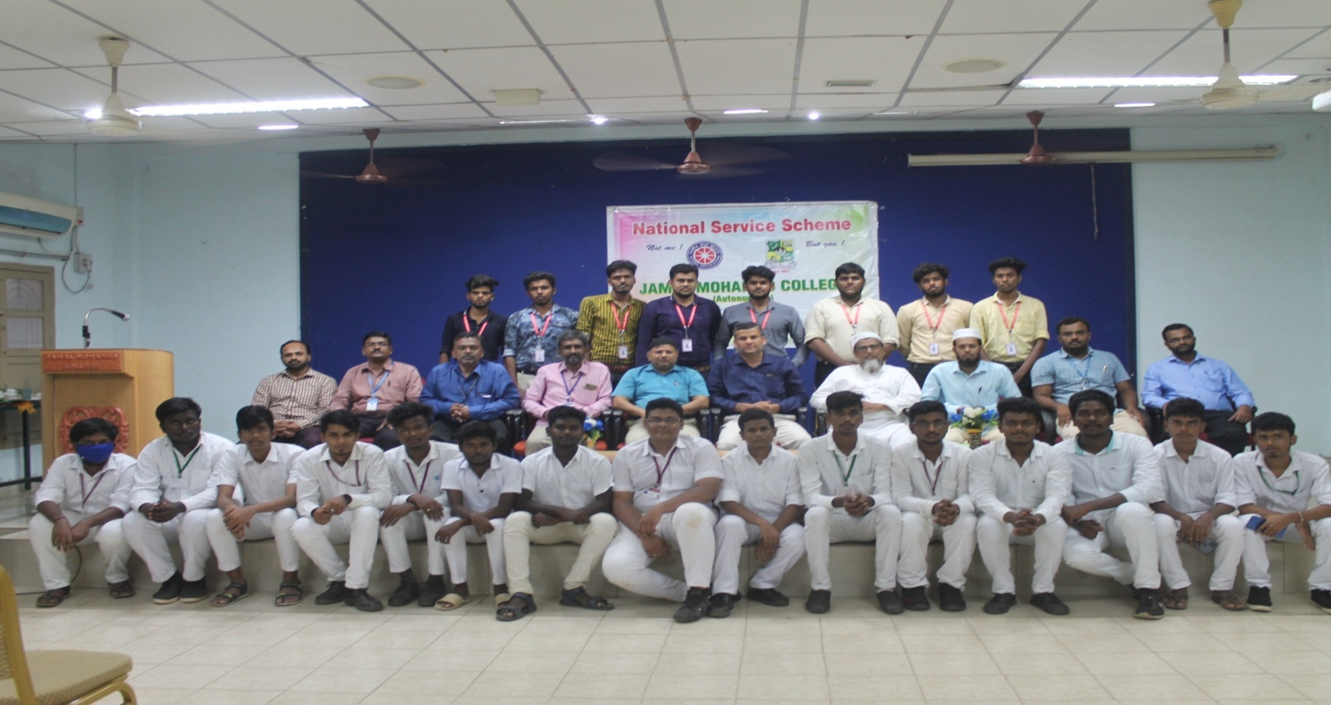

COLLEGE DAY CELEBRATION
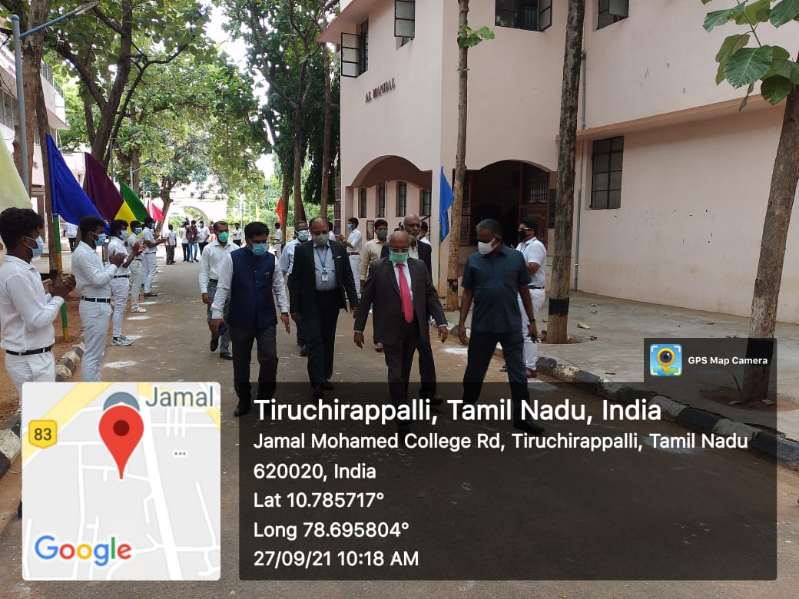
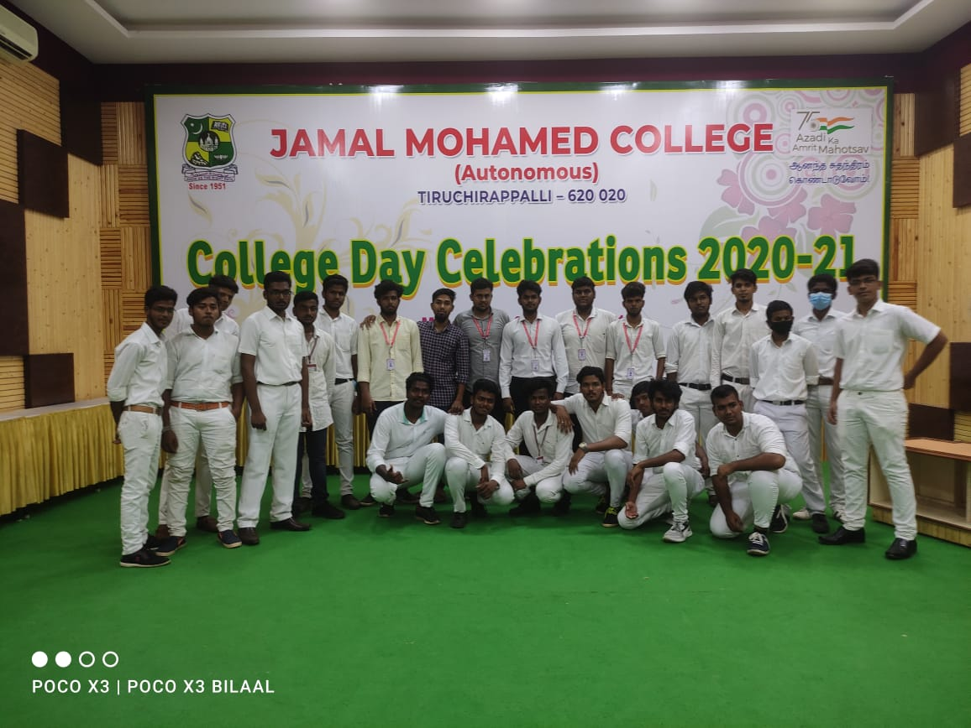
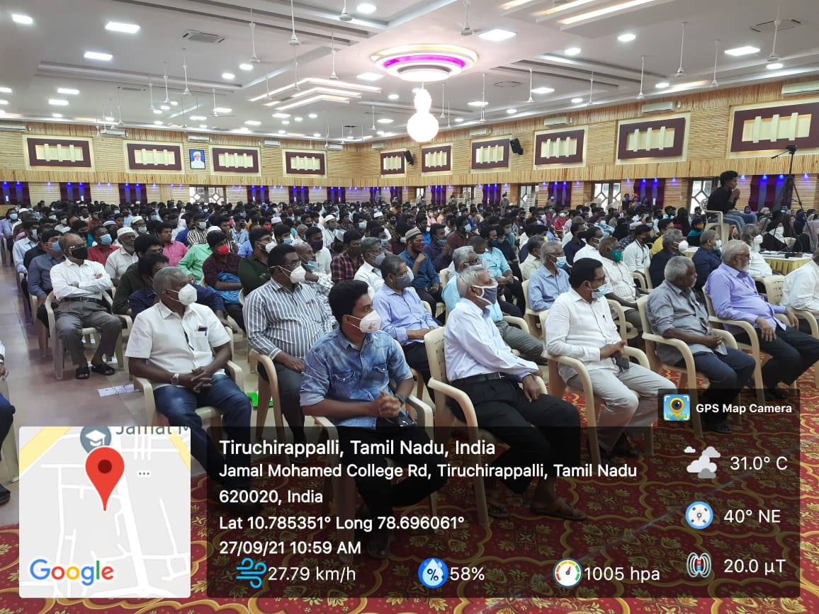
WISH PROGRAMME AT BDU
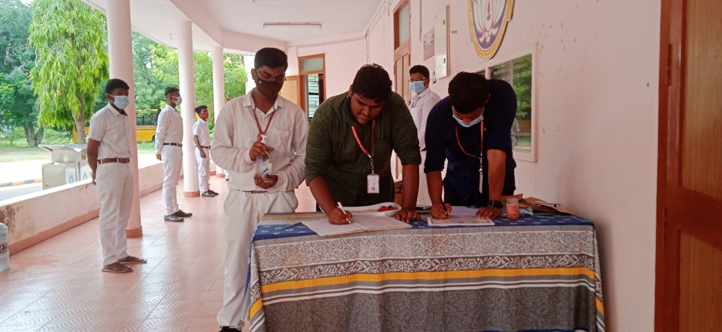

MEGA VACCINATION CAMP
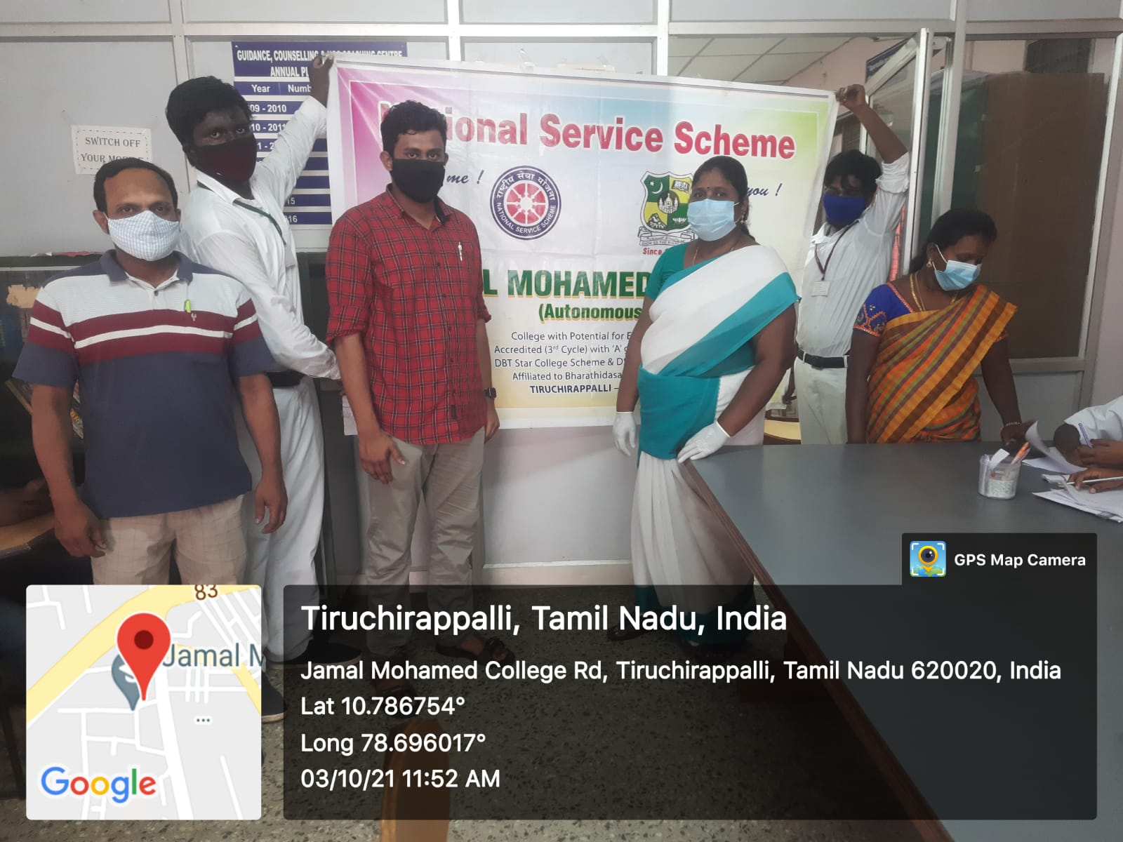
PRE RD SELECTION AT BDU
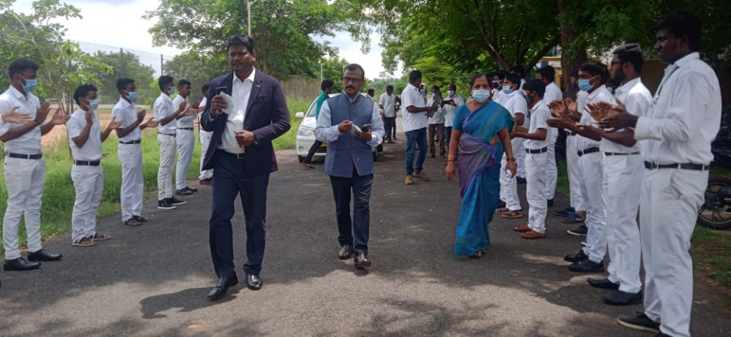
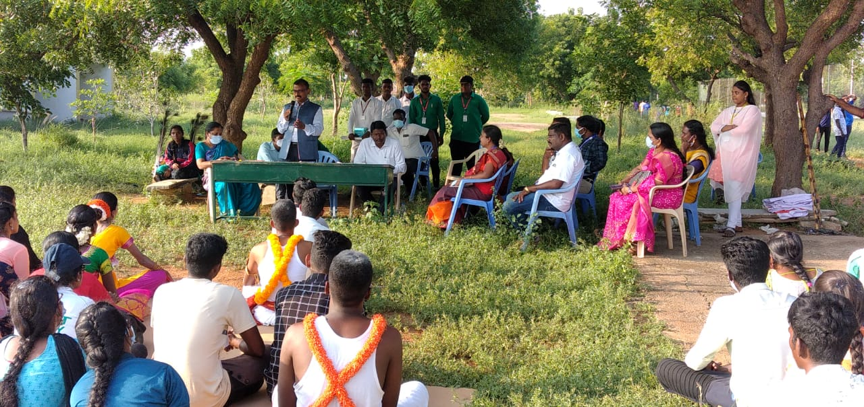

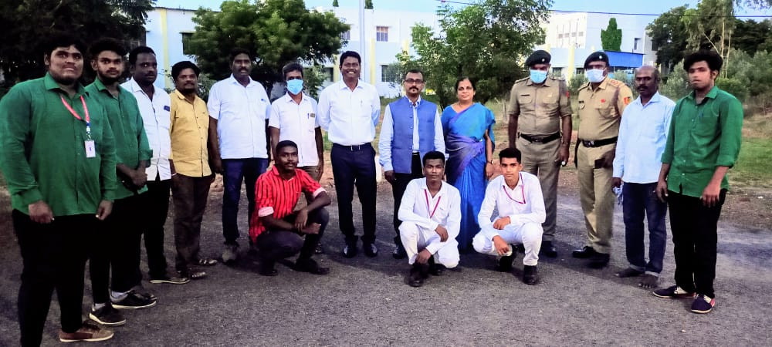
CAMPUS CLEANING
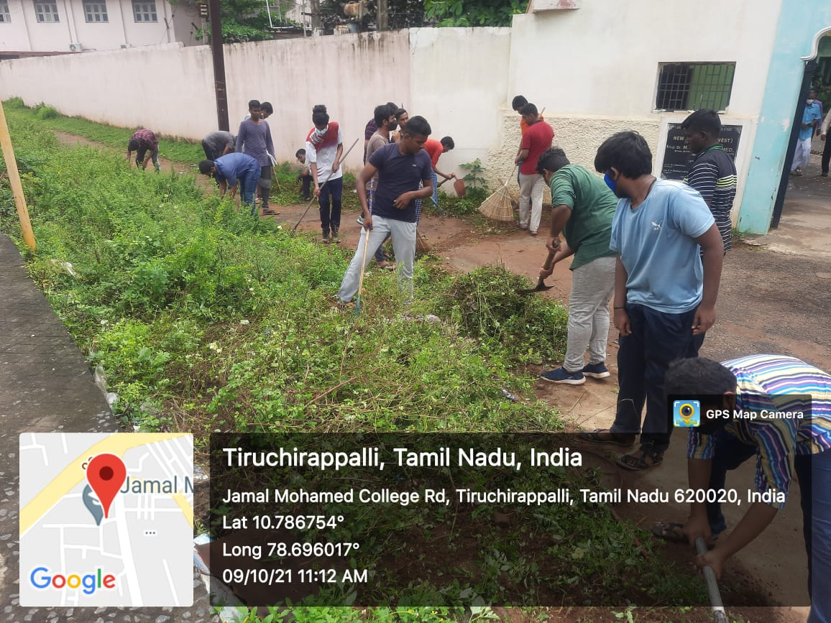
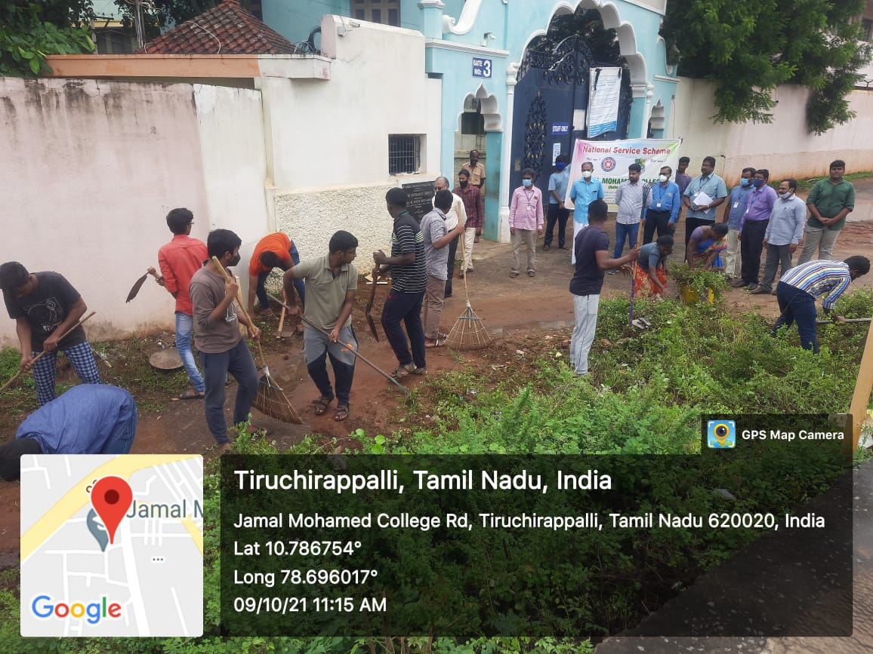
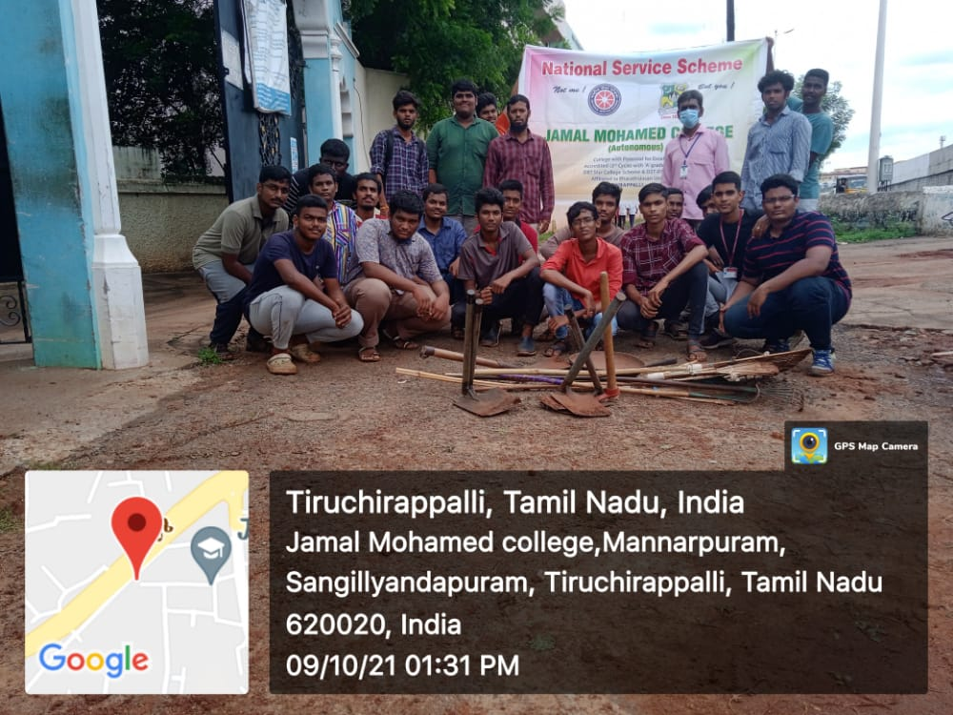
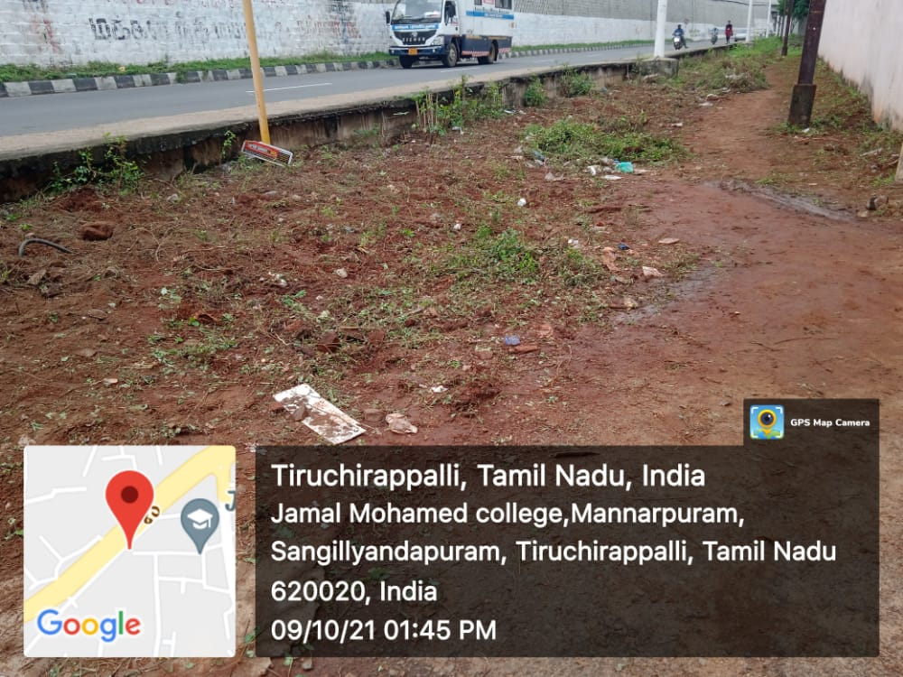
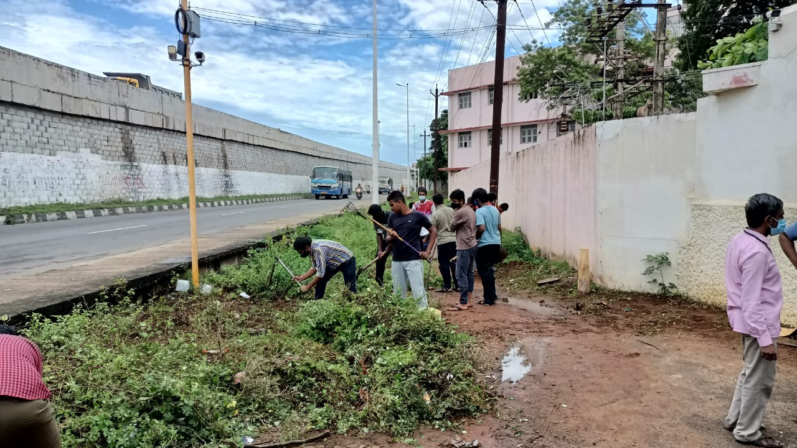
FRESHERS WELCOME DAY
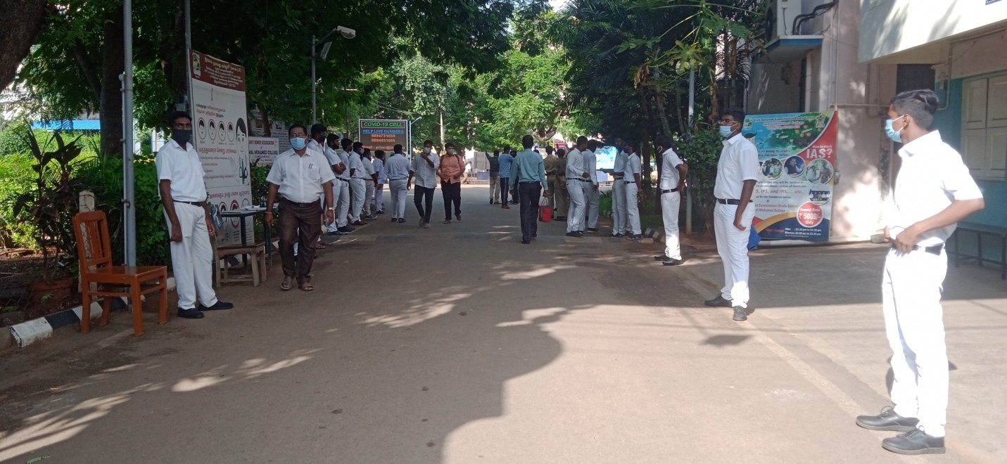
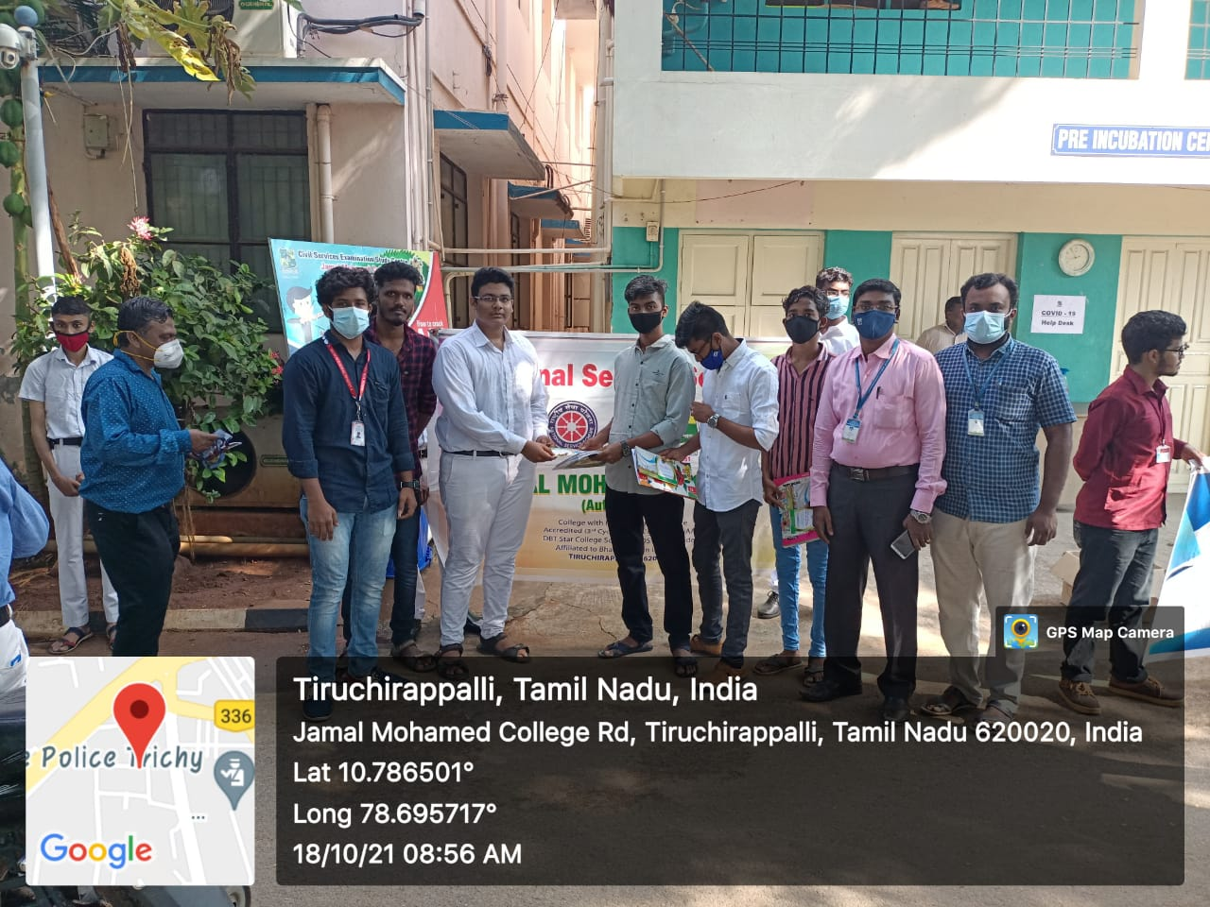
WORLD SIGHT DAY
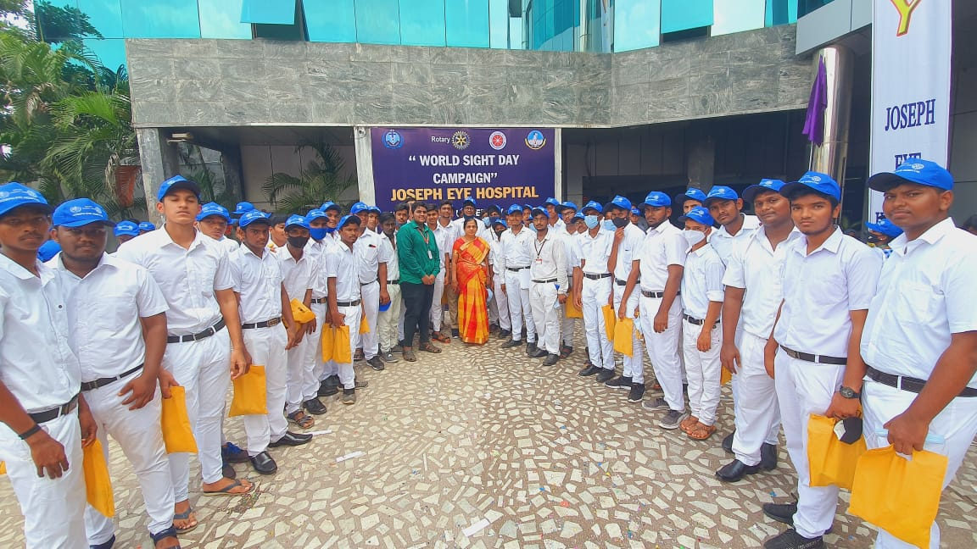
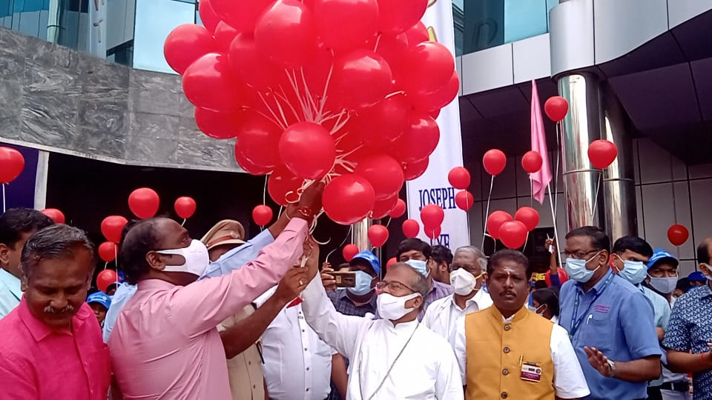
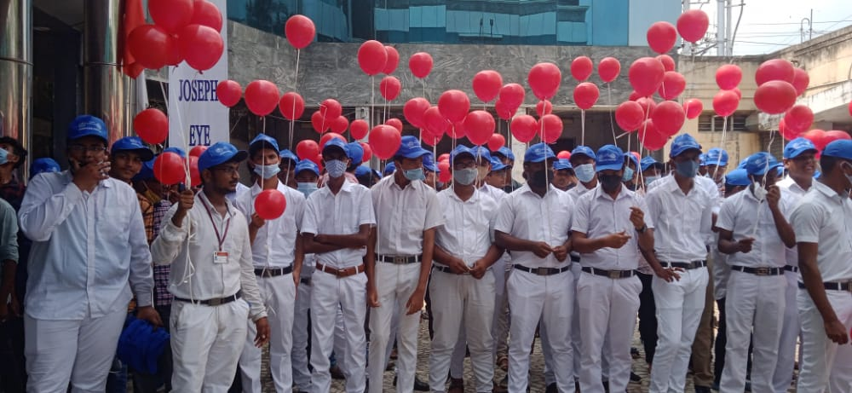
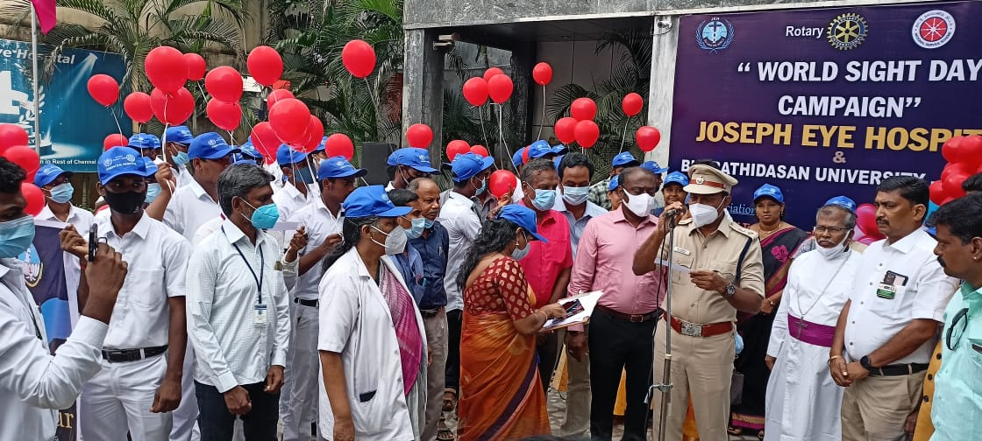
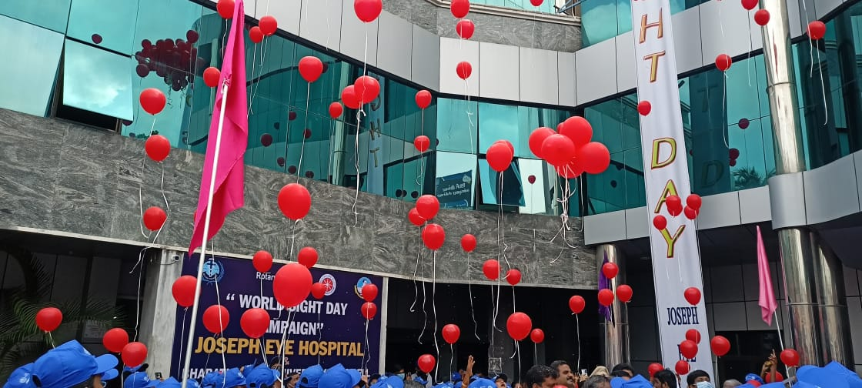
CYCLE RALLY
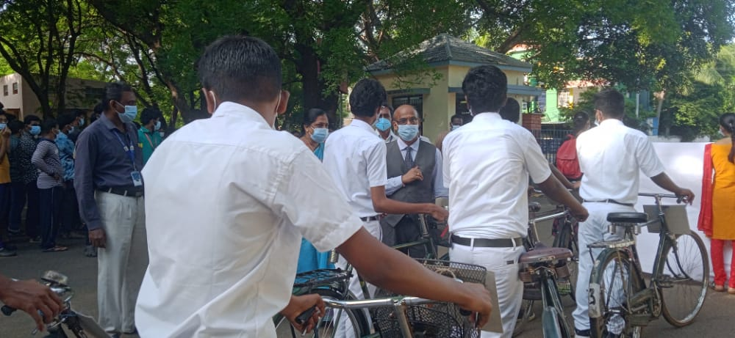

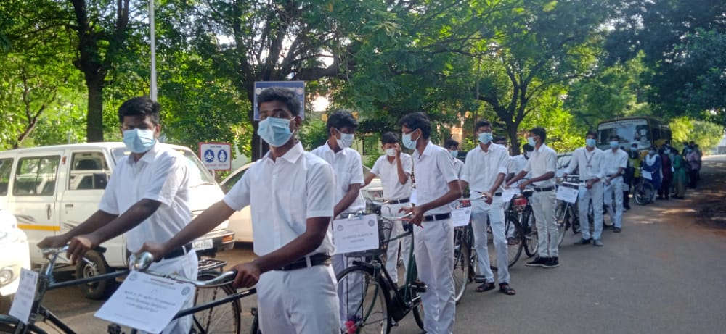

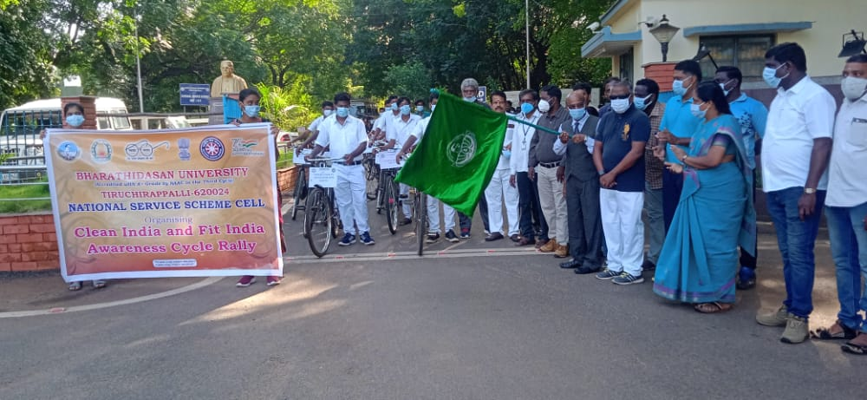

CLEAN INDIA PROGRAMME

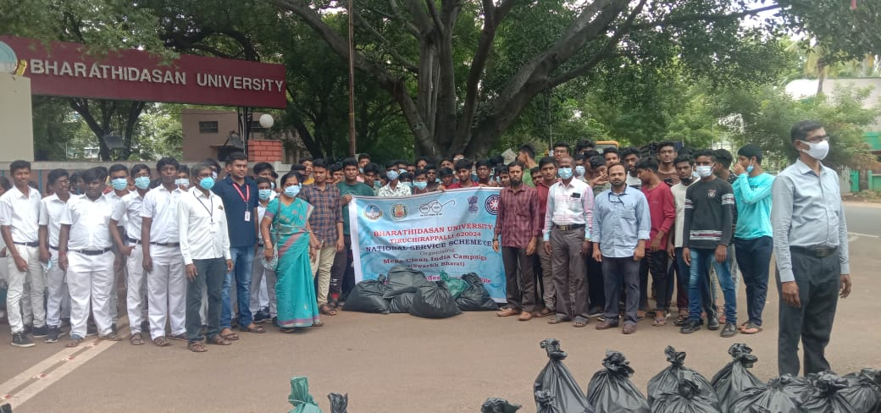
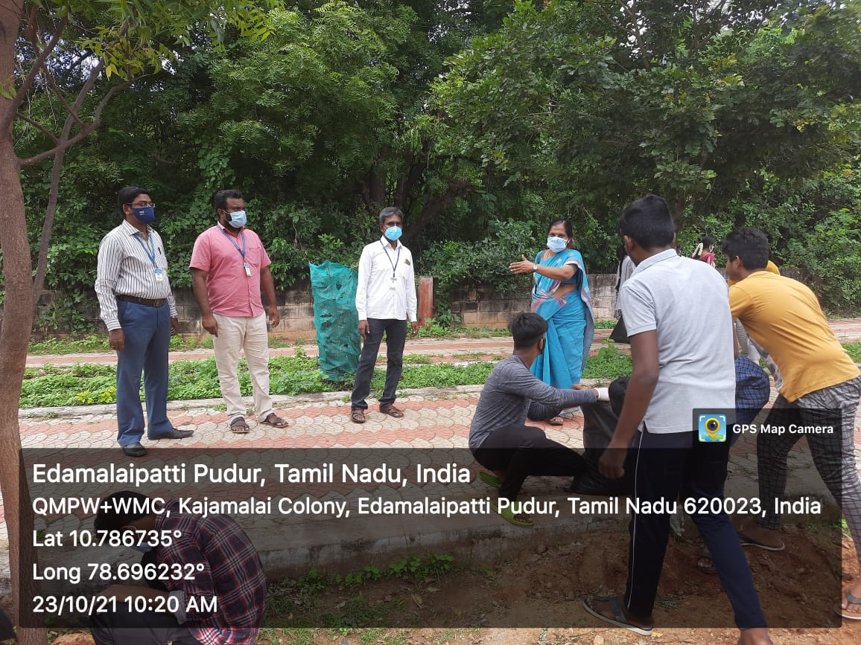

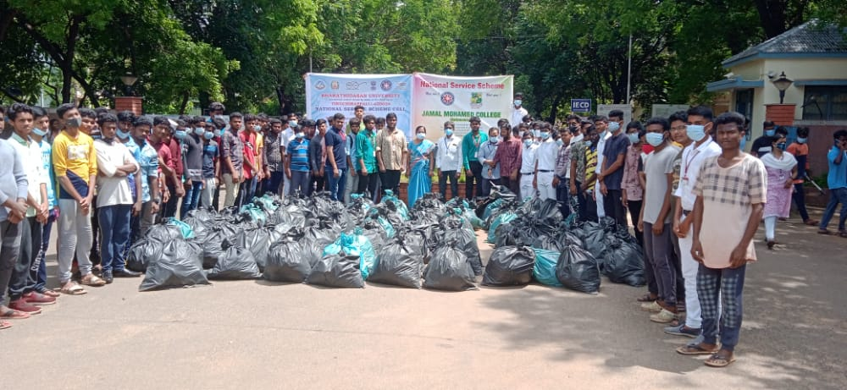

TRANSGENDER ID CARD UPDATING PROGRAMME

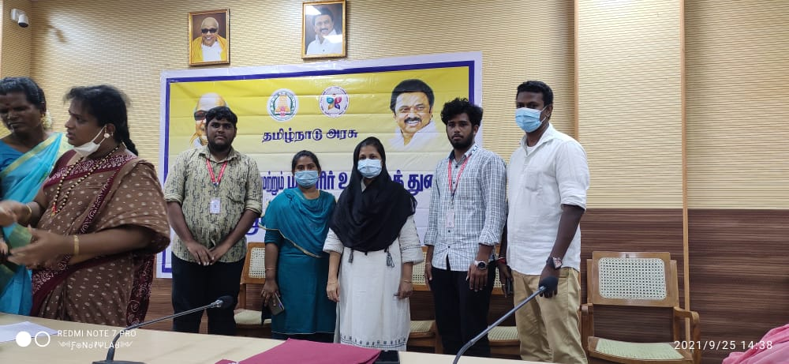

DIWALI AWARENESS PROGRAMME

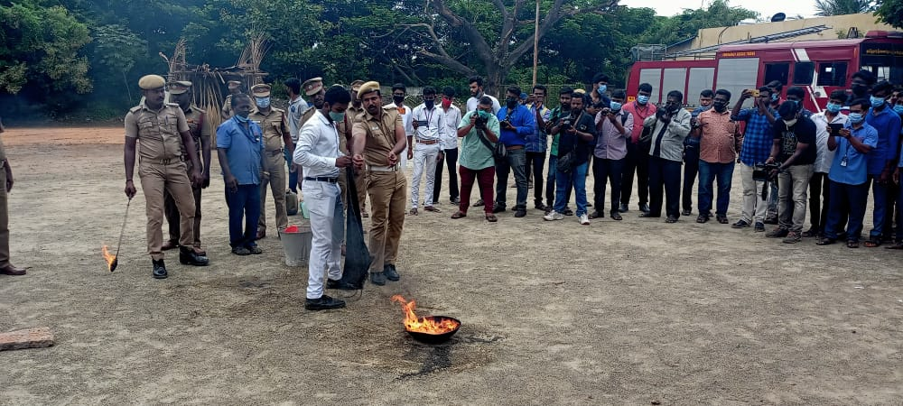
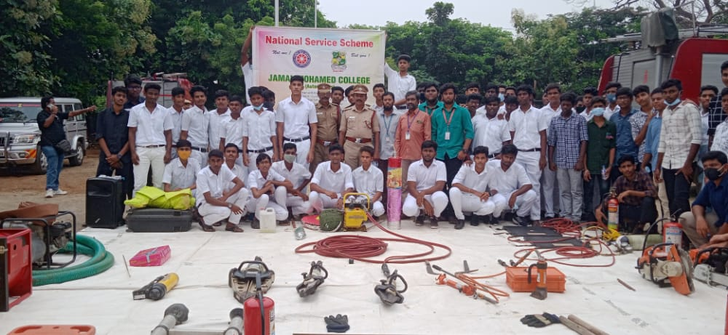
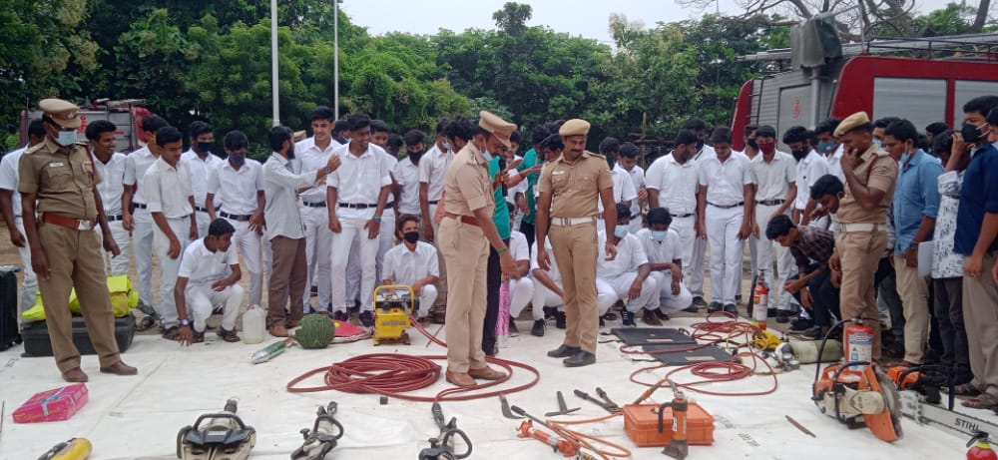
ARABIC COLLEGE CLEANING PROGRAMME
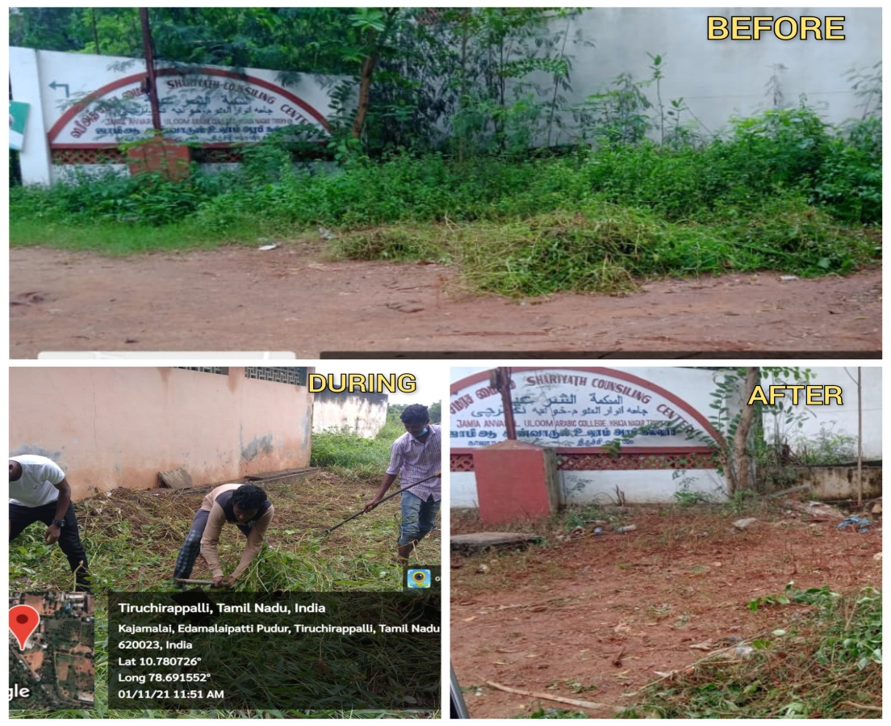
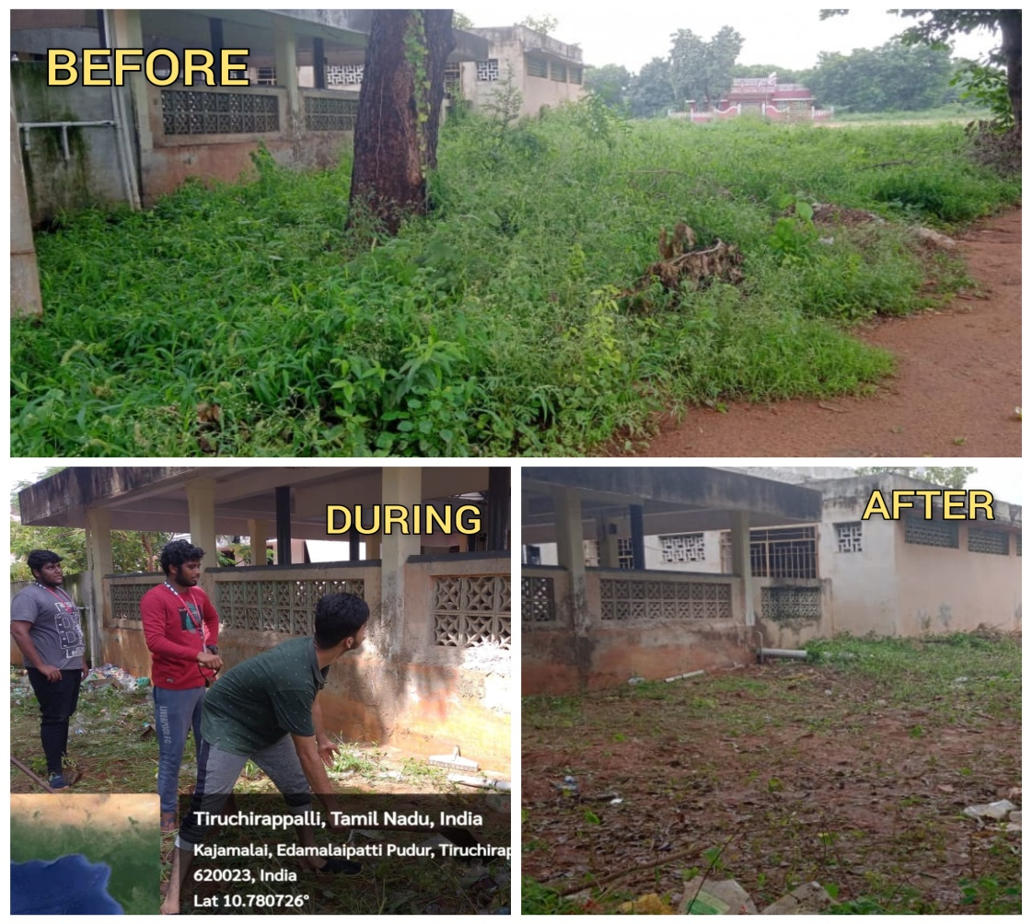
MEGA VACCINATION CAMP
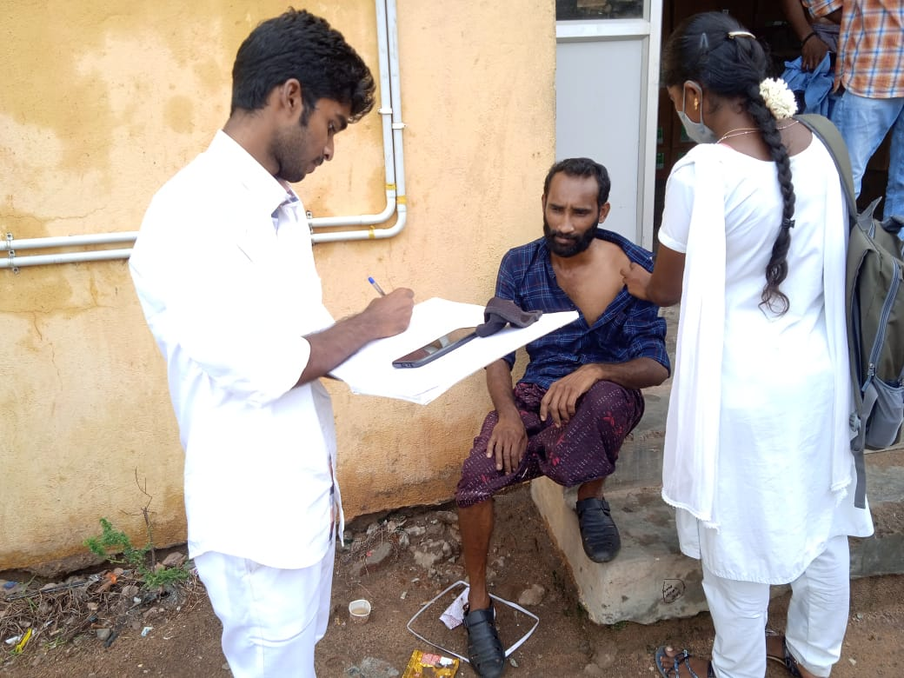
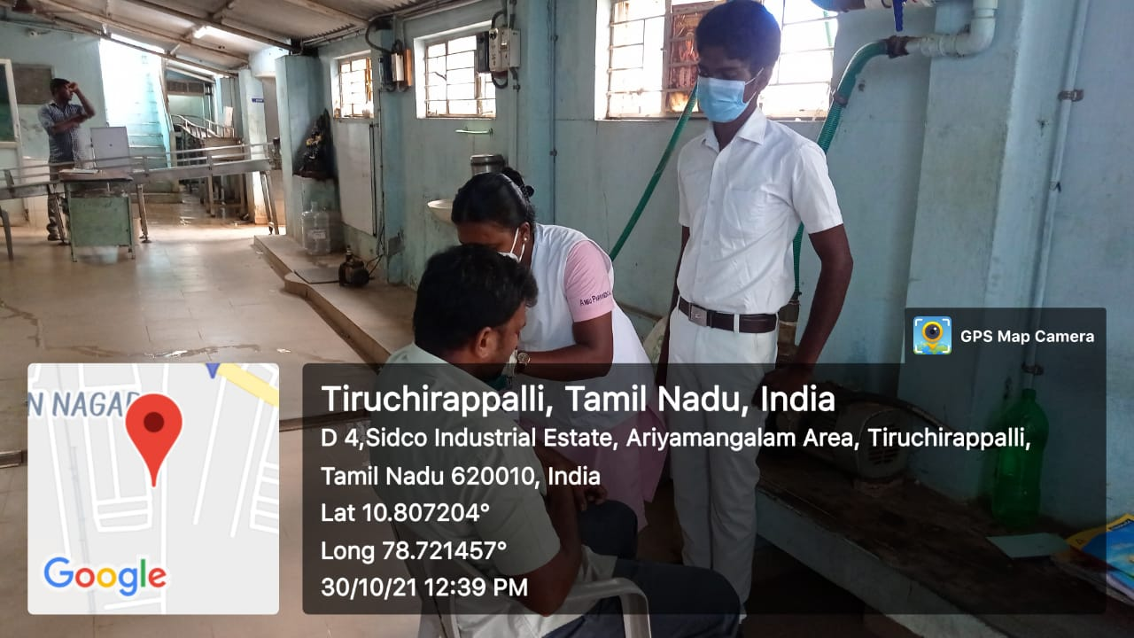
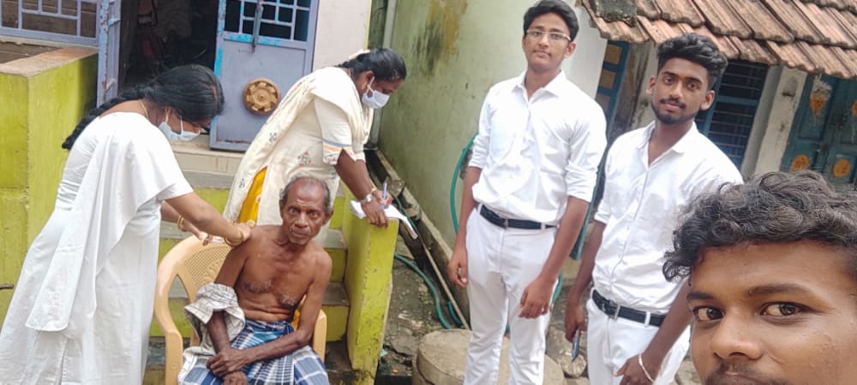
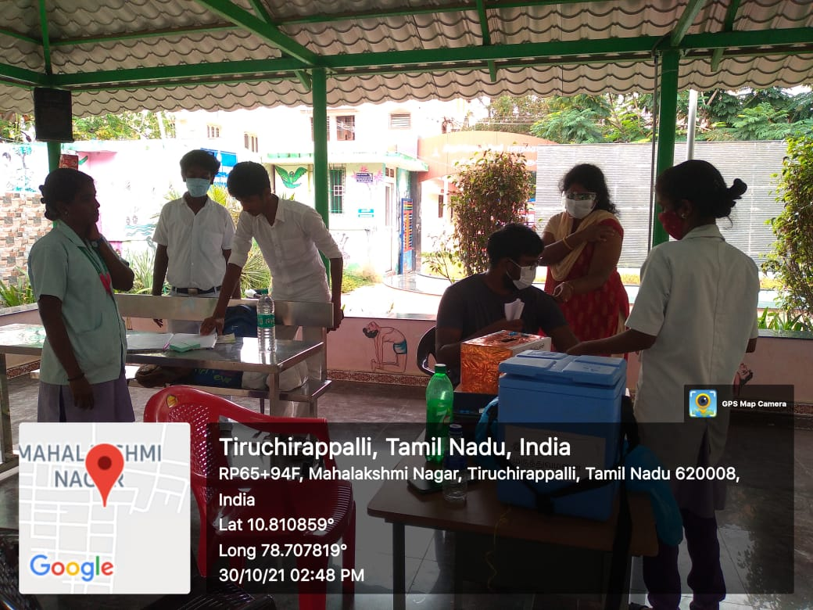
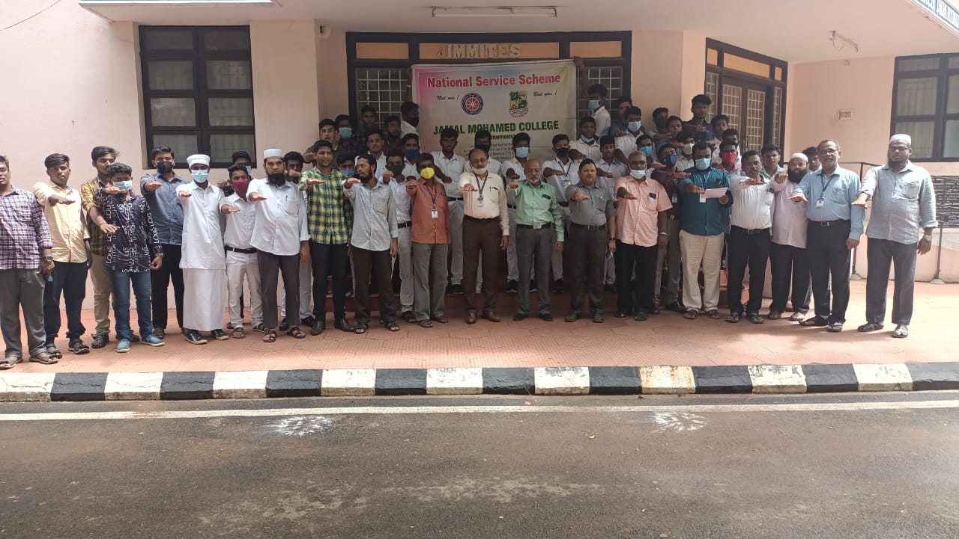
NATIONAL UNITY DAY PLEDGE

CHILDRENS DAY CELEBRATION
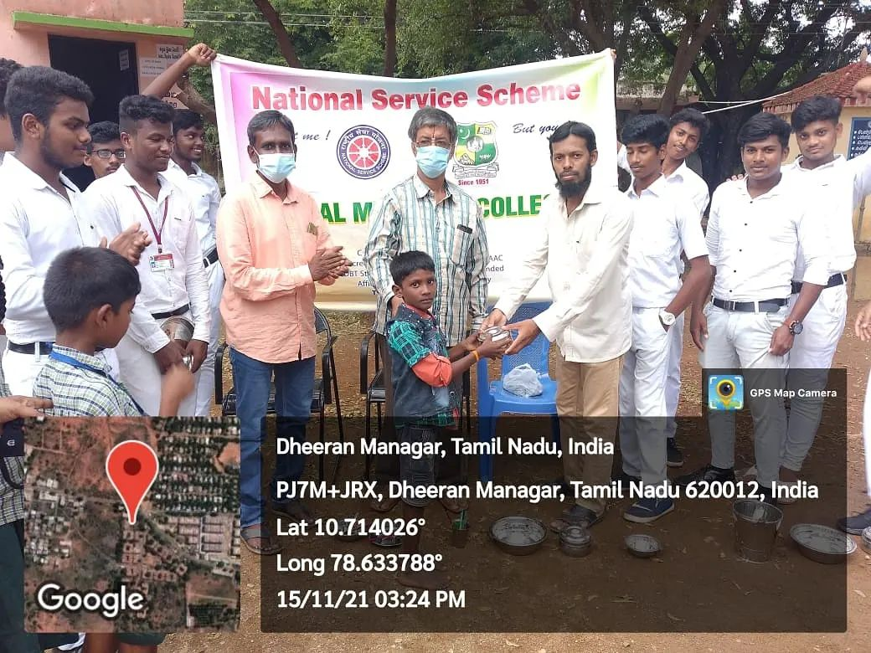

BOOK FAIR
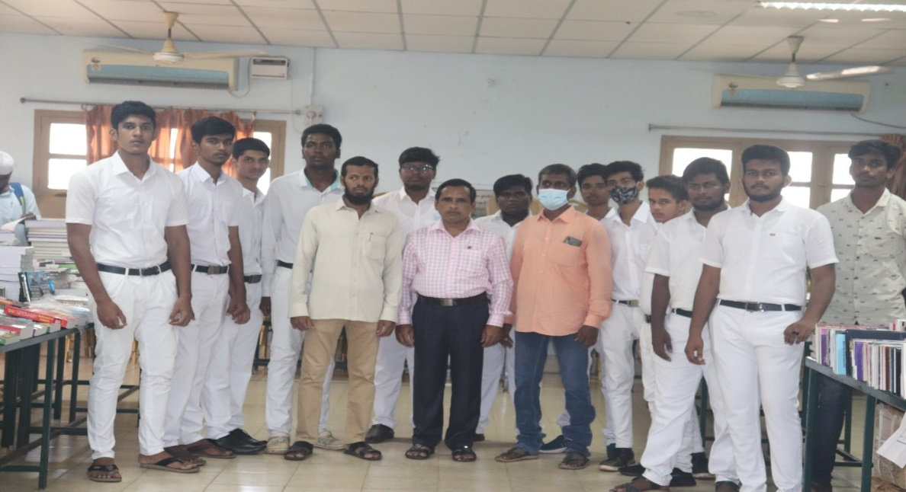

WORLD DIABETES DAY
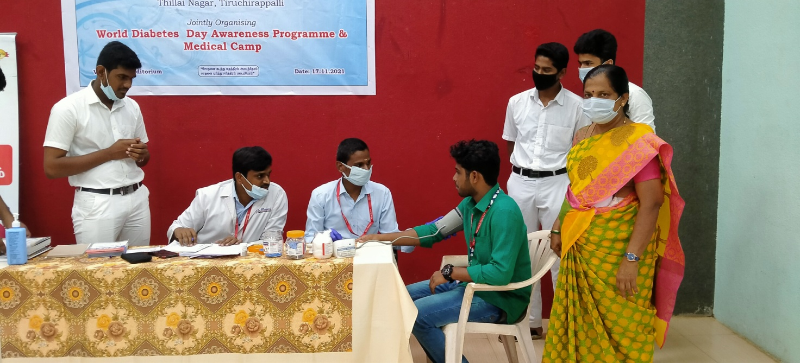
NATIONAL INTEGRATION DAY
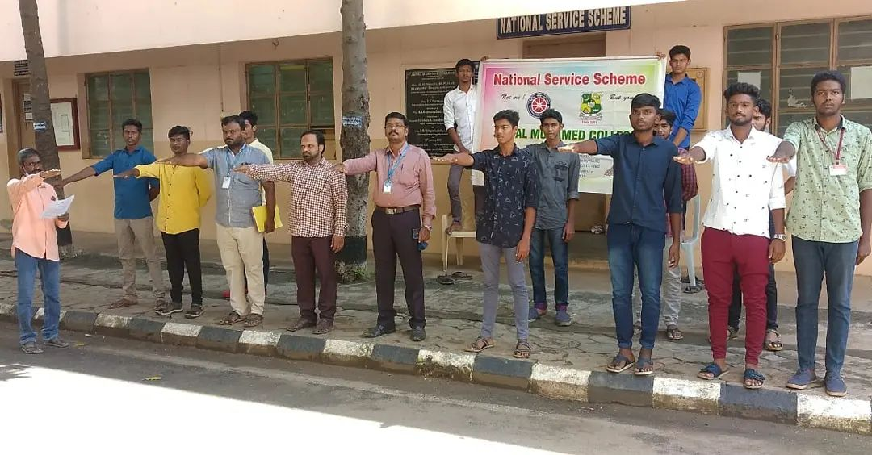

STUDENTS INDUCTION PROGRAMME
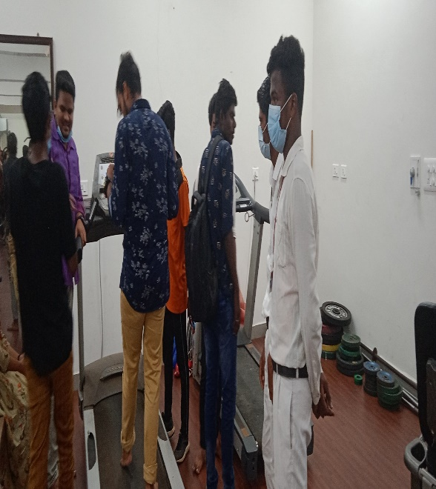
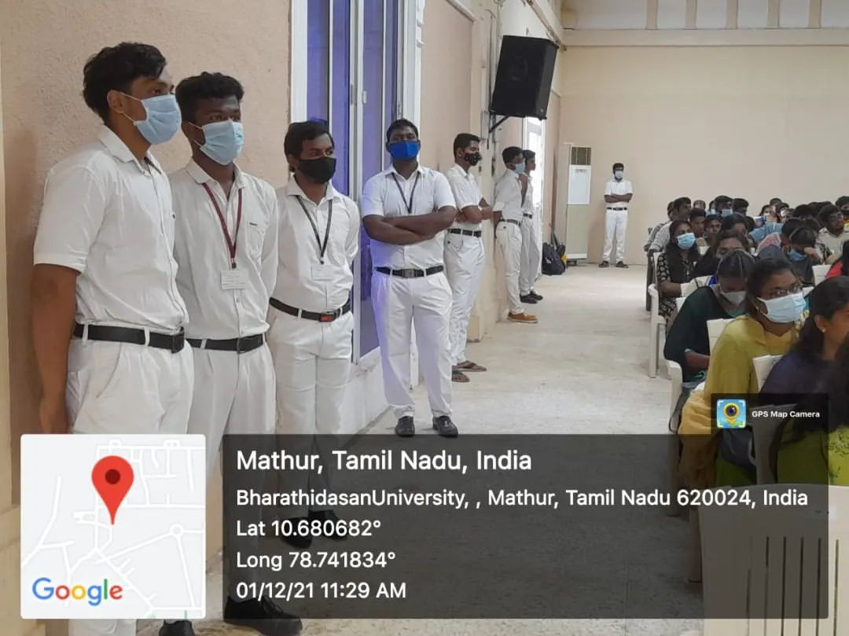
TREE PLANTATION AT BDU
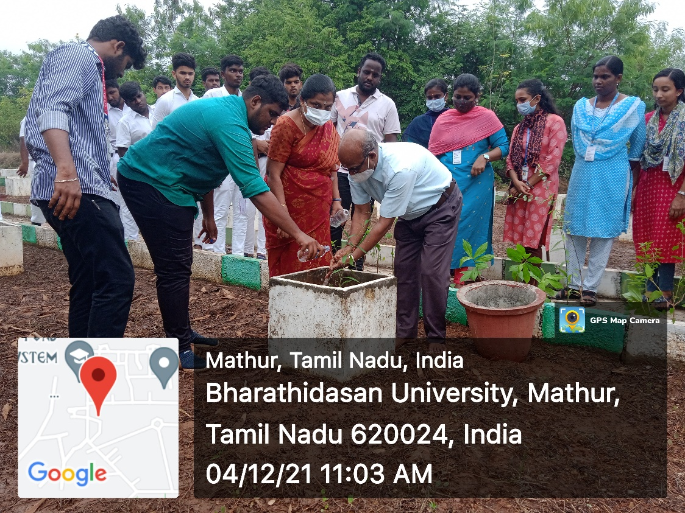

HERBAL GARDEN CLEANING

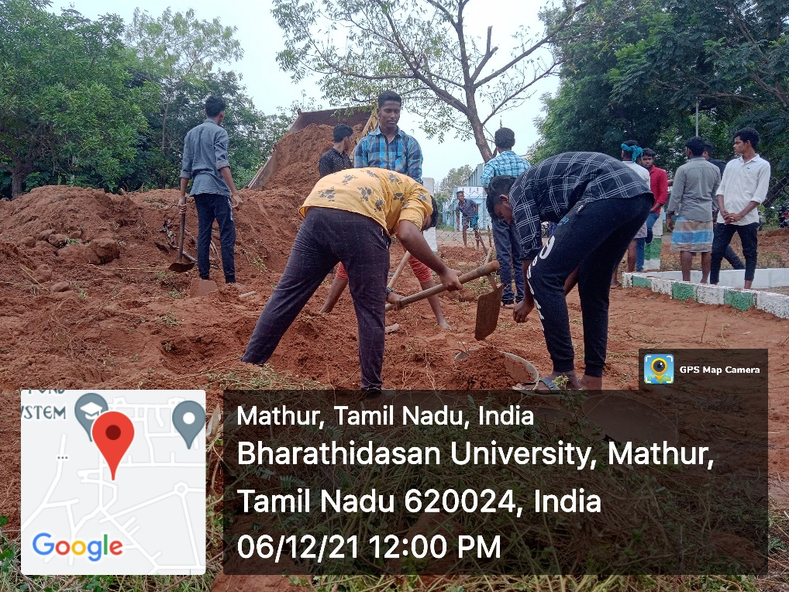
NSS ORIENTATION PROGRAMME
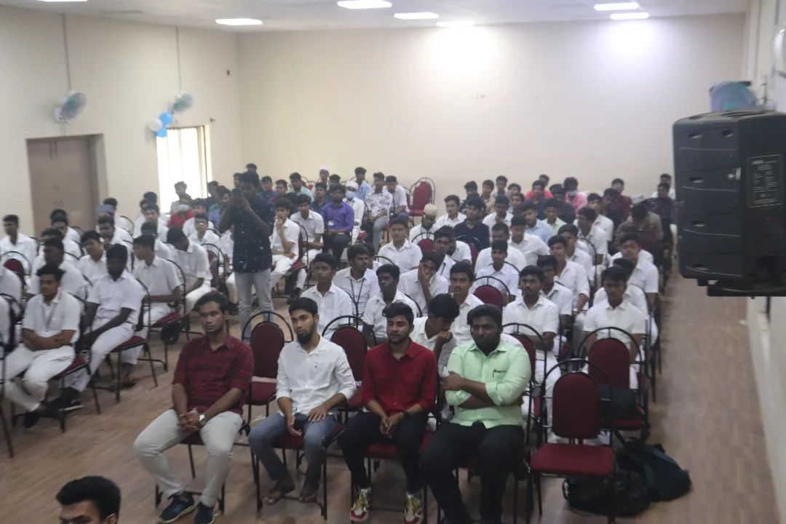
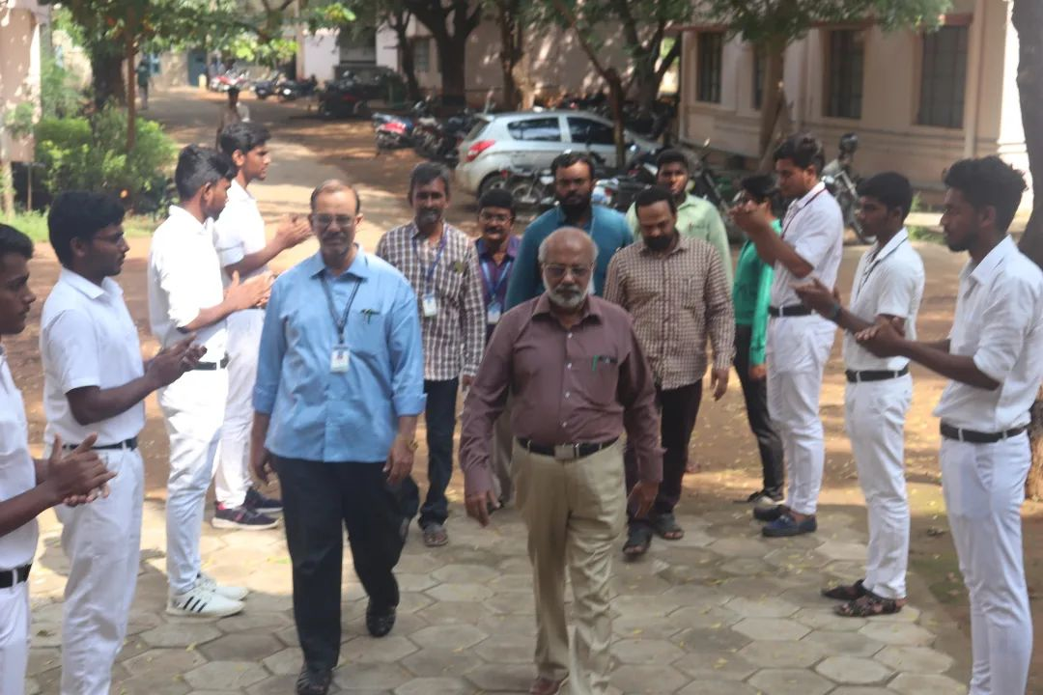
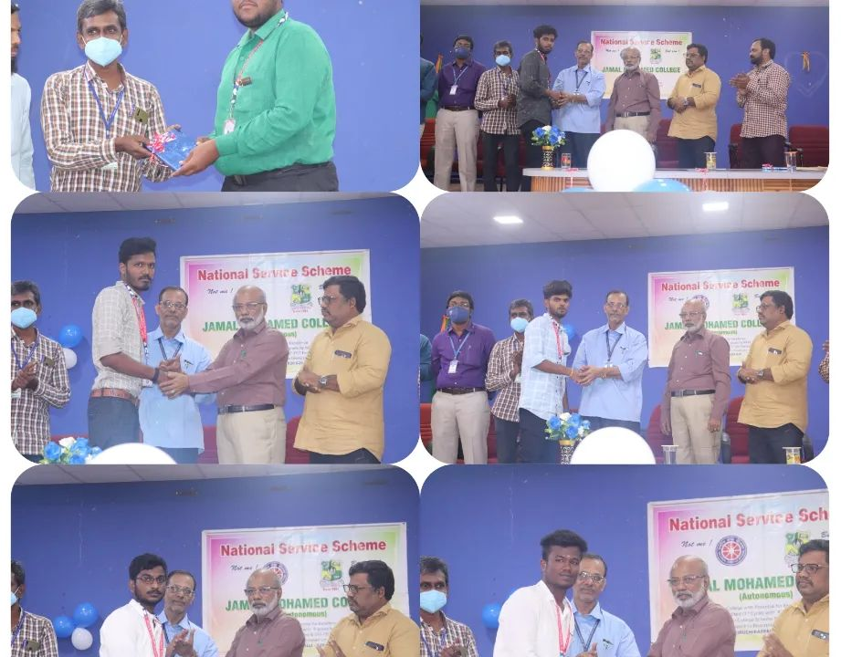

R.S. PURAM KOVIL CLEANING

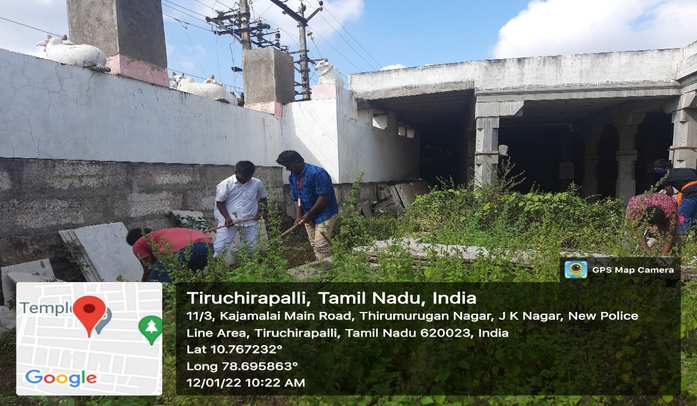
a

NATIONAL VOTERS DAY
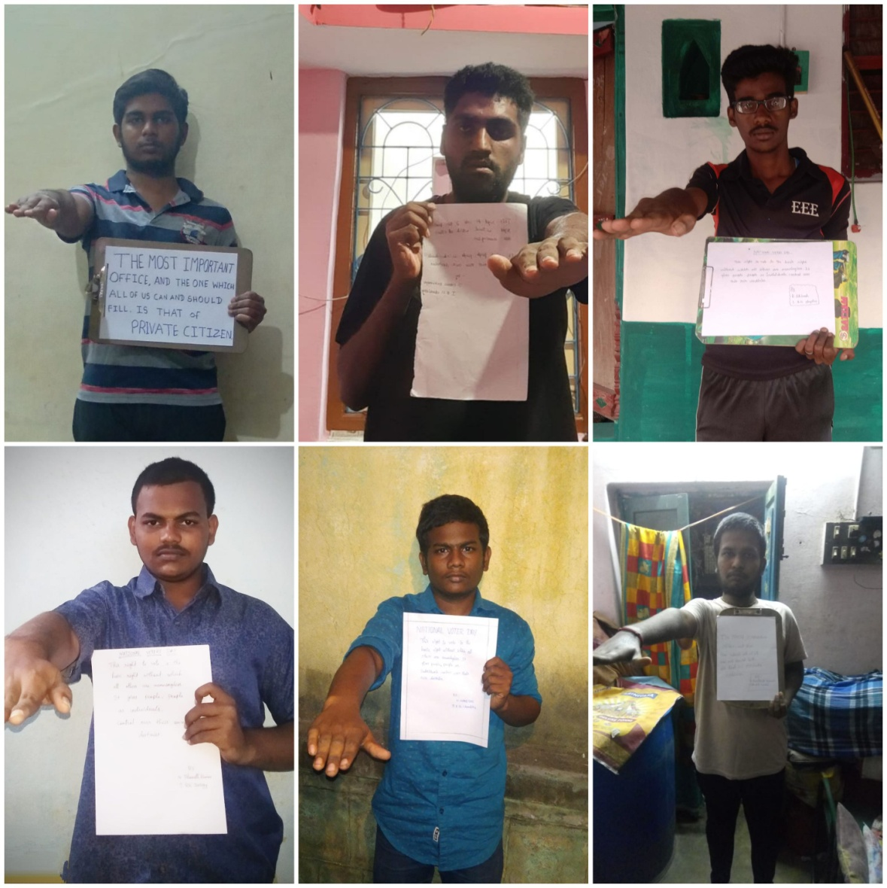

72ND REPUBLIC DAY CELEBERATION JMC

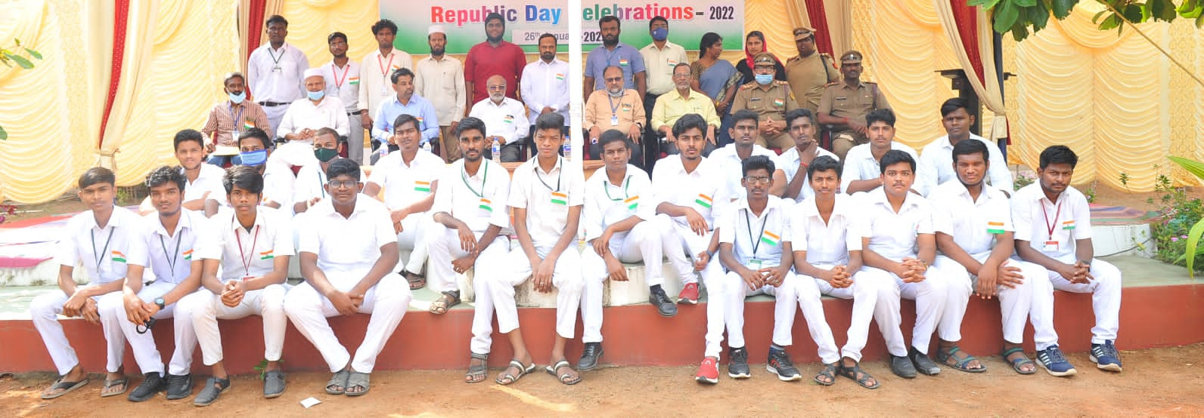
72ND REPUBLIC DAY CELEBERATION BDU
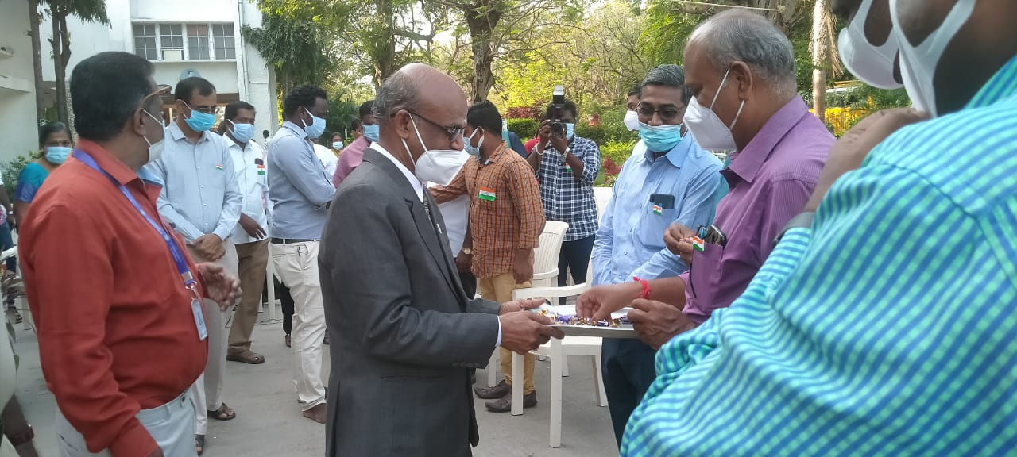
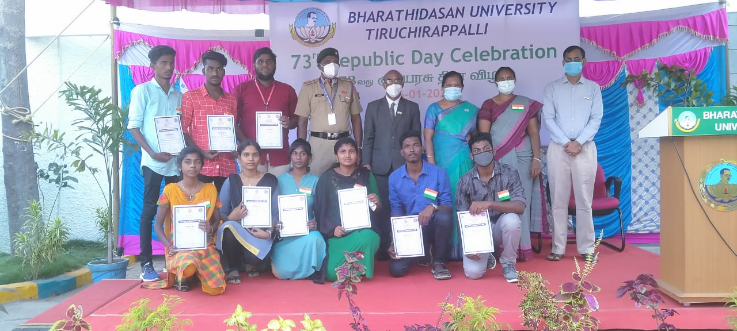
CHILD LABOURS DAY PLEDGE
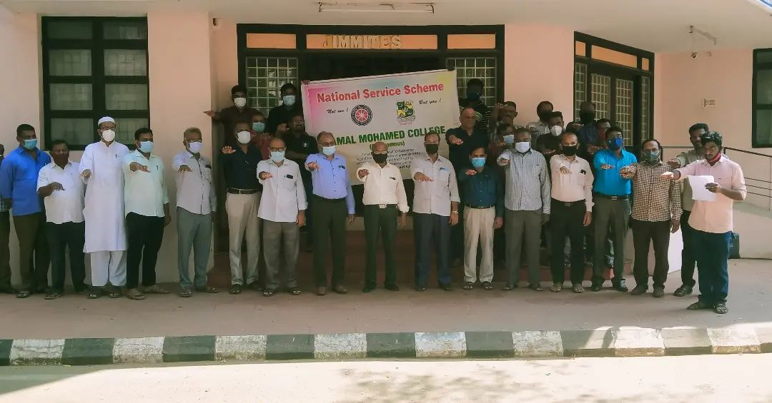

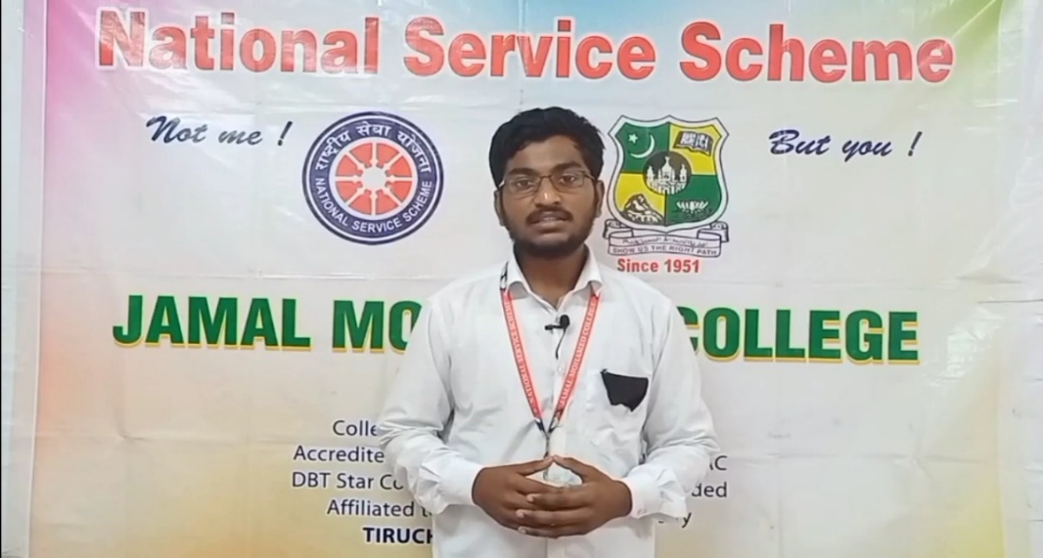
PULWAMA ATTACK

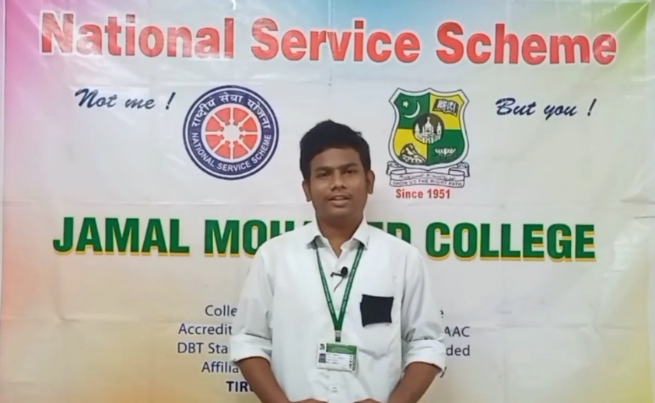
SCIENCE EXHIBITION AT BHARATHIDASAN UNIVERSITY
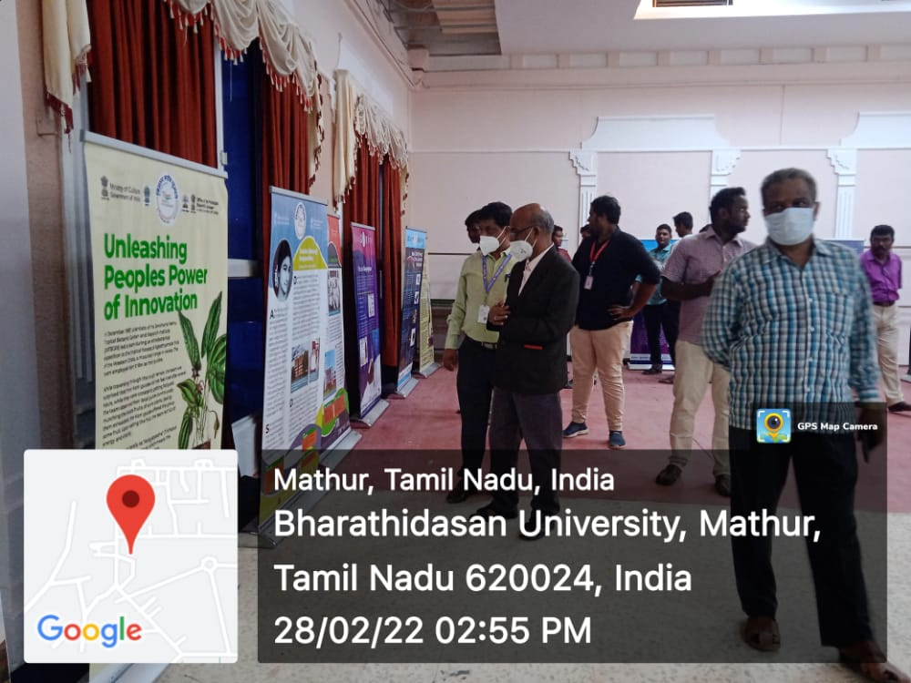

CONVOCATION DAY

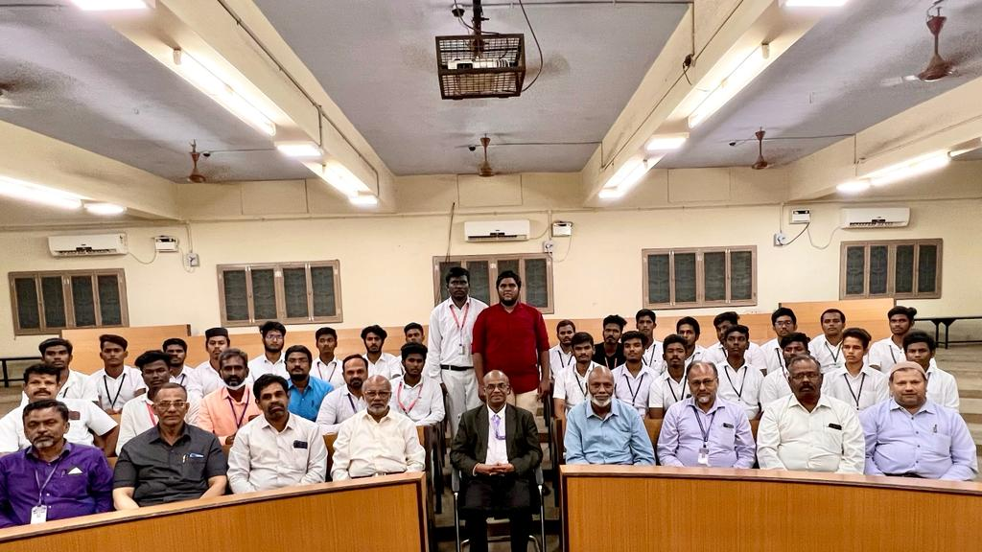

NSS ORIENTATION PROGRAMME AT BHARATHIDASAN UNIVERSITY
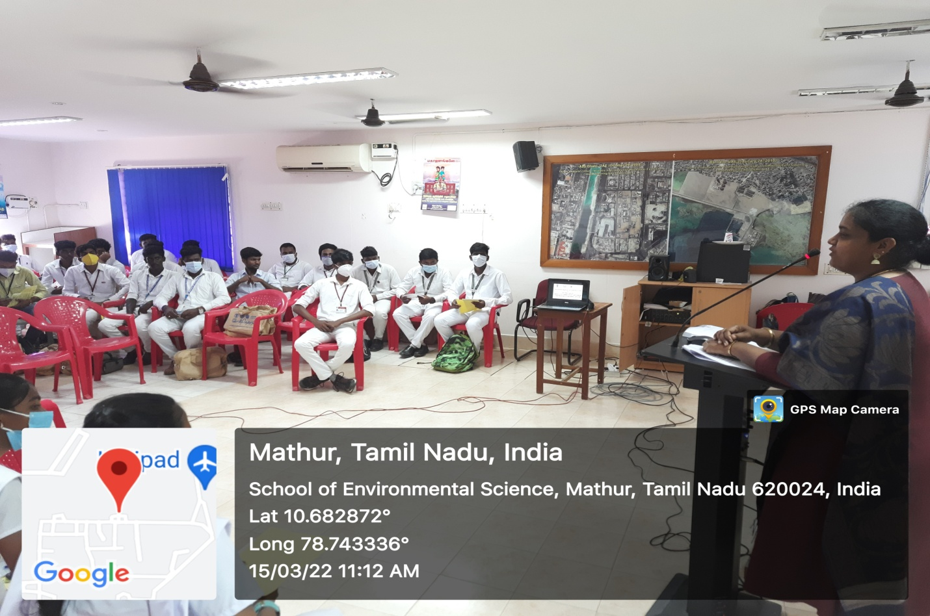

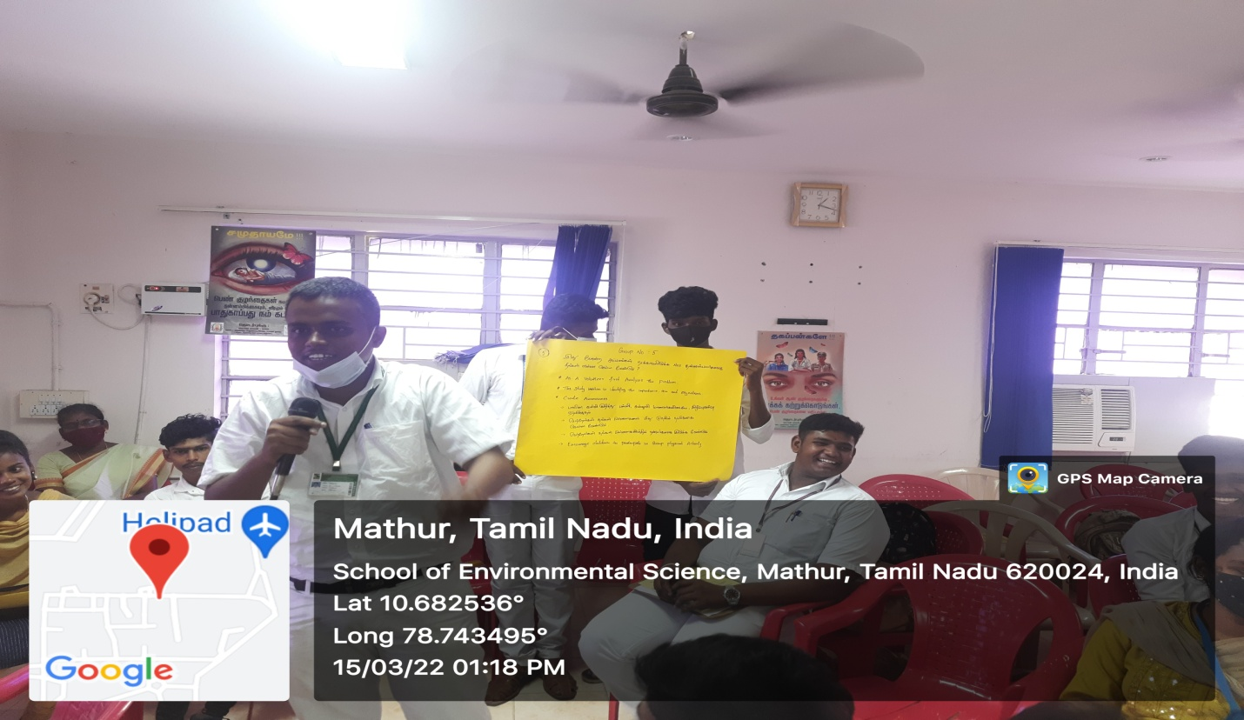

MARTRY’S DAY
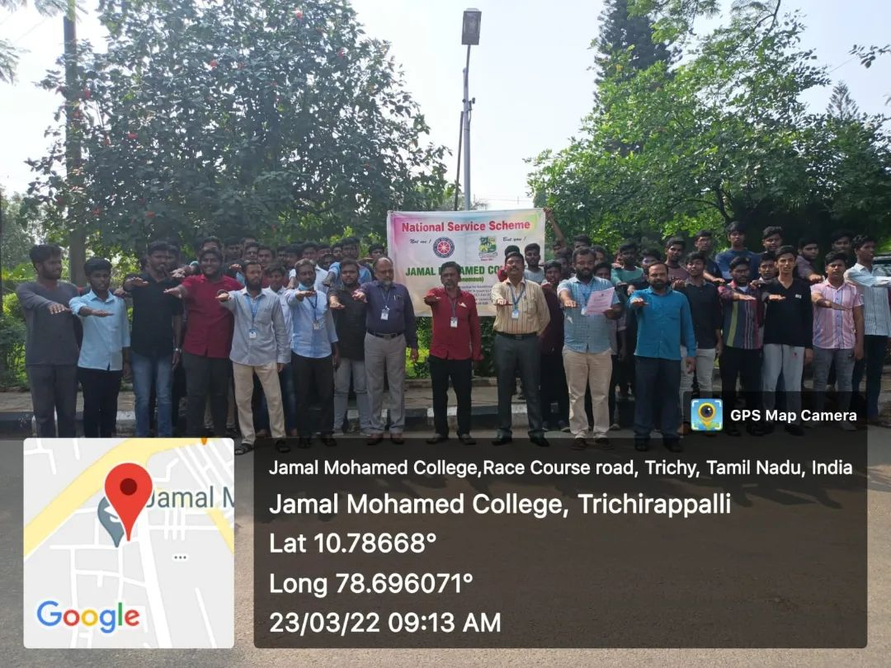

TB RALLY

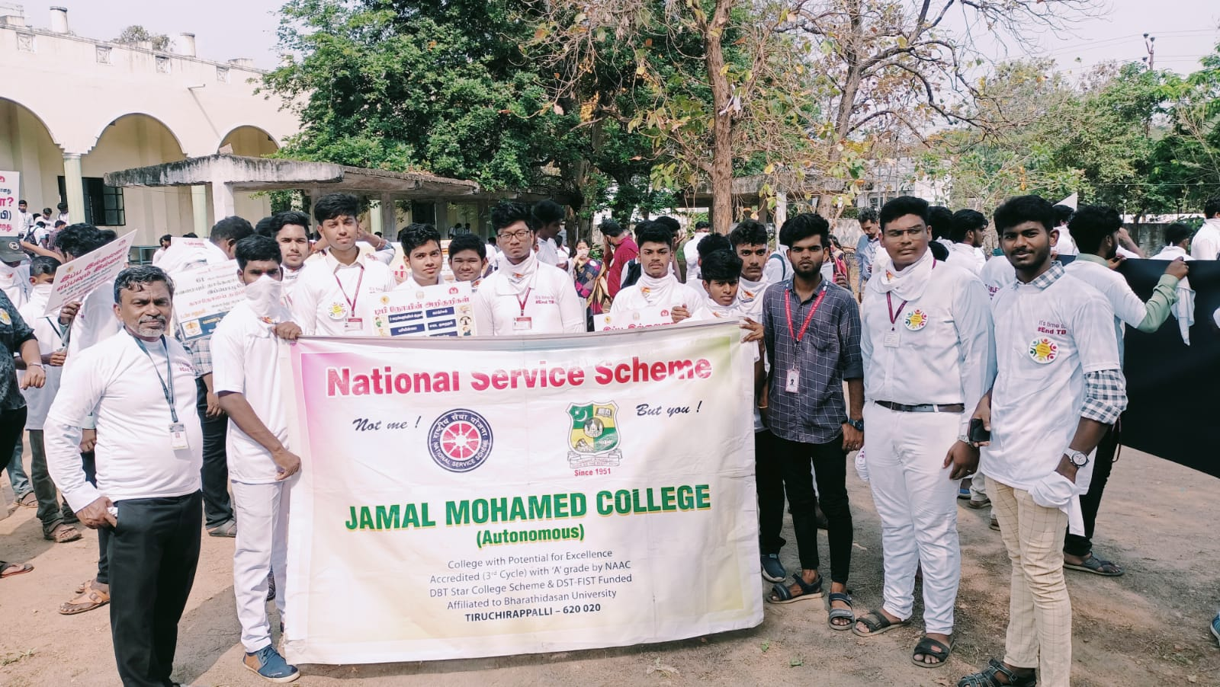
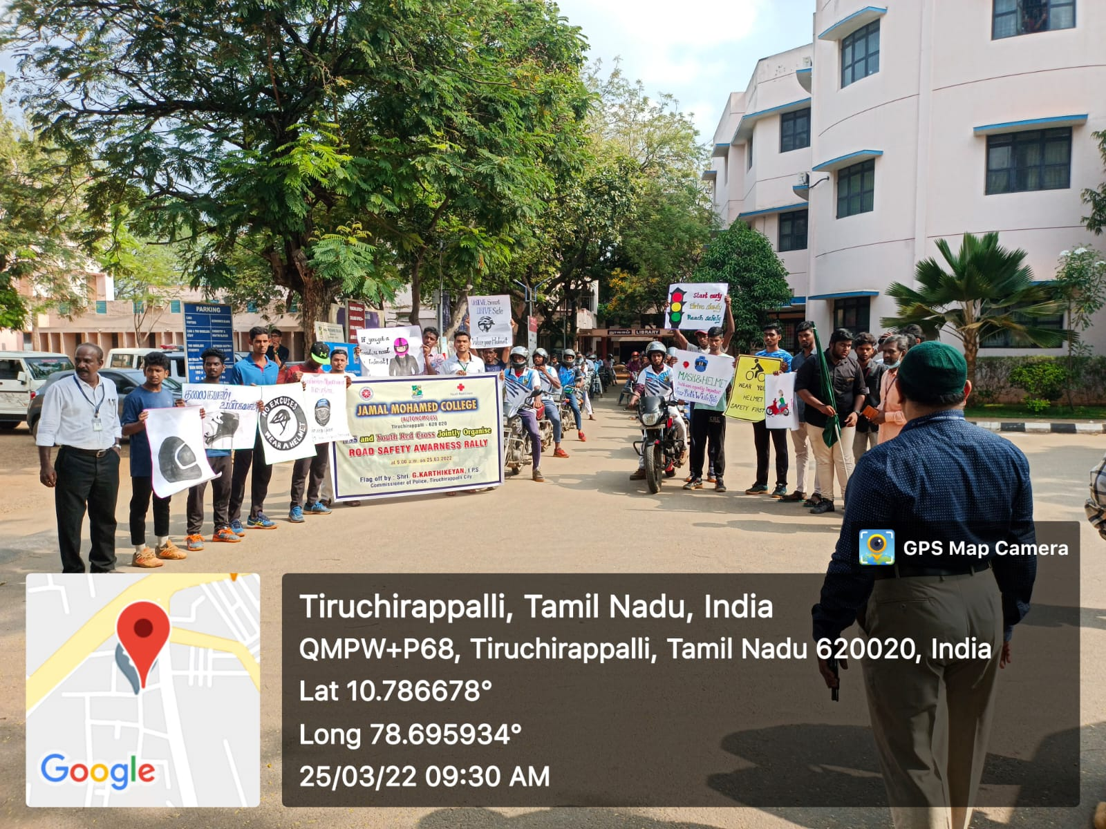
BIKE RALLY ROAD SAFETY AWARENESS

MEGA JOB FAIR
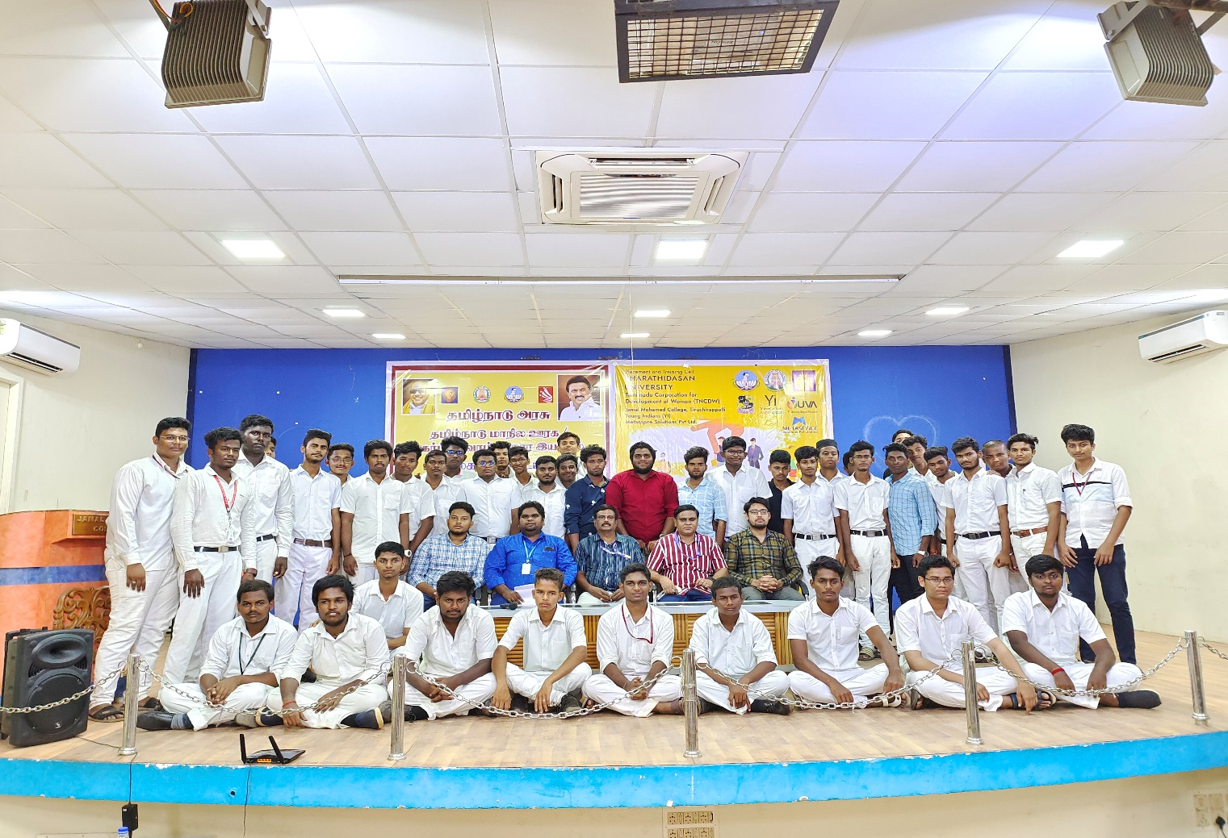

FOOD DONATION
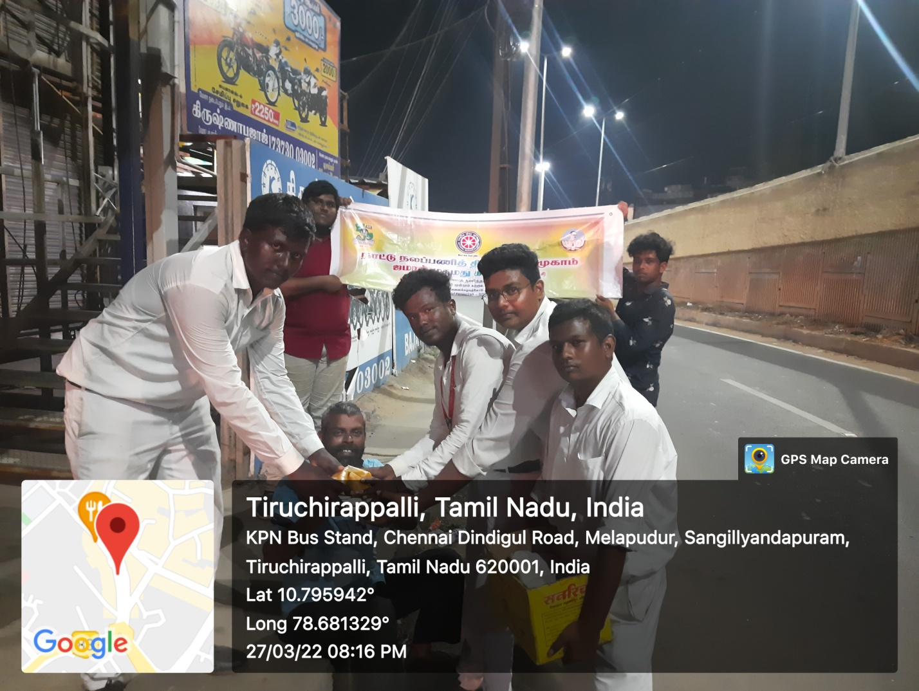

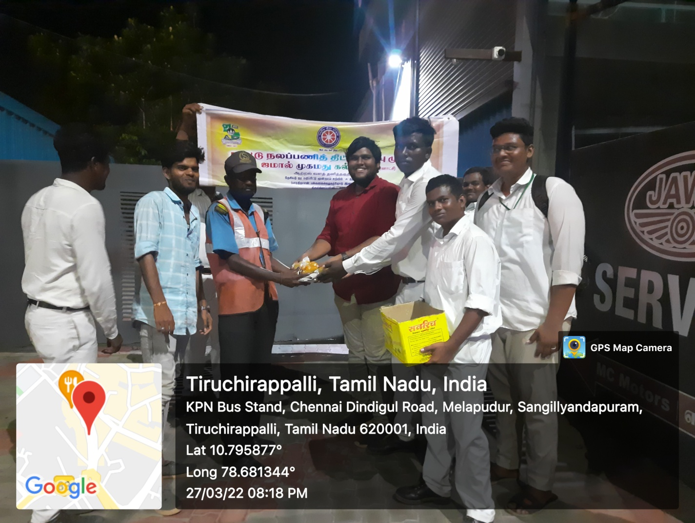
WOMEN’S EMPOWERMENT & PERSONALITY DEVOLOPMENT AT BDU
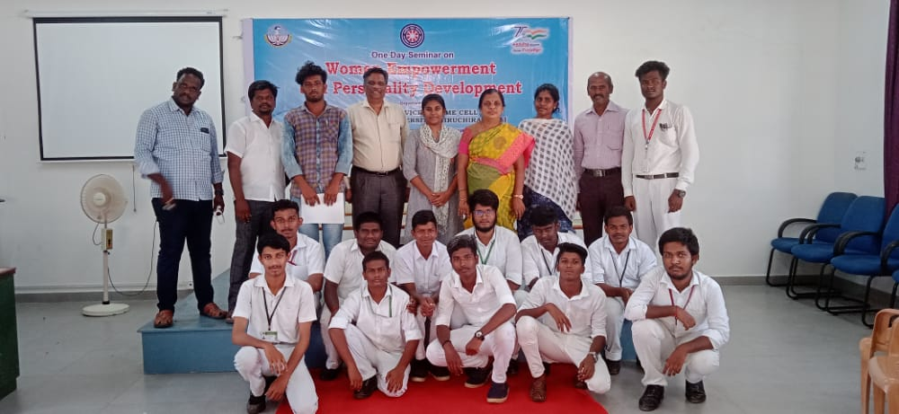

MASJIDH CLENING AT COLLEGE CAMPUS

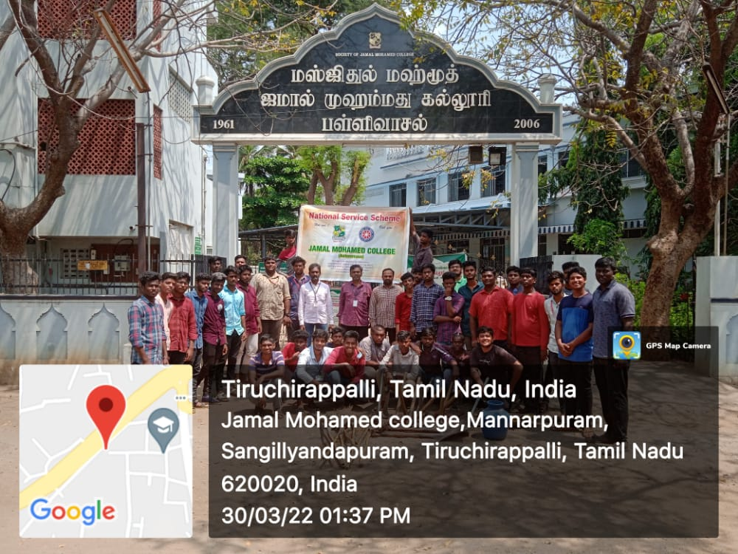
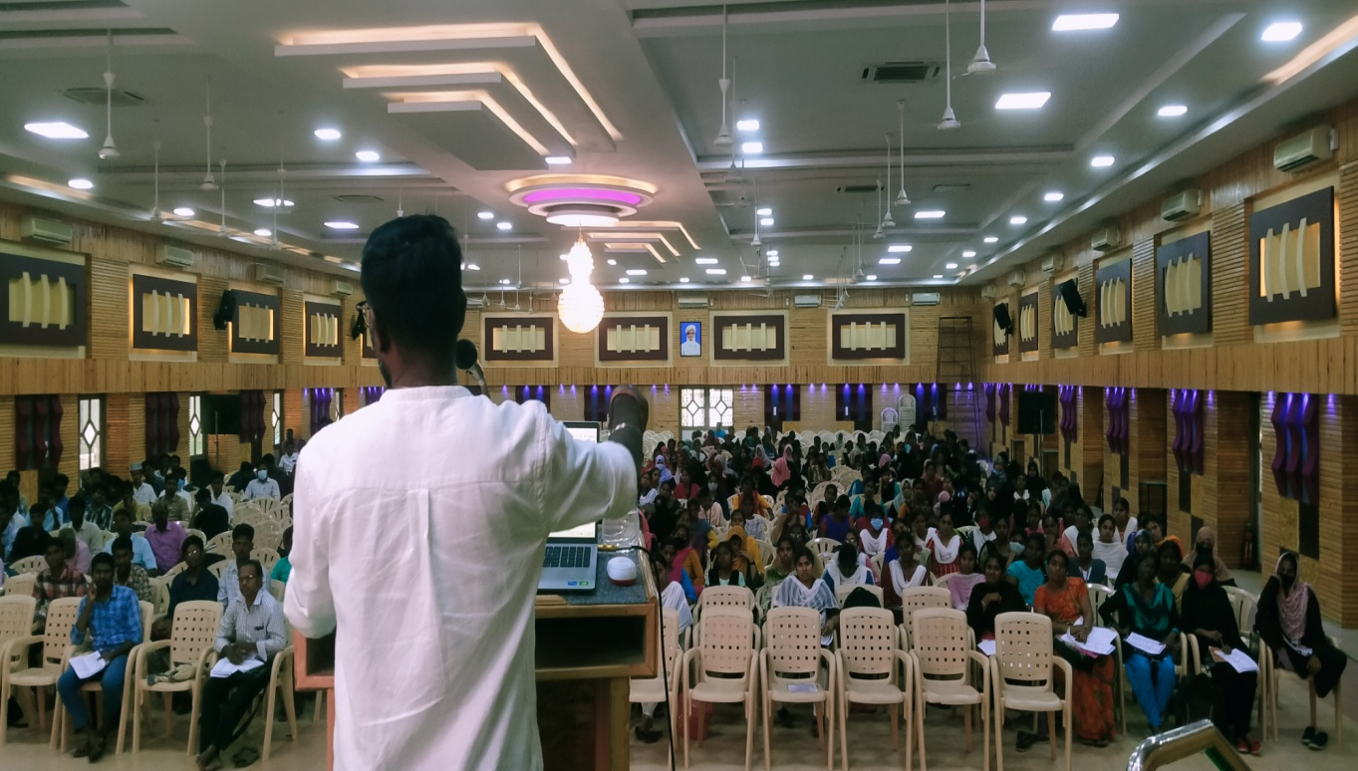
TNPSC COACHING & GUIDING PROGRAM

SPECIAL CAMP

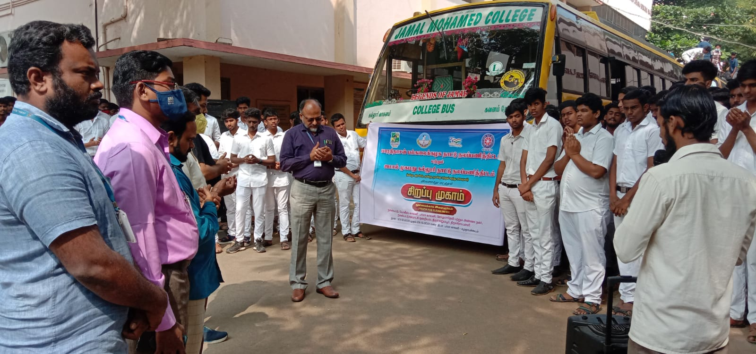
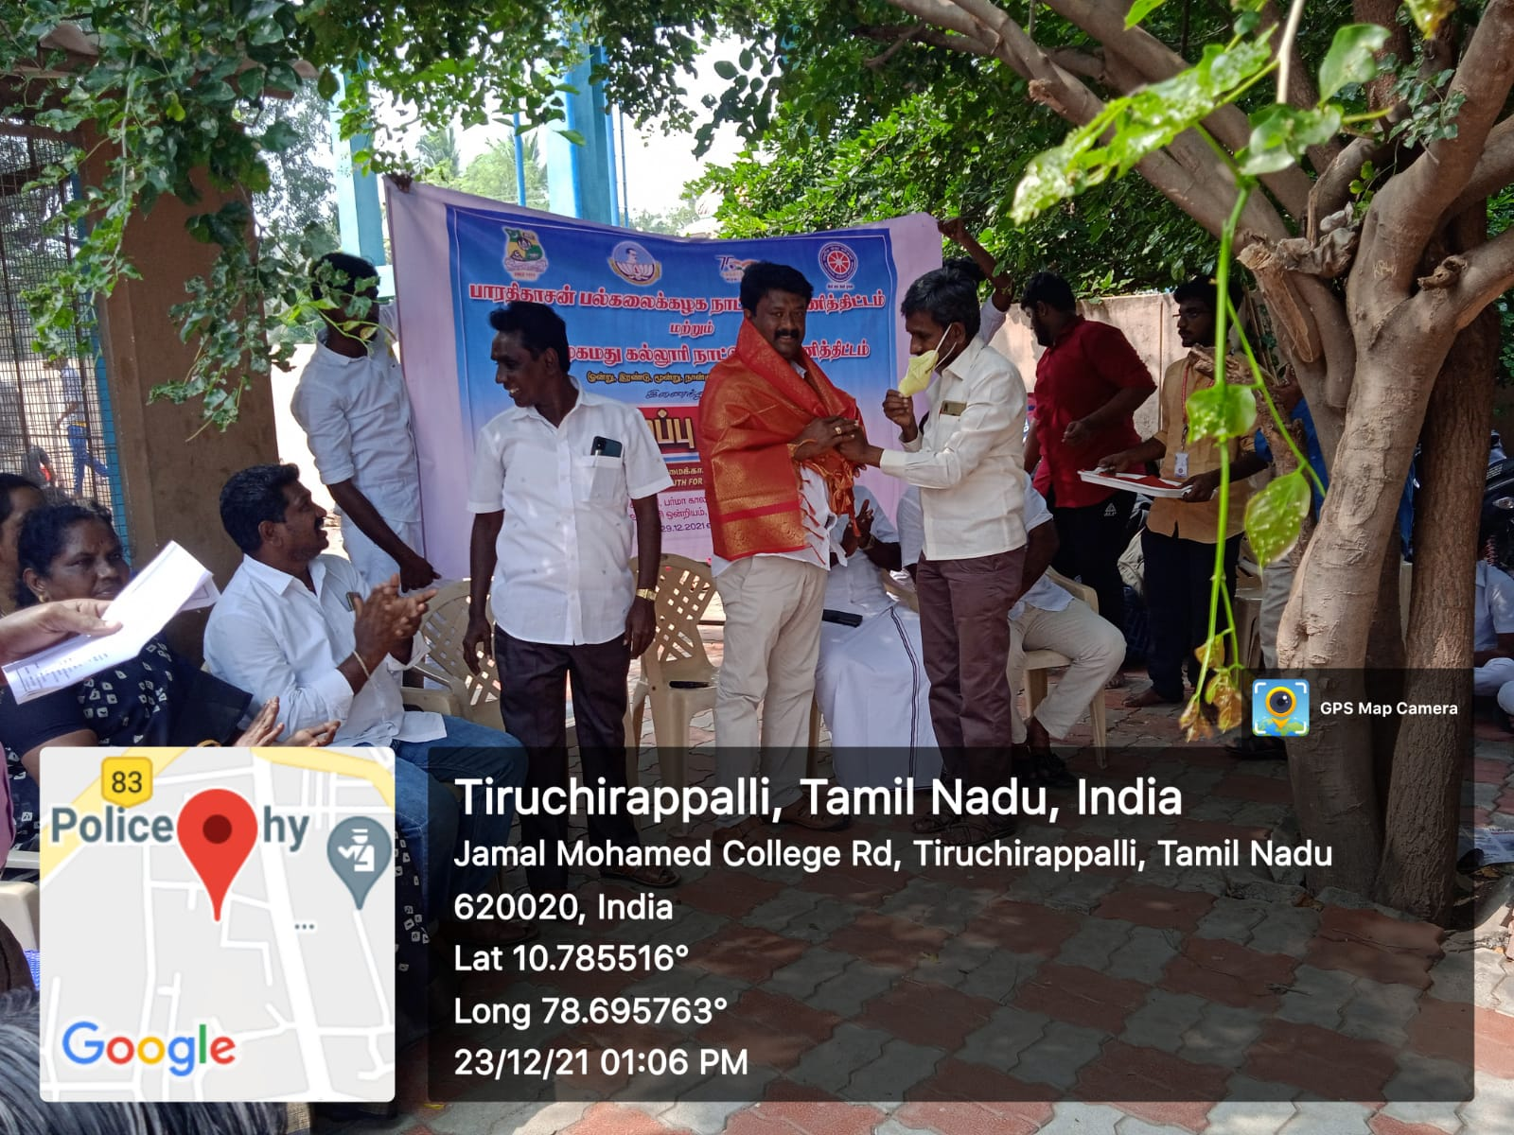

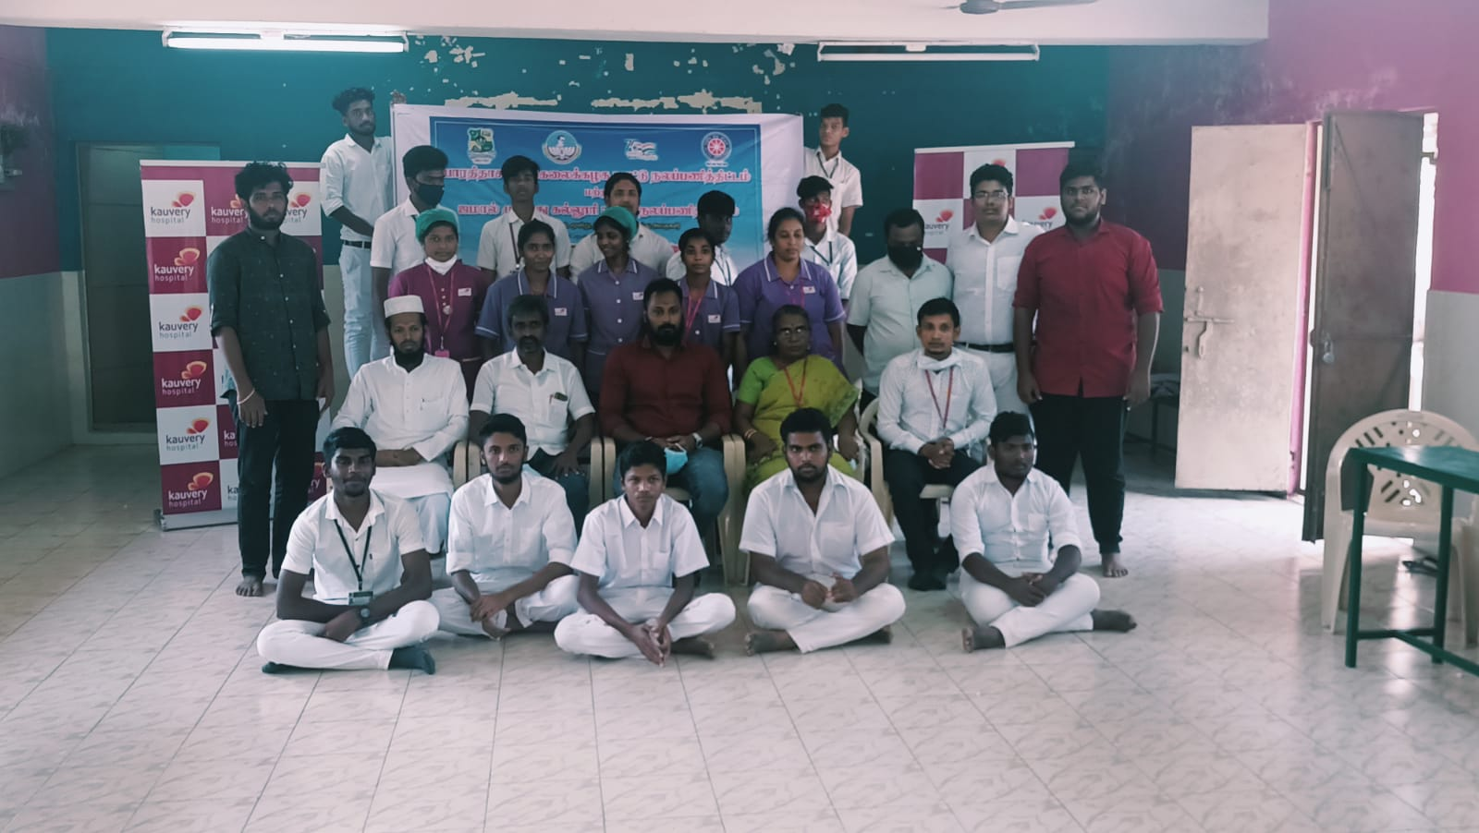
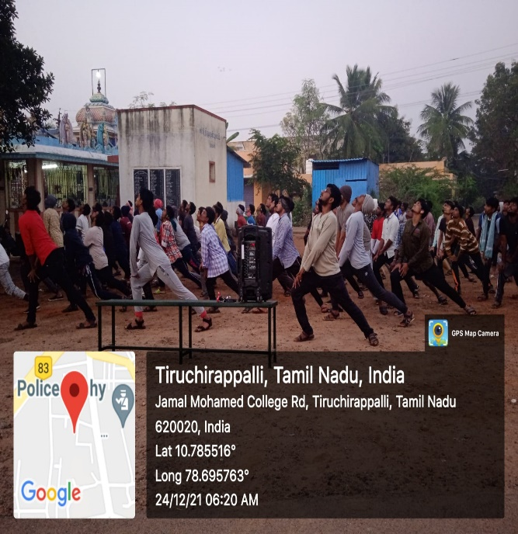
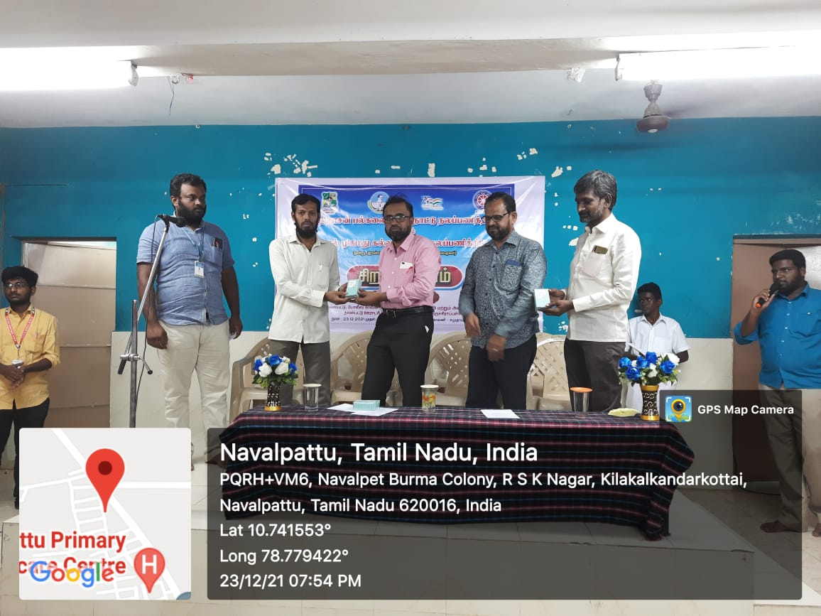
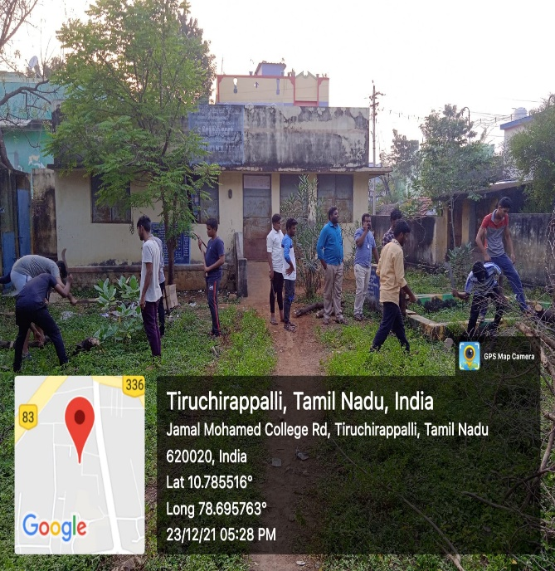
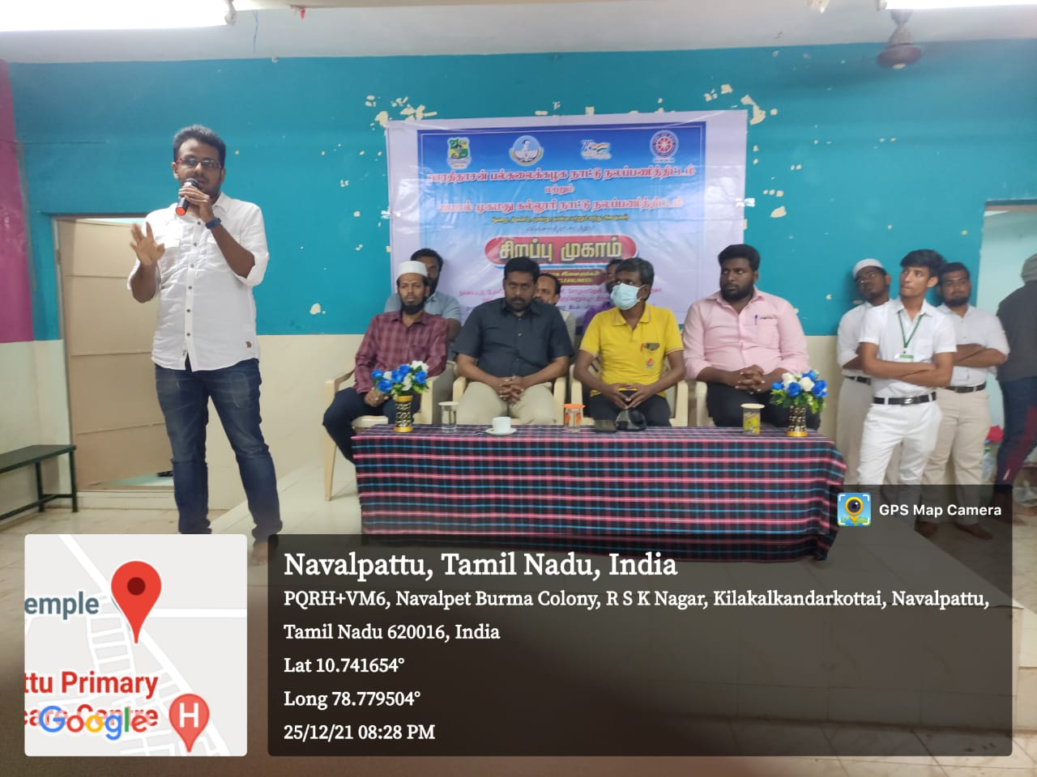
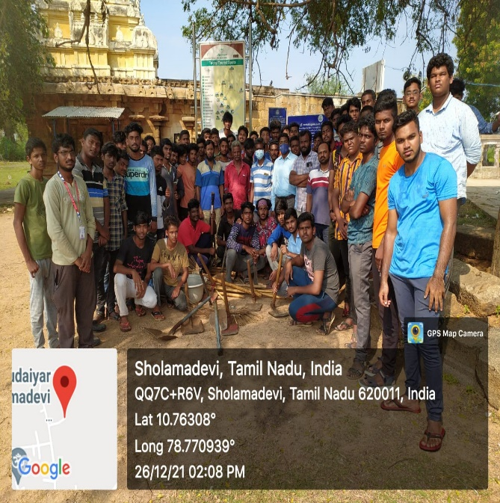
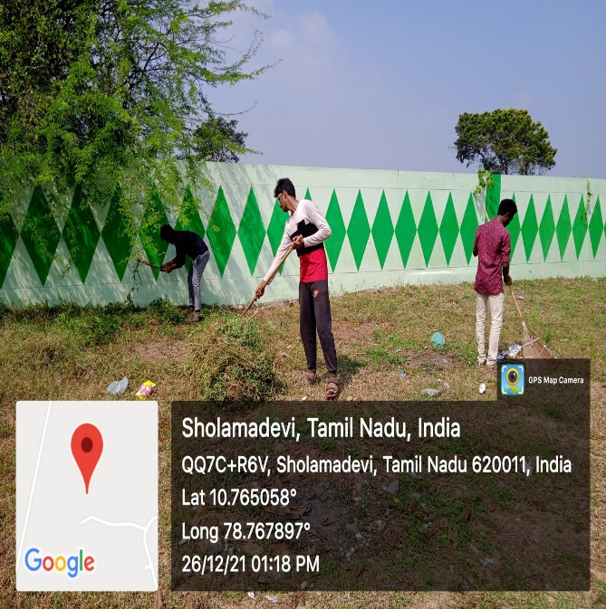
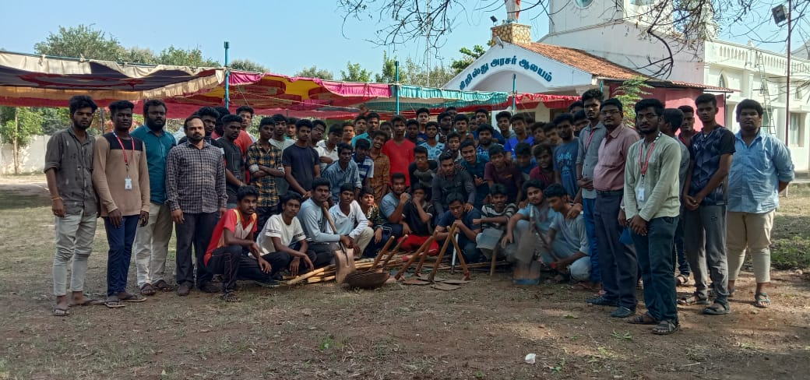
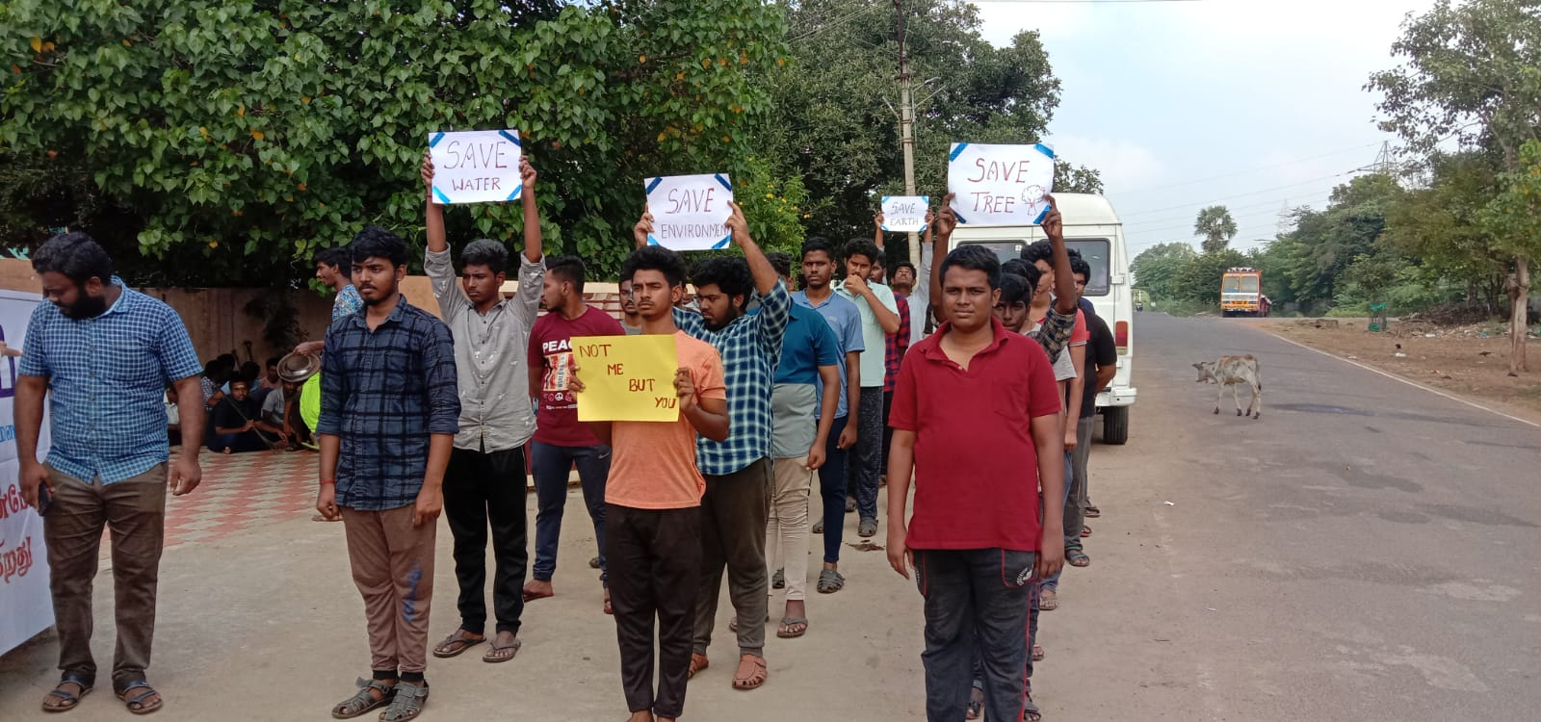
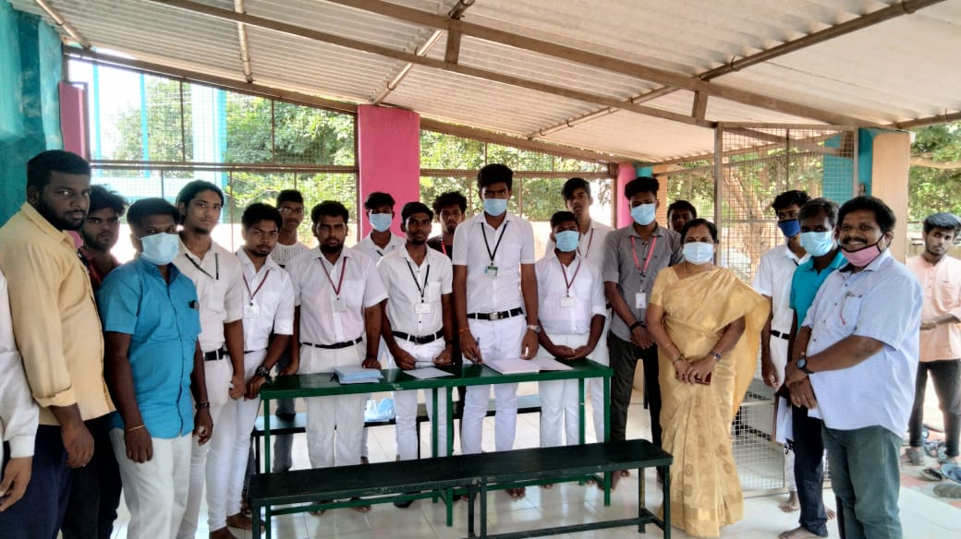
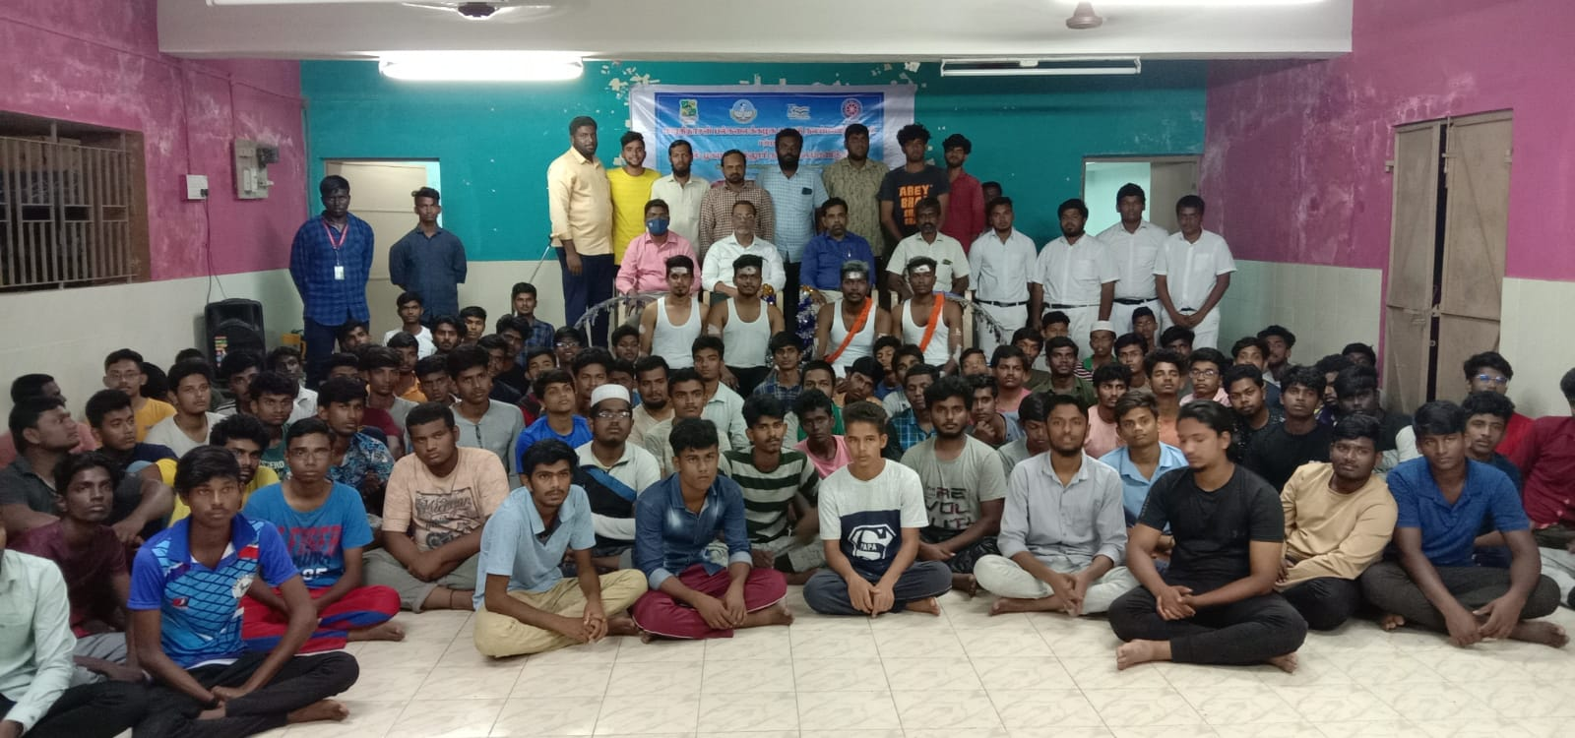
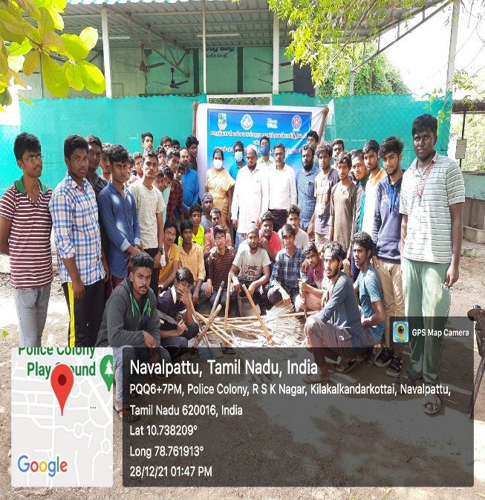
OUR SINCERE THANKS TO

- Founders
- President
- Secretary & Correspondent
- Assistant Secretary
- Treasurer
- Principal
- Vice principal
- Additional vice principal
- Director & Bursar (SF)
- Director-Hostel Administration
- Director-Hostel Administration & Register of Attendance
- Deputy Director- Hostel Administration (Women)
- HOD & Staff Members of all Departments
- Part V Coordinator
- Programme officers
- Coordinator Khajamian hostel
- Legal advisor
- Deputy Wardens
- Sub Wardens
&
- All the Teaching and non-teaching Staffs

OUR SINCERE THANKS TO

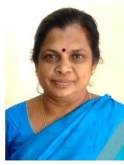

Dr. A. LAKSHMI PRABHA
Coordinator i/c
National Service Scheme
Red Ribbon Club
Organizing Secretary
Bharathidasan University.

SEVAI
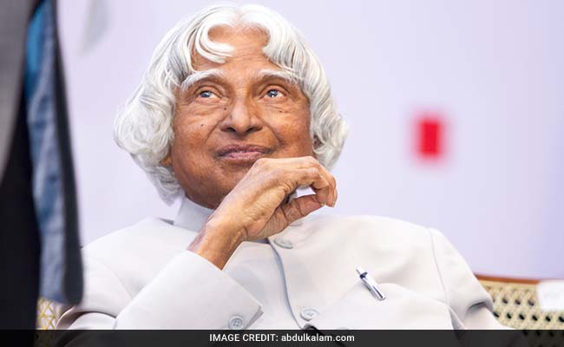

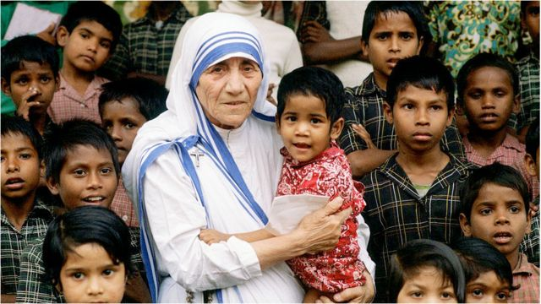

TO BE CONTINUED………

